Project no. 229792
Tecforlife
Assistive Technology Cluster for Quality of Life

FP7 – Regions – 2008 – 2 Regions of Knowledge
FP7 CSA – Support Action

Deliverable.2.2
Policy implications for the support of assistive technology clusters

Due date of deliverable: 31st July 2009
Actual submission date: 31st July 2009

Start date of project: 01/01/2009 Duration: 24 months

Organisation name of lead contractor for this deliverable: Fundación Ingema.

Project co-funded by the European Commission within the Seventh Framework Programme (2007-2013)
Dissemination Level
PU | Public | X
PP | Restricted to other programme participants (including the Commission Services)
RE | Restricted to a group specified by the consortium (including the Commission Services)
CO | Confidential, only for members of the consortium (including the Commission Services)

Table of Contents

INTRODUCTION: SCOPE AND PURPOSE OF THE REPORT 3
1. Ageing, disability and Demographic transition in Spain 5
1.1 Elderly people and disabled people in Spain and the Basque Country 7
1.1.1 Spain and the Basque Country: an ageing society 7
1.1.2 Disabled people in Spain and the Basque Country 11
2. GLOBAL EPIDEMIOLOGICAL CHANGES AND PROFILES 18
2.1 Relevant factors 18
2.2 Indicators of epidemiological transition 20
2.3 Ageing and Disability 21
2.4 Disability projections (OECD, 2030) 23
2.5 Age related chronic diseases 24
2.6 Obesity and Disability 27
2.7 Main Implications of Epidemiological Transition for AT 30
3. Political changes and opportunities: Spain’s Presidency of the European Union and the Basque Country’s change of administration 31
4. Analysis of trends and implications for the Tecforlife Cluster 32
5. Conclusions and Recommendations 34
6. References 37

Figures

Figure 1. Map of Spain, The Basque Country and San Sebastian Metropolitan Area 8
Figure 2. Spain. Disability rates by sex (1/1000). 2009 11
Figure 3. Spain. Disability rates (1/1000) by age groups, 1999-2009. 12
Figure 4. Average amount of disabilities in Spain caused by each group of deficiencies 16
Figure 5. Percentage of disabled people in Spain, per type of help they receive. 16

Tables

Table 1. Spain’s general population and people aged 65 and over. Data for the Basque Country, its provinces and San Sebastian Metropolitan Area. 8
Table 2. San Sebastian Metropolitan Area: People aged 65 and over by cities and towns (01/01/08) 10
Table 3. Disability in Spain: Highlights for the AT Cluster. 13
Table 4. Disabled people in Spain aged 6 or more, per disability group 13
Table 5. People disabled for BADL, per amount of disabilities and maximum difficulty WITHOUT HELP 14
Table 6. People disabled for BADL, per amount of disabilities and maximum difficulty WITH HELP 14
Table 7. Disabled people aged 6 or more in Spain, per group of deficiencies 15
Table 8. Incidence and prevalence rates of dementia from the EURODEM meta-analyses for European studies 25
Table 9. World Health Classification for obesity 28
Table 10. Proportion of Life Years Spent With Various Diseases (Self-reported), By Weight at Age Seventy 29

INTRODUCTION: SCOPE AND PURPOSE OF THE REPORT

This report (Deliverable 2.2) is a follow-up to the previous document submitted as Deliverable 2.1: “Report on local, national and European policies and initiatives in support of AT or related sectors”. It picks up on the baseline information gathered in the document and resumes the analysis of policy implications for the support of an assistive technology cluster in San Sebastian.
It focuses on health-related policy implications for it is health the steering idea of the potential cluster. Thus, major contemporary health challenges are covered, underpinning the actual situation in San Sebastian and the role Assisitive Tecnology can play.
As a starter, let us say technological developments are one of the most promising ways of improving the quality of life of people with sensorial, cognitive and physical impairments. Thus, Assistive Technology can be a very powerful means of achieving such a purpose and hence increasing independence of people with disabilities.
Chapter one highlights the implications of the demographic transitions contemporary societies have been undergoing for the last century and the potential scenarios coming up in the next few years. Special emphasis will be made on San Sebastian and the Basque Country as part of a more general trend in the Spanish scenario.
Scientific advancements and improvements in living standards of the population have made it possible for people to live longer lives, even with increasingly severe impairments. Population worldwide is ageing, and the healthcare systems of different countries must deal with a larger number of people with independence difficulties related to physical, cognitive or sensory disabilities. Chapter two comprises a globally-based analysis of the epidemiological transition arising from the so-called demographic transition and the political implications to be taken into account by public administration.
Chapter three is meant to draw a picture of the political changes and opportunities arising from the changes that have recently taken place in the regional Basque Government. Can the new Government priorities trigger actual support for the set up of a AT-based cluster in San Sebastian? If so, how? Is the Tecforlife consortium able to grasp the chance?
Finally, chapter four intends to be an analytical synthesis of the political implications laid out in the previous sections. As potential AT clients are growing in number, there are new ways in which they relate to technology. They are more knowledgeable, have a familiarity with technology used in everyday life, and are less likely to be intimidated by its usage. Besides, many clients are increasingly demanding, as they have more complex needs, derived from the improved survival rates of persons with severe levels of impairments. Furthermore, AT users are more likely to be supported by caregivers around them who may also be at ease with technology assistive devices. Are politicians and health practitioners aware of that? The evidence is vaguely confirming that they are increasingly aware, but the vast majority is still facing these facts as scenarios in the long-run.

Ageing, disability and Demographic transition in Spain
The improvement of living conditions for the world population, although not equally distributed, and the demographic changes in fertility and mortality rates across the life course are the main reasons underlying the actual ageing phenomenon and the mainstreaming of disability into the general public agenda.
Although “ageing” is increasingly in the media spotlight, political debates and regular conversations, its meaning is rarely spelled out (Timonen, 2008). Hence, before going any further, it is helpful to define what “ageing” means from different angles: individual ageing, population ageing and qualitative changes in ageing (OECD, 1996; Timomen 2008).
Individual Ageing refers to the experience of people living longer than members of previous generations. Surviving into older ages is historically a very recent development (Timonen. 2008). In 1900, life expectancy at birth in Spain was 34,8 years; in contrast and according to the latest official statistics (2004) it is currently 80,2 years (IMSERSO, 2009). Spain holds one of the highest life expectancy rates in Europe, especially for women (84,4 years).
As said before, the main reason for this incredible leap is the decrease of mortality, especially, child mortality. Nowadays, out of every 100 children born in Spain, 83 will probably live up to 65 years of age or older. In 1900, it was only 26% (IMSERSO, 2009).
Population Ageing refers to the result of two processes coming together: lower mortality and birth rates. Not only are people living longer, but they are having fewer children because of many reasons not to be discussed here. The combination of these two processes leads to an increase in the share of older people in the population as a whole (OECD, 1996; Timomen 2008). In other words, population ageing refers to the changes in the age structure and age group distribution in any given society.
The shift from high fertility-high mortality rates to low fertility-low mortality rates is the core of the so-called demographic transition. The progression is obviously far more complicated than this easy explanation (especially because not every country follows the same pattern), but this is basically the idea and it will serve our purpose in this document. In Spain, for example, by 2006, the average number of children per women was 1,4 .
Finally, the concept Qualitative Changes in Ageing (OECD, 1996; Timomen 2008) refers to the least well understood and most controversial aspects of ageing: the (qualitative) changes that are occurring in people’s lives as they live longer. In view of the fact that no previous society has witnessed such a process nor has any society been able to develop specific policies to this matter before, individuals and societies are building their responses as they age and live ageing throughout their life course. For example, in the so-called developed world, it is likely “to survive to the age of 40 or even beyond without experiencing the death of any close relatives – whereas this was extremely rare in the not too distant past” (Timomen 2008).
Coming back to the decrease in mortality rates, there are basically two reasons to the fall: the development of preventive medicine and the improvement of health care. These two have allowed individuals and public health to better prevent and control diseases that directly had an effect on mortality and morbidity rates.
Likewise, disability has observed a change throughout the last century both because of the changes and improvements aforementioned and because of more complex changes in social values, norms and ethics. In this paper, persons with disabilities are understood as “…those who have long-term physical, mental, intellectual or sensory impairments which in interaction with various barriers may hinder their full and effective participation in society on an equal basis with others.” (United Nations, 2006).
In Spain, there are 3,8 million people suffering from a disability (INE-IMSERSO, 2008). That is 8,5% of the population as a whole. Most of them are women (2,3 million), especially those over 45 years of age.
At this early stage, it is important to refute two well spread myths about ageing and disability. One is the assumption that ageing means more spending on health, social care and pensions; and the other is a simple correlation between ageing and disability: ageing means more disability (Walker and Walker, 2006). Not all elderly people suffer from disabilities and not every disabled person is also an aged person. Disability can happen at any age, to any one, at any place. As people age, they become more fragile and may become more dependant on other to accomplish every day life activities, but dependency and disability are not the same (Walker and Walker, 2006).
It is now important to provide a general and solid description of the main target population for the AT Cluster: elderly people and disabled people.

Elderly people and disabled people in Spain and the Basque Country

Spain and the Basque Country: an ageing society
As of 1 January 2009, Spain’s general population was 46.6 million people, 7.8 million were aged 65 or older, representing 16,6% of the whole population (INE, 2009). In 1900, people aged 65 or older represented only 5,2% (IMERSO, 2009). Over a century, elderly people have more than tripled their share in the Spanish population (Table 1).
As of 1 Juanuary 2009, the Basque Country’s population surpasses 2.1 million people, and more than 400.000 were aged 65 or over. This represents 18,8 % of the region’s population. In the province of Gipuzkoa (being San Sebastian its capital and main city), the figures are alike: the whole population is 705.421people and people aged 65 and over represent 18,6% (Table 1).
Finally, the figures for San Sebastian Metropolitan Area (SSMA officially named as “Donostialdea” – see Figure 1) and for the city of San Sebastian encompass some slight differences. First, the general population of the SSMA is 322.148 and the weight of people 65 and over is 18,78%, 2% higher than the average percent in Spain, but not the oldest in the Basque Country as the Province of Vizcaya is the most aged region. Second, the general population for the city of San Sebastian is 184.248 and the percent of people 65+ is 20,9%, more than 3.5% above the Spain average (Table 1).
It is also remarkable the situation of women both in SSMA and in San Sebastian city as they represent 60,11% and 60,88% of all the people aged 65+ (Table 1).

Figure 1
Map of Spain, The Basque Country and San Sebastian Metropolitan Area
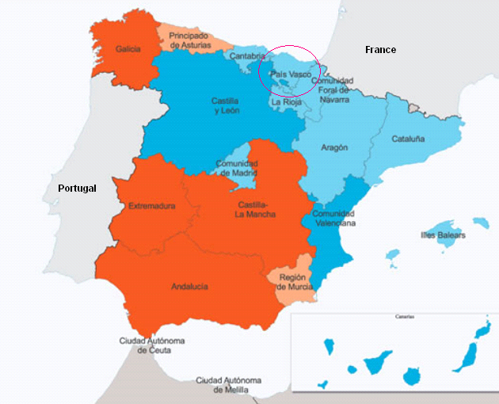 | 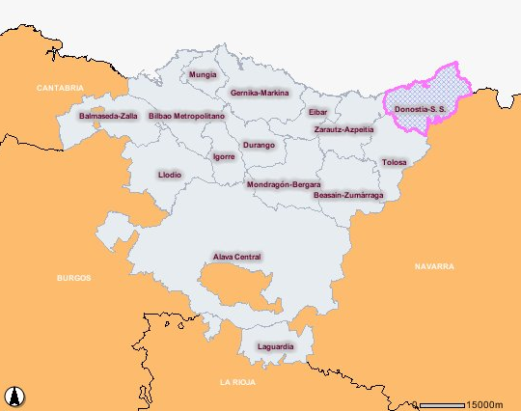
Source: Spain’s map taken from the European Social Fund web page. Country Profile: Spain. Last accessed: 20 April 2009. (http://ec.europa.eu/employment_social/esf/members/es_en.htm) . Basque Country’s map taken from the Basque Government’s Department for Territorial Planning estimates the SSMA population to reach 396.306 people (http://www1.euskadi.net/udalplan/visor/viewer.htm).

Table 1
Spain’s general population and people aged 65 and over.
Data for the Basque Country, its provinces and San Sebastian Metropolitan Area. 2009.
 | Total | 65+ |  | Women |  | Men
 | Total | Absolute figures | % of the whole population | Absolute figures | % of the 65+ group | Absolute figures | % of the 65+ group
Spain | 46.661.950 | 7.780.830 | 16,67% | 4.471.023 | 57,46% | 3.309.807 | 42,54%
Basque Country | 2.171.243 | 409.532 | 18,86% | 238.631 | 58,27% | 170.901 | 41,73%
Alava | 313.592 | 53.298 | 17,00% | 29.756 | 55,83% | 23.542 | 44,17%
Vizcaya | 1.152.230 | 224.629 | 19,50% | 131.942 | 58,74% | 92.687 | 41,26%
Guipuzcoa | 705.421 | 131.605 | 18,66% | 76.933 | 58,46% | 54.672 | 41,54%
Donostialdea¹ ² | 322.148 | 60.536 | 18,79% | 36.390 | 60,11% | 24.146 | 39,89%
San Sebastian | 184.248 | 37.018 | 20,09% | 22.905 | 61,88% | 14.113 | 38,12%
1 Donostialdea is the official name of the Metropolitan Area of San Sebastian. It comprises the following cities and towns: San Sebastian (184.248), Rentería (38.505), Hernani (19.229); Lasarte (17.694), Pasajes (15.996), Andoain (14.227) Oiartzun (9.847), Lezo (6.022), Urnieta (6.065), Usurbil (5.793), and Astigarraga (4.522).
2 Data as of 1 January 2008. The 2009 update is on process at the INE).
Source: Instituto Nacional de Estadística –INE- (2009). Avance del Padrón a 1 de enero de 2009. Datos provisionales. Comunidades autónomas y provincias. At: http://www.ine.es/jaxi/tabla.do ; Accessed 10 July 2009.

Concerning the closest population to the prospective AT Cluster, it is important to go in further details of the SSMA. As pointed out before, the SSMA population reaches 322.148 people, 60.536 (18,79%) being 65+. Yet, as stated before (see footnote 1), elderly people are diverse and different. Hence, the large life course people go through from 65 to, let us say, 99 years of age cannot be considered as a single unit.
Out of the 60.536 people aged 65+, 36.390 (60,11%) are women and 24.146 (39,89%) are men. But the distribution of age and sex is not equal in all the territories encompassed in the SSMA.
Breaking the whole 65+ group into smaller age groups makes the invisible differences arise. For instance, there are more people aged 70-74 (25%) than people aged 65-69 (24%). With regard to the 85+ group (“the oldest old”), the percent of women in every territory is over 65%, being San San Sebastian the city with the highest percentage of women aged 85+ (75,11% of the age group) (Table 2).
It is very important to highlight that elevated presence of the oldest old in every territory impels a prospective response from every sector in the public and private spheres due to the fact that life expectancy in Spain is sure to surpass 85 in the next years, especially –again- for women and to the fact that aged women hold higher rates of disability than men. An AT Cluster must be aware of the characteristics and needs of this population and policy makers must adapt their decision making processes, too.

Table 2
San Sebastian Metropolitan Area: People aged 65 and over by cities and towns (01/01/08)
 | 65-69 | 70-74 | 75-79 | 80-84 | 85 + | Total
San Sebastián city | 8.616 | 8.827 | 8.224 | 6.031 | 5.320 | 37.018
Women | 4.769 | 5.078 | 5.043 | 4.019 | 3.996 | 22.905
Men | 3.847 | 3.749 | 3.181 | 2.012 | 1.324 | 14.113
Errenteria | 1.789 | 1.970 | 1.548 | 1.019 | 767 | 7.093
Women | 952 | 1.124 | 886 | 648 | 547 | 4.157
Men | 837 | 846 | 662 | 371 | 220 | 2.936
Pasaia | 737 | 974 | 775 | 533 | 387 | 3.406
Women | 416 | 574 | 459 | 344 | 290 | 2.083
Men | 321 | 400 | 316 | 189 | 97 | 1.323
Hernani | 781 | 902 | 720 | 510 | 333 | 3.246
Women | 408 | 499 | 433 | 322 | 241 | 1.903
Men | 373 | 403 | 287 | 188 | 92 | 1.343
Lasarte-Oria | 1.064 | 869 | 556 | 334 | 254 | 3.077
Women | 514 | 423 | 295 | 203 | 193 | 1.628
Men | 550 | 446 | 261 | 131 | 61 | 1.449
Andoain | 636 | 629 | 557 | 377 | 252 | 2.451
Women | 319 | 337 | 312 | 232 | 171 | 1.371
Men | 317 | 292 | 245 | 145 | 81 | 1.080
Oiartzun | 386 | 375 | 286 | 193 | 149 | 1.389
Women | 198 | 177 | 146 | 130 | 100 | 751
Men | 188 | 198 | 140 | 63 | 49 | 638
Usurbil | 248 | 237 | 188 | 129 | 86 | 888
Women | 117 | 126 | 106 | 82 | 56 | 487
Men | 131 | 111 | 82 | 47 | 30 | 401
Lezo | 198 | 188 | 187 | 127 | 79 | 779
Women | 101 | 110 | 105 | 79 | 59 | 454
Men | 97 | 78 | 82 | 48 | 20 | 325
Urnieta | 194 | 175 | 150 | 88 | 79 | 686
Women | 83 | 98 | 74 | 50 | 55 | 360
Men | 111 | 77 | 76 | 38 | 24 | 326
Astigarraga | 149 | 112 | 113 | 82 | 47 | 503
Women | 73 | 64 | 69 | 53 | 32 | 291
Men | 76 | 48 | 44 | 29 | 15 | 212
Total | 14.798 | 15.258 | 13.304 | 9.423 | 7.753 | 60.536
Women | 7.950 | 8.610 | 7.928 | 6.162 | 5.740 | 36.390
Men | 6.848 | 6.648 | 5.376 | 3.261 | 2.013 | 24.146
Source: Instituto Nacional de Estadística –INE- (2009). Padrón a 1 de enero de 2008.Datos por municipios. At: http://www.ine.es/jaxi/tabla.do ; Accessed 10 July 2009.

Disabled people in Spain and the Basque Country
In Spain, there are 3.847.900 people suffering from a form of disability (INE-IMSERSO, 2008). That is 8,5% of the population as a whole. Most of these people are women (2,3 million), especially aged women (Figure 2).
Women and men present very different pattern when it comes to disability. From 0 to 45 years of age, men present higher rates of disability than women. After this age, women’s rate tends to increase. At this point it is important to notice that disability tends to happen more frequently after the age of 55 (Figure 2). That is the reason why women surpass men by almost one million cases. In Chapter two, when discussing, the epidemiological profile of the elderly and the disabled persons, the different types of disabilities will be discussed.

Figure 2
Spain. Disability rates by sex (1/1000). 2009
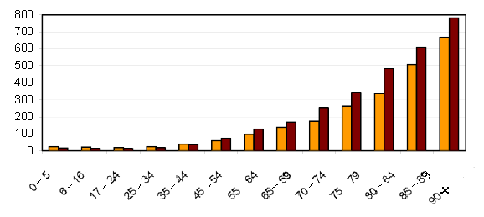
 | Men (1,55 million) |  | Women (2,30 million)
Source: INE-IMSERSO (2008).

Despite the high rates in older age groups, there has been a decrease in the disability rate for the whole population if the 2008 (8,5%) data are compared to the 1999 results (9,0%) (Figure 3). This is so because even though there has been a great increase of the share of people aged 65+ with respect to the whole population, the “new” elderly people do not suffer of a disability as much as the “former” elderly people used to, thanks to better social and health conditions. As can been seen in Figure 2, there has been a decrease in every age group from 16 to 90 years of age, especially the 75-79 group (-16,2%) and the 80-84 group (-10,2%). The average age of people with disabilities is 64,3. In 1999, it was 63,3. This means disability tends to happen later in the life course.

Figure 3
Spain. Disability rates (1/1000) by age groups, 1999-2009.
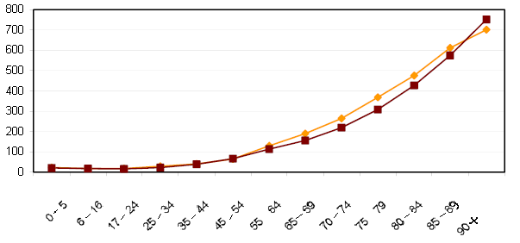
 | 1999 |  | 2008
Source: INE-IMSERSO (2008).

A very interesting feature is that more than 600.000 people suffering from disabilities In Spain live by themselves. As the number of living solo households is generally increasing in Spain, policy makers are expected to address the need of both solo living households and solo living households of a disabled person. Yet, as a general rule, people living with disabilities live in two-people households. As a whole, there are 3,3 households where one of their members lives with a disability. This represents 20,0% of the total households in Spain.
Therefore, two conclusions can be drawn at this stage: suffering from a disability does not lead to an early death as it was the case years before and disability tends to happen later in the life course (INE-IMSERSO, 2008). This is part of what was previously stated as the core of the demographic transition (high fertility-high mortality rates to low fertility-low mortality rates) and also part of another phenomenon called epidemiological transition, which is to be addressed in Chapter two.
In the near future, as the share of older people in the whole population will increase, so will the rates of elderly people suffering from disabilities, especially women. Policy making must then be based on a precise, clear and coherent gender perspective in order to accurately tackle the differences between men and women as they age or become disabled.

Table 3
Disability in Spain: Highlights for the AT Cluster.
- 3.847.900 people suffer from of disability in Spain
- That is 8,5% of the population as a whole
- 2,30 million are women; 1,33 million are men
- Men present higher rates of disability than women in 0-45 age groups.
- Women present higher rated starting from the 46-50 age group
- Disability tends to happen later in the life course thanks to better social and health conditions
- Better social and health conditions allow people to live longer with their disability
- More than 600.000 disabled people live alone, but most disabled people live in two-people households
- 20,0% of the total households in Spain present at least one person with a disability
- Gender-based policy making is needed to address this phenomenon
- Gender-based approach to potential users and buyers needs to be taken into account by the AT Cluster

Source: INE-IMSERSO (2008).

The main disability problems affecting Spanish aged 6 or more are: mobility problems (affecting 6% of population), domestic life (4.9%) and self-care (4,3%). Inside the group with mobility problems, two out of three people have problems for going out of their homes.
Table 4
Disabled people in Spain aged 6 or more, per disability group
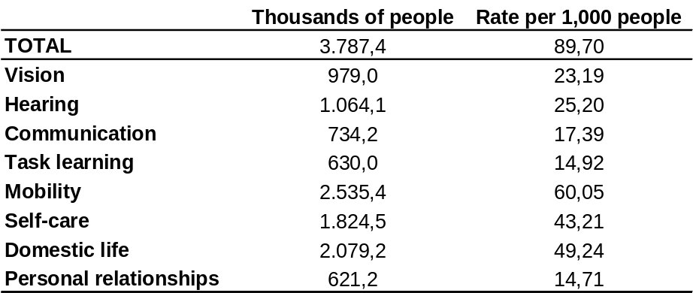

Source: “Survey about Disability, Personal autonomy and Situations of Dependence”. 2008. INE
Of the total disabled people in ages 6 or older, 74% (2.8 million) have some dificulty for carrying out Basic Activities of Daily Life (BADL). Half of them cannot make some of these activities without help. By gender, 80,3% of disabled women have some restriction for these activities, compared to 64,6% of men. Limitations become more important as the age increases and, so, 86% of of disabled aged 80 or more have difficulties for BADL.

Table 5
People disabled for BADL, per amount of disabilities and maximum difficulty WITHOUT HELP (Thousands of people)
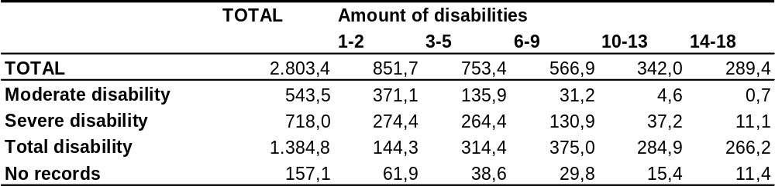

Source: “Survey about Disability, Personal autonomy and Situations of Dependence”. 2008. INE

Among the 2,8 million people disabled for BADL, 80.5% receives some kind of help. That allows a significant decrease in the severity of their impairments and it even allows 339,000 people to overcome them.

Table 6
People disabled for BADL, per amount of disabilities and maximum difficulty WITH HELP (Thousands of people)
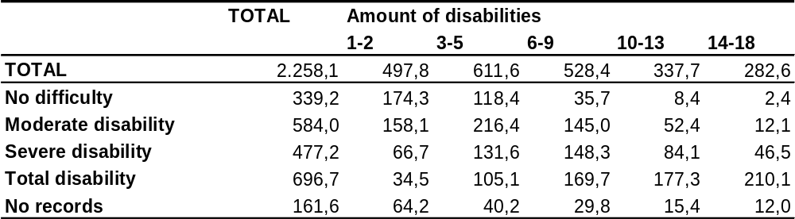

Source: “Survey about Disability, Personal autonomy and Situations of Dependence”. 2008. INE
The most frequent deficiencies causing disability in Spain are: bones and joints problems (39.3%), hearing problems (23.8%), visual problems (21%) and mental problems (19%).
In the group of people aged 6 to 44, the main deficiencies are the mental, affecting a third of the disabled people. After the age of 45 the osteoarticular deficiencies are present in 4 out of 10 disabled people.
The disabilities related to personal relationships, communication, task learning and self-care have a higher incidence among people aged 6 to 44, because these are all disabilities very closely affected by menthal deficiencies. On the other hand, the disabilities for mobility, domestic life, vision and hearing become more prevalent as the age increases.
The cause of health deficiencies in 7 cases out of 10 is an illness (common illness, not professional). The second most important are other causes (such as ageing), followed by accidents and genetic or birth problems.

Table 7
Disabled people aged 6 or more in Spain, per group of deficiencies.
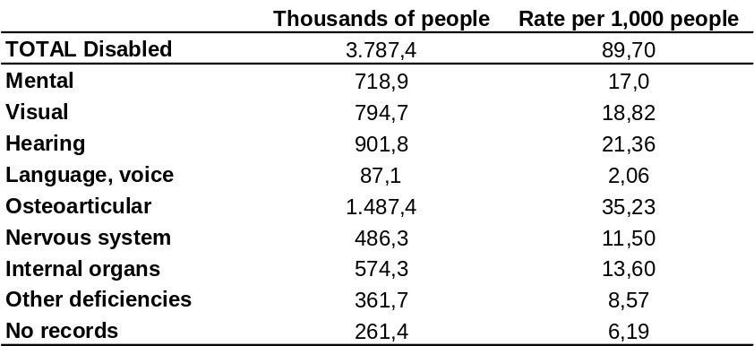

Source: “Survey about Disability, Personal autonomy and Situations of Dependence”. 2008. INE

The average amount of disabilities that the disabled people have is 8.2. This figure varies significantly depending on the type of deficiency that causes the disability: Mental deficiencies cause the highest amount of disabilities on the person (11.5), followed by the deficiencies in the nervous system (10.2). On the other hand, the hearing, visual and language/voice deficiencies cause the least amount of disabilities (less than 3 on average).

Figure 4
Average amount of disabilities in Spain caused by each group of deficiencies
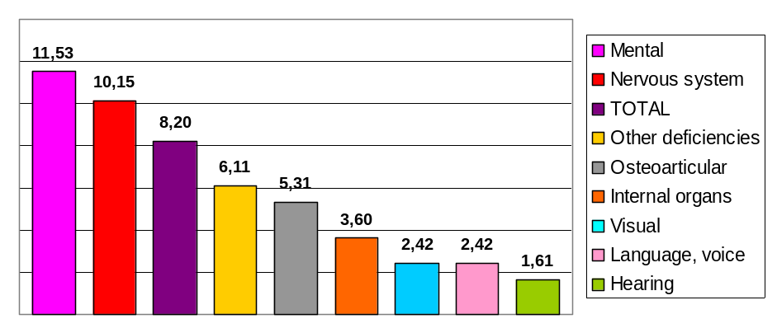

Source: “Survey about Disability, Personal autonomy and Situations of Dependence”. 2008. INE

66.9% of disabled people receive some kind of help. On the contrary, more than 1 million disabled people do not receive any help whatsoever (26.6%). Some 60.7% of disabled women receive help from other people, compared to 47,1% of men. The percentage of disabled people relaying only on technical aids is quite low (13.6% of men, 10.3% of women).

Figure 5
Percentage of disabled people in Spain, per type of help they receive.
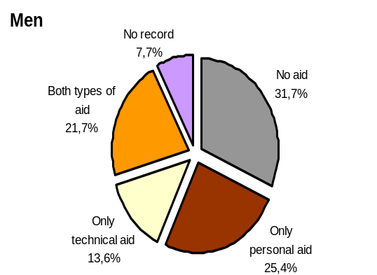
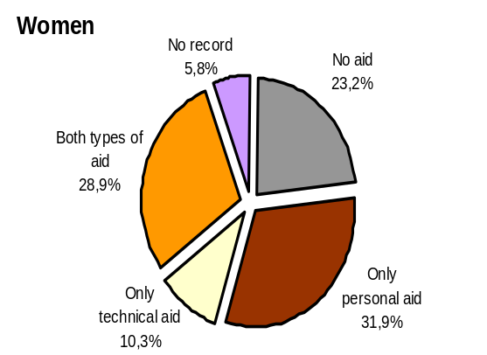

Source: “Survey about Disability, Personal autonomy and Situations of Dependence”. 2008. INE

In the case of the Basque Country the number of people living with any form of disability reaches 169,400 people and the patterns are the same: more women with disabilities in the whole population (especially elderly population), but higher rates for men under 45 years of age. (INE-IMSERSO, 2008).
The general disability rate is of 8.5% among people aged 6 or more. This rate increases with age and almost 50% of people aged 80 or more are disabled in the Basque Country.
The main disability problems affecting Basques aged 6 or more are: mobility problems (affecting 6.9% of population aged 6 or more), domestic life (5.8%) and self-care (4.9%). These figures are very simmilar to the general pattern in Spain.
In the group of people aged 65 or more that are disabled, more than a half has a complete disability (53.4%), followed by the group of the severely disabled (25.2%) and the moderately disabled (21.4%). In this group the use of only technical aids is a bit higher than in Spain but still quite low (13.3%); 36.6% receive both technical and personal help, 23.3% only personal help and the rest can manage without help.
For evaluating the economic impact that this figures have in the public budgets, there is some available data for the province of Gipuzkoa in the year 2008: The average cost of personal help in the homes of the elderly people was of 5.830€ per user/year, while the average cost of the teleassistance service was of 133€ per user/year.

GLOBAL EPIDEMIOLOGICAL CHANGES AND PROFILES
Epidemiological transition is usually defined as a process in which degenerative and man-made diseases displace pandemics of infection as the primary causes of morbidity and mortality (Omran, 1971). The transition is a collateral result of the so-called demographic transition characterised by a sudden and stark increase in population growth rates, followed by a re-stabilization of population growth, due to subsequent declines in birth rates.
The epidemiological transition implies a shift from acute infectious and deficiency diseases to chronic non-communicable diseases. Usually, after this first phase, human birth rates drastically decline. This change entails the sociological adaptations associated with transitions to living in more urbanized environments, and a shift from agriculture and industrial-based production output economies to technological and service oriented economies.
Epidemiological transition is not so much a unidirectional process but one with different health development phases, because of each society evolves in diverse ways based on demographic, socioeconomic, technological, cultural, environmental and biological factors. In addition, it is important to note that several stages of epidemiological transition may overlap in the same country. For instance, the decline in infectious diseases may be slow or stagnant among some sectors of the population while non-communicable diseases can be increasing in another sector of the society. This can happen, for example, in developing countries with great social differences between social groups.

Relevant factors
The main factors involved in the epidemiological transition are the changes in demography and the changes in risk factors (Wahdan, 1996):
- Demographic changes: Demographic changes are a composite of changes both in mortality and fertility. As populations become healthier, a reduction in mortality, particularly of infants and children, usually occurs, followed later by a fall in fertiliy rates. Therefore, more people will survive to adulthood (including “old age”) and will have the disease patterns of adults, with non-communicable diseases at the top of list. They will also be exposed to diseases that more frequently affect elderly people, such as cancer and cardiovascular diseases. Thus, even with constant age-specific incidence rates of non-communicable diseases, the absolute number of cases and deaths from these diseases increases substantially with the above-mentioned demographic change.
- Changes in risk factors: The risk factors involved in the epidemiological transition include biological factors (micro-organisms), environmental factors, social, cultural, and behavioural factors and the practices of modern medicine:
- Biological factors: Micro-organisms constantly undergo changes that enable them to cope with and increasingly hostile environment. In fact, the development of mechanisms that permit survival of the most adaptable micro-organisms is more rapid than the development of defence mechanisms that allow their hosts to combat microbial invaders. That adaptive process involves finding and exploiting weaknesses in the defences of the host and can happen by means of several mechanisms: alteration in antigenic identity, emergence of drug-resistant strains and dual infection.
- Environmental factors: There is conclusive evidence that certain changes in the patterns of diseases, in particular a decrease in the occurrence of communicable diseases, are the result of the development of environmental sanitation, particularly a clean water supply, sanitary disposal of waste and proper housing.
- Social, cultural and behavioural factors: Social, cultural and behavioural factors are closely related and interlinked. The so-called process of modernization (urbanization, changes in family patterns, more individualized social norms and values) produces changes that affect people’s health. An example of the change in community relations is the care of the elderly. In les modernized societies or communities where extended family used to prevail, care of the elderly was essentially a family responsibility. This is no longer the case, particularly in urban areas.
- Practices of modern medicine: Several changes have occurred in the quantity, distribution, organization and quality of health services that have contributed to the epidemiological transition. The discoveries and technological developments of the twentieth century, such as the development of antibiotics and antimicrobial agents, insecticides, vaccines and diagnostic and therapeutic technologies, have resulted in remarkable progress in the prevention and control of many diseases and in the effective management of many others.

It is clear that there is no unique path in the transition that leads to low mortality, less incidence of communicable and deficiency diseases and an increase in incidence of chronic and non-communicable diseases. On the contrary, there are many paths, a multiplicity of stages, and no society has the same experience as any other.

Indicators of epidemiological transition
The most evident indicators of epidemiological transition are mortality and morbidity indicators that can individually and collectively throw light on the changing pattern of disease (Wahdan, 1996):
- Mortality indicators: Although cardiovascular diseases are becoming relatively more important than communicable diseases as a cause of death, the death rates from cardiovascular diseases, especially in developed countries, are not increasing. This means that more people will live to old age, when cancer is more likely to occur. Mortality from cancer is increasing all over the world. Of all major causes of death, cancer is the only one that is rising significantly.
- Morbidity indicators: It is important to realise that when fatal acute diseases dominate the health profile, mortality data often give an inadequate description of the prevailing health problems. With reduced incidence and fatality of many acute diseases and the emergence of chronic, often incurable but not immediately fatal conditions, causes of death would only reflect a small fraction of the complex health profile of the population.

The changing pattern of diseases observed in these indicators, from acute infectious and deficiency diseases to the chronic non-communicable diseases, is a continuous process of transformation with some diseases disappearing and others appearing or reappearing.
It is clear that infectious diseases are still an important public health problem and a major cause of death and of illness and will continue to be so for future generations (an example of this is the current concern about the world flu pandemic). In fact, this transition is very and is subject to breaks in continuity, slowdowns or even reversals. Nevertheless, the process of epidemiological transition is expected to continue, especially in the developing countries.

Ageing and Disability
Disability can be defined as the inability to live independently and take care of one’s own personal needs. The most severe disability is generally defined as inability to provide self-care, and this is measured by the inability to perform or difficulty in performing Instrumental Activities of Daily Living (IADLs), which often include doing housework, shopping, preparing meals, using the telephone, managing medications, or using transportation.
In a simplified view of health change in a population, it can be considered that the increases in risk factors leads first to diseases, then to functioning loss and to disability. However, individuals do not have to pass through all phases of health deterioration: Some people have a sudden problem and die before they ever know they have a condition, before they have a chance to be disabled. In addition, individuals can move in and out of some of these health states: Disability and functioning loss can be transitory, and people can return to full functioning and ability.
Population ageing can be considered a risk factor as there are many diseases associated with functional limitations and disabilities in old age: Changes in the prevalence of chronic conditions play a dominant role in explaining changes over time in old-age disability rates. The following conditions are among the most frequently associated with functional limitation or disability: Arthritis/Rheumatism, Heart problem, Hypertension, Back/Neck problem, Diabetes, Vision problem, Lung/Breathing problem, Fracture/Bone/Joint injury, Stroke, Hearing/Vision problem, Diabetes, Cognitive diseases (such as dementia) and Osteoporosis.

At least three general theories have been proposed on possible trends in old-age disability in a context of rising life expectancy(citation needed):
- Expansion of morbidity/disability: increasing longevity would be linked to a prolonged period of morbidity and disability at the end of life, due to improved survival rates of sick persons and a growing prevalence of ageing-related diseases such as dementia (Gruenberg, 1977).
- Compression of morbidity/disability: increasing longevity would be linked to a shorter period of illness and disability at the end of life, resulting from disease prevention efforts by individuals, organisations and governments (Fries, 1980).
- Dynamic equilibrium: increasing longevity would be linked to an expansion of light morbidity and disability but with a reduction of severe morbidity and disability, due to improvements in health care and the increased use of assistive devices. This means that with mortality reduction there would also be a reduction in the rate of deterioration of the vital organ systems of the body (Manton, 1982).

There are mixed views regarding the prevalence of disability among the elderly population. A specific study carried out to analyse this trend in the U.S. (Schoeni, 2001) shows that only routine care disability has declined, whereas more severe personal care disability shows no improvements. It also points out that gains have been concentrated among the most educated elderly people, and gains in education appear to be an important confounder of the improvements. There were no improvements in disability among people with 12 or fewer years of schooling. It is therefore a policy priority to continue enlarging schooling rates amongst the population.
In Spain, for example, elderly people’s years of schooling are not so many. Thus, 7,4% of the population aged 65 and older is illiterate (IMSERSO, 2009), most of them being women (10,4% against 4,5% of men). Moreover, only 42,5% of the 65+ population finished primary school (IMSERSO, 2009).
There are many “causal pathways” by which a higher level of education might translate into lower disability. A higher level of education is often associated with higher incomes, higher standards of living and a lower risk of work-related injuries or diseases. The “education” effect might therefore be a proxy for broader “socioeconomic status” effects (if these other socioeconomic variables are not controlled for). A higher level of education may also be related to the adoption of more healthy behaviours, such as a lower prevalence of smoking, less alcohol drinking, and a more healthy diet.
One of the main policy implications that can be drawn from the findings of these studies is that it would not be prudent to count on future reductions in the prevalence of severe disability among elderly people to offset completely the rising demand for long-term care that will result from population ageing. Even though disability prevalence rates have declined to some extent in some countries, the ageing of the population and the greater longevity of individuals can be expected to lead to increasing numbers of people at older ages with a severe disability and in need of long-term care.
Also, educational attainment of the older population has increased over time and is expected to continue to increase over the coming decades. However, this factor alone will not be able to reduce the prevalence of disability among the elderly.

Disability projections (OECD, 2030)
The number and share of population aged 65 years and older have risen in all OECD countries since 1960, according to the data from the OECD Demographic and Labour Force Database. This trend is expected to continue in future decades given the ageing of the “baby-boom” generation born after World War II (those who will start turning 65 years old and older in 2010), further gains in life expectancy at 65 and older ages, and declining fertility rates.
Looking ahead to the future, current population projections at the national level and international level generally assume that: firstly, gains in life expectancy observed in the past will continue in the future; secondly, patterns of declining fertility will not revert rapidly; and thirdly, future international migration will only have a limited contribution to changing current population trends. Under these assumptions, the number and share of the population 65 and older will increase rapidly between now and 2030, at a time when the post-war baby-boom generation (those born between 1946 and the mid-1960s) will start reaching that age group in many OECD countries. By 2030, more than one person in five could be 65 years and older on average in OECD countries.
OECD has used available data on past trends in severe disability in combination with population projections by age and sex group, to extrapolate the projected rise in the number of elderly people who might be severely disabled up to 2030, based on two scenarios (OECD, 2007): 1) a “static” scenario, whereby there would be no change in the (age and sex-specific) prevalence of severe disability among elderly people in the future (compared with the latest estimates in each country); and 2) a “dynamic” scenario, whereby changes in the prevalence of severe disability observed in the past years would continue at the same rate in the future.
The following definition of “severe disability” has been used by the OECD in this study: “People reporting one or more severe ADL limitations, defined as a core set of self-care/personal care activities (including eating, dressing, toileting, bathing, getting in/out of bed, and any other clearly defined self-care activity.”
Under the “static” projection scenario, the pure demographic effect is strongest for those countries with a projected strong increase in the number of elderly people (and in particular among the very old population) between now and 2030. The results from the “dynamic” projections show different effects across countries, depending on the direction of the past trend that is being extrapolated in the future. In those countries where there is evidence of a general decline in severe disability among people aged 65 and over, the extrapolation of these downward trends results in a considerable reduction in the projected rise in the number of severely disabled elderly persons, compared with the “static” projection.
The results from both the “static” and “dynamic” projections indicate that the number of severely disabled elderly people can be expected to rise over the next few decades in all countries due to population ageing. But the extent of the rise will be strongly influenced by the evolution in the prevalence of severe disability at older ages.
The level of uncertainty surrounding future trends in longevity and in severe disability among elderly people is very high, because there are several factors affecting either positively of negatively old-age disability rates in the future. On the positive side, further improvements in the socioeconomic status of elderly people (including rising levels of education and rising income and living conditions) can be expected to play a positive role in improving the health and functional status of elderly people. The gradual reduction in some risk factors to health, such as smoking, can also be expected to play a positive role. On the negative side, the rising prevalence of certain chronic conditions, such as arthritis and diabetes, and of important risk factors, such as hypertension and obesity, can be expected to increase related functional and activity limitations among elderly people, unless greater efforts are made to either prevent or treat these conditions.
In conclusion, there will be a need to expand the capacity to respond to the growing need for long-term care over the coming years in all OECD countries which will arise from population ageing. As the populations age, the “oldest old” (people aged 85 and over) will tend to grow the fastest, having this group the most severe disabilities and greatest long-term care needs. One factor that might help mitigate this increase of the demand for long-term care would be some steady improvements in the health and functional status of people aged 65 and over, which would enable them to live independently as long as possible.

Age related chronic diseases
For the older population there have been general increases in the prevalence of health problems like dementia, arthritis, cardiovascular disease, diabetes, some cancers, hearing problems, orthopedic problems, pneumonia and bronchitis (Crimmins and Saito, 2000). Some of these are detailed ahead:

Dementia
Dementia is an acquired syndrome of decline in memory and other cognitive functions sufficient to affect daily life. Alzheimer’s disease is the most common form of dementia.
The prevalence of dementia increases with age. According to the EURODEM study about European population, the overall prevalence for males and females doubles (Table 3.1) for every five year increase in age after the age of 65. Dementia is largely a disease of older people, but 2% of those affected are under 65 years of age.

Table 8
Incidence and prevalence rates of dementia from the EURODEM meta-analyses for European studies.

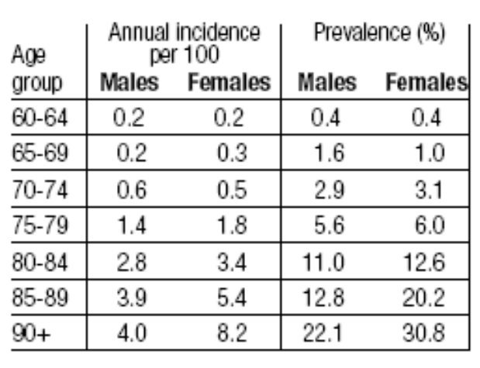
“Incidence of Dementia and major subtypes in Europe” (Fratglioni & Co., 2000)

Alzheimer’s Disease International (ADI) estimates that there are currently 30 million people with dementia in the world, with 4.6 million new cases annually (one new case every 7 seconds). The number of people affected will be over 100 million by 2050 (ADI Factsheet, December 2008).
Dementia is a disease of particular concern because the decline in memory and other cognitive functions that characterizes this condition also leads to a loss of independent function that has a wide-ranging impact on individuals, families and healthcare systems. As the number of elderly people increase, the number of individuals with dementia is also expected to increase because as individuals age, the risk of suffering from dementia increases. It is necessary to state, however, that, ageing does not lead to dementia; it is just a very conditioning factor, but not a determinant.
In Spain, around 700.000 people suffer from Alzheimer’s Desease (F.A.E., 2009) and around 100.000 are expected to become new sufferers every year. In Europe, the estimations reach 8 million people (F.A.E., 2009). By 2020, figures are expected to double (16 million) and by 2050, to triple (24 million people). This is not only a serious and challenging public health problem, but also an opportunity to develop new a market niche.
There are several stages throughout the desease, in every stage caregivers and people suffering from the disease require different aids, including technical aids, such as assistive technologies.

Arthritis
There are two main types of arthritis: 1) rheumatoid arthritis, which is an inflammatory disease that causes pain, swelling, stiffness and loss of function in the joints. It generally begins in middle age and occurs with increased frequency in older people; and 2) osteoarthritis, which is a joint disease that mostly affects the cartilage, thereby allowing bones to rub together, causing pain, swelling and loss of motion of the joint. Osteoarthritis is the most common type of arthritis, especially among older people, and one of the most frequent causes of disability (NIAMS, 2002, cited in Canaves and Fogel, 2005). Unless otherwise stated, data on arthritis prevalence refer to all types of arthritis.
In Spain, around 300.000 people suffer from Arthritis (SER, 2002).

Heart problems
Heart problems cover a range of diseases, including ischaemic heart disease (heart attack), pulmonary heart disease (embolism) and cardiac arrythmia.
Stroke is a vascular disease for which mortality and morbidity are relatively well-documented because most stroke victims are admitted to hospitals. Trends in stroke mortality, incidence, and prevalence are somewhat similar to those for other cardiovascular conditions. Stroke mortality has been decreasing since the 1960s, but without a consistent decrease in stroke incidence. In addition, persons suffering from cardiovascular and cerebrovascular disease and stroke tend to be less disabled than in the past (Crimmins, 2004).
In Spain, the average cardiovascular mortality rates drastically is 274 / 100.000; however, this rates increases drastically from age 65 (301,6) and reaches its highest peak at age 95+ (13.147,7) (IMSERSO, 2009).

In Spain, the average cardiovascular mortality rates drastically is 274 / 100.000; however, this rates increases drastically from age 65 (301,6) and reaches its highest peak at age 95+ (13.147,7) (IMSERSO, 2009).

Diabetes
There are different types of diabetes which have the common elements of hyperglicemia and glucose intolerance due to insulin deficiency. Type 2 diabetes is the most common form of diabetes, representing more than 90% of all cases (International Diabetes Federation, 2006). It usually occurs after the age of 40, but can remain asymptomatic (and therefore not diagnosed) for many years.
In Spain, 17,6% of people aged 65+ suffer from Diabetes (IMSERSO, 2009). Both men and women present very similar figures.

Cancer
Predictions of incidence based on several considerations, including demographic structure and prevalence of predisposing factors, have been tried with cancer. It is predicted that the number of new cases of all types of cancer in the world will increase in the future. This increase could be higher in the developing countries due to the epidemiological transition.
Cancer is the second cause of death in Spain for the general population and also for the 65+ age group (IMSERSO, 2009). The main type is colon (intestine) cancer.

Obesity and Disability
Obesity is a risk factor for many of the leading causes of disability (e.g., arthritis, heart disease, stroke, diabetes, respiratory problems). While the reduction in certain risk factors to health such as smoking might have contributed to reducing some functional limitations in old age, the rising prevalence of obesity among adults of all ages over the past two decades in developed countries might be having the opposite effect.
Studies have been carried out that found significant relationships between obesity and disability (measured either as people reporting at least one ADL limitation or people reporting that they were limited in their work due to health problems). Obesity is associated with the development of some of the most prevalent diseases of modern society. The greatest risk is for diabetes mellitus where a Body Mass Index (Table 4) above 35kg/m² increases the risk by 93-fold in women and by 42-fold in men. The risk of coronary heart disease is increased 86% by a 20% rise in weight in males, whereas in obese women the risk is increased 3.6-fold. Elevation of blood pressure, hyperlipidaemia and altered haemostatic factors are implicated in this high risk from coronary heart disease. Gallbladder disease is increased 2.7-fold with an enhanced cancer risk especially for colorectal cancer in males and cancer of the endometrium and biliary passages in females. Endocrine changes are associated with metabolic diseases and infertility, and respiratory problems result in sleep opnoea, hypoventilation, arrhythmias and eventual cardiac failure.
Table 9
World Health Classification for obesity
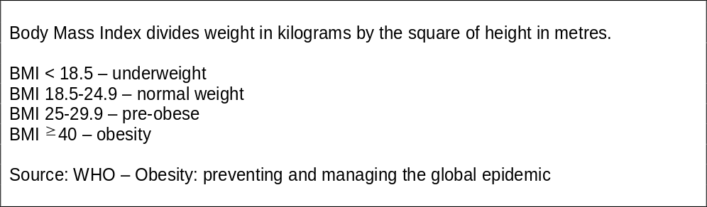
“Obesity: preventing and managing the global epidemic” (WHO, 2000)
A study carried out among older Americans (Snih, 2007) shows that disability-free life expectancy is greatest among subjects with a BMI of 25 to less than 30. Simmilarly, other studies show that even the obesity in earlier life contributes to an increased risk of mobility limitation in old age (Houston, 2009).
Studies also show that obesity is more strongly related to morbidity and disability than to mortality. For example, a study carried out on American adults (Reynolds, 2005) showed that obese older adults are less likely to remain active than non-obese adults (41.5% vs 50.5%) but were more likely to remain disabled (14.5% vs 6.4%). There were also differences in the likelihood of becoming disabled for obese and non-obese adults. For both men and women, those who were obese had a significantly higher probability of becoming disabled across the older ages. For instance, obese women at age 80 had a 27% likelihood of becoming disabled; for non-obese women, the figure was 18%. Besides, for the obese, the years lived with disability are longer, and the years lived free of disability are shorter. At older ages, the proportion of life lived with disability increases for both the obese and the non-obese, but it is higher at each age for the obese.
According to a study on health and consequences of obesity among the future elderly, people who are obese at age 70 experience considerably higher prevalence of disease than their normal-weight peers (Lakdawalla, 2005) (Figure 5). In fact, obese people (aged 70 and older) suffer from diabetes for 41 percent of their life years, while normal-weight people suffer for just 17 percent of their life years. The gradient in hypertension is also quite large.
In fact, overweight and obesity may lead to joint wear and tear, reduced exercise capacity, and a higher rate of chronic disease such as cardiovascular disease, diabetes, and arthritis, thus resulting in physical disability. The onset of overweight or obesity in young and middle adulthood may result in lower physical activity levels, contributing to decreased muscle strength and cardiovascular fitness and greater declines in physical function because of longer duration of excess body weight and earlier chronic disease.

Table 10
Proportion of Life Years Spent With Various Diseases (Self-reported), By Weight at Age Seventy
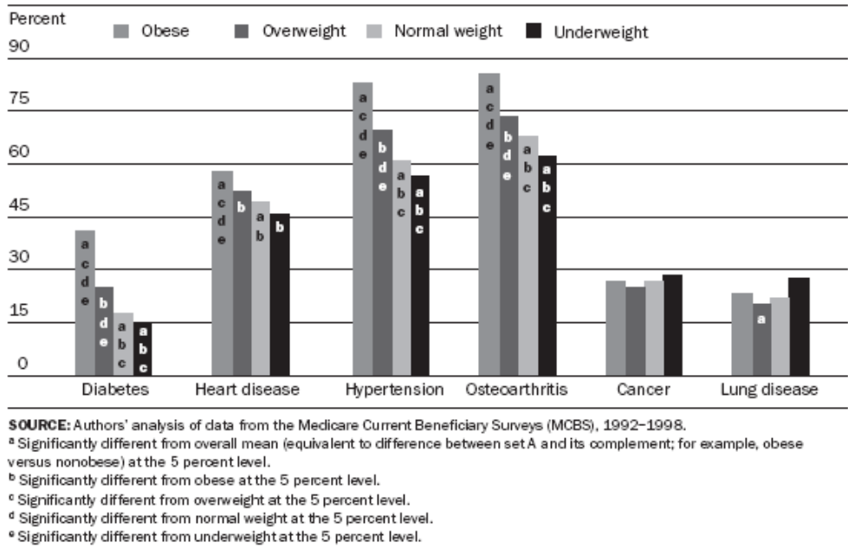
“The Health and Cost Consequences of Obesity among the Future Elderly” (Lakdawalla & Co., 2005)

There is some optimism that trends in obesity prevalence could be reversed and, clearly, interventions targeting prevention of overweight and obesity (starting in young and middle-age) are needed for preventing or delaying the onset of mobility limitation later in life. However, changing the behaviour of the population is notoriously difficult and, if current trends in obesity continue through future decades, this process, together with the ageing of population, would easily offset possible reductions in disability prevalence from other factors (such as improved socioeconomic status).

Main Implications of Epidemiological Transition for AT
Improved treatment and diagnosis have led to an increased life expectancy for those with a disease, as well as a delay in the progression of disease to disability, but there are also strong cohort factors that are likely to have played a role in some of the improvements in health. Education has increased markedly in recent years in the older population and the compositional change among the old to a higher lifelong socioeconomic status may have important implications for reducing old age mortality. Further, recent older cohorts had healthier younger lives then previous cohorts owing to the reduction in infectious disease, which fuelled the long-term mortality decline up to the middle of the twentieth century.
Certainly, the general epidemiological picture is that older people of today are healthier than older people of two decades ago. There have been improvements in most dimensions of health: People live longer and have fewer disabilities, have less functional loss, and report themselves to be in better health. However, weight increase has been notable during this period and, because people live longer, a greater percentage of people have some specific common diseases. On average, older people live with more diseases and the key to continued improvement in health is to delay the onset of risk factors, disease, and disability in older-aged individuals.
The process of epidemiological transition means that there will be an increasing demand to re-engineering of health services. Chronic illness demands routine surveillance, highly determined patterns of work and a professional work more amenable to external regulation.
AT can make important contributions to these new needs by providing information systems (for managing decissions about treatment), devices that define objective criteria for medical care or telehealthcare services, just to mention a few. These new systems can make the epidemiological transition be accompanied by a more time- and cost-effective relationship between patients and health providers.

Political changes and opportunities: Spain’s Presidency of the European Union and the Basque Country’s change of administration
During the first half of 2010, Spain will hold the Presidency of the European Union. The previous months to January 2010 as well as the whole six-month period of the Presidency may represent an opportunity to position the AT Cluster as an attractive spotlight for political forces, the administration and the private sector. Spain priorities have not been made public yet, but they soon will.
In parallel to the Spanish EU Presidency, Spain will be the Guest Country to the “CeBIT Global Conference in Hannover, Germany (2 - 5 March 2010), the most important event and leading trade fair in the world. More than 4.300 stakeholders will gather at CeBIT 2010 to exchange, buy, get to know and network on ICT solutions and business. The potential Tecforlife consortium must take analyse what advantages can be drawn from this event. The motto for the Spanish participation is “Spain, Technology for Life”.
Furthermore, in 2010, the State-run FECYT (Fundación Española para la Ciencia y la Tecnología) will set out a scientific event called “European City of Science and Innovation” (Ciudad europea de la Ciencia y la Innovación 2010) as part of the actions framed under the Spanish EU Presidency. It is then necessary to identify what use the Tecforlife consortium can get from this event to promote the AT Cluster and network with other stakeholders.
Similarly, last March, the Basque Country’s regional government changed administration. The new Executive took office very recently and is still outlining the priorities for every sector. As the current financial and economical crisis gathers all the efforts made by the current administrations, the potential economic boost an AT cluster might have over the SSMA and Basque Country’s economy is to be highlighted. Both the new regional government priorities and the Gipuzkoa Aurrera Policy Priorities are to be addressed if the cluster is to gather political support.

Analysis of trends and implications for the Tecforlife Cluster
As potential AT clients are growing in number, there are new ways in which they relate to technology. They are more knowledgeable, have a familiarity with technology used in everyday life, and are less likely to be intimidated by its usage. Besides, many clients are increasingly demanding, as they have more complex needs, derived from the improved survival rates of persons with severe levels of impairments. Furthermore, AT users are more likely to be supported by caregivers around them who may also be at ease with technology assistive devices. Are politicians and health practitioners aware of that? The evidence is vaguely confirming that they increasingly are, but the vast majority is still facing these facts as scenarios in the long-run.
After revising the changes in the demographic, epidemiological and political sectors, it is time to summarize the policy implications with regards to the AT Cluster field of work.

Ageing:
- AT solutions must be age-balanced: there are significant personal and cultural differences between 65-year-olds and 85-plus-year-olds, for example. Public policy aimed at the elderly usually makes all these differences invisible. AT solutions can take advantage of this situation and make them visible for the benefit of users and buyers.
- The significant increase of the oldest old (85+) must be addressed by any action or direction the AT cluster follows as this age group is the fastest growing age group in the world. San Sebastian and SSMA are is especially aged with regard to this group.
- Not only do women make the major part of the aged population, they are also greater than men with regard to disability. Thus a gender-based policy making is needed to address this phenomenon and the AT Cluster must make the most effort to avoid gender-unspecific solutions as the soon-to-be-old women will have grown are more independent consumers.

Territory
- Being San Sebastian a medium-scale city, it is wiser to have a broader perspective on the territory the AT Cluster is to play on. In addition, the territory known as SSMA (Donostialdea) is seen a single unit for many public planning actions. Population ageing in the SSMA follows a very similar patter in every territory, but the qualitative changes of ageing need to be further studied.

Disability:
- Household composition is a key element to be taken into account when developing any AT solution from the AT Cluster. Most people living with disabilities live in two-people households, thus one of the household member is inevitably a care giver. The fact that living solo households with disabled people are increasing in number needs to be observed, too.
- Further and deeper analysis of the epidemiological profile of the potential users and buyers of the AT cluster must be conducted. Today’s consumers and those of the near future come from very different social background, even though they share a common cultural context.
- The correlation “ageing-disability” needs to be avoided by any AT Cluster approach and a greater understanding of dependency needs also to be studied as the potential markets of the AT Cluster.

Conclusions and Recommendations
As the average life expectancy has increased (80,2 years in Spain) due to aspects such as improvement of living conditions, fertility and mortality rates changes, new challenges must be addressed. Nowadays 16,6% of the Spanish population is over 65 years of which 8,5% have some form of disability. In the Basque Country the rate of people older than 65 years reaches 18,8% of the population, so it is above average. Both in Spain and in the Basque Country there is an inequality between the number of older men and women; there are more older women than men.
Together with the ageing of the population and the increase of obesity rates in some western countries, health related changes will occur resulting in a growth of the disabled population in future decades. This process creates important challenges to the public institutions, such as, the need of an important increase in healthcare expenditure.
On the other hand, the improvement of quality of life, health care, educational level, reduction in the number of smokers and other underlying variables are creating an antagonistic effect to that expected. Despite having more older people, the number of disabled people does not seem to grow to the same extent. As a result, in the following years more and more older people will live alone, independently and for longer time in their homes.
There are two consequences of this situation:
- Governments will be able to reduce the relative expense of hospitalization for elderly people.
- Elderly people will be able to live in their environment for a longer time.
Nevertheless, although the percentage of people with disabilities is reduced, the number of people suffering from different diseases will be increased due to increased life expectancy. Because of this, elderly people will require some type of assistive technology to help them in certain tasks of daily life. Because of that, it is necessary to think about the type of elderly people that will be living in their homes in ten years. Taking into account that these “new” elderly people will be more skillfull in using technology, the usage of Assistive Technologies won't find many detractors among the elderly because they will be more open to using them.
At the political level there are some aspects that must be highlighted. On the firs hand, during the first half of 2010 Spain will hold the Presidency of the European union. On the other hand, during this period the CeBIT Global conference will be held. The German IT and telecommunications sector and CeBIT has decided in favour of Spain as the official Partner Country in 2010. Because of that, exhibitors from Spain will benefit from their special status at CeBIT. As the Partner Country, Spain will also make an important contribution to boosting business at CeBIT 2010. Finally, as a part of the actions framed under the Spanish EU Presidency, the state-run FECYT will set out a scientific event called “European city of Science and Innovation”
The future context of ageing has already been foreseen by public authorities as shown in the Summary of the Communication of 12 October 2006 from the Commission to the Council and the European Parliament: “The long-term sustainability of public finances in the EU, the main challenge for Member States seems to be the impact of an ageing population on public finances. In the light of this challenge, public debt needs to be quickly reduced, employment rates increased, and pensions, health care and long-term care systems reformed as appropriate”.
This new situation forces public authorities to find more economic-efficient ways to manage the new social challenges derived from the changes in their populations. In this context, assistive technologies can play an important role by providing more time- and cost-effective aid and treatment to patients. Many of the assistive technologies are already allocated to elderly people and, in the future, the demand from this social group will increase and can be extended to other social groups.
It is reasonable to believe that both national and European public policies will promote the development of assistive technology because it greatly reduces their relative health care costs and provides a better quality of life for older people by living independently for a longer time.
The importance of the Assistive technology in public policies is not only for giving an effective answer to increasing health and social needs, but it can be also an important source of economic activity for those areas where this industry is promoted. Public policies must support the Assistive Techonology sector in the challenge of translating laboratory success into useful and marketable products. It is especially relevant to provide financial support for developing new projects in a context of international credit crunch, as this will in turn revert in a benefit for the community. On the side of the end-users, it is also important that public policies encourage the purchases of assistive technologies in order to make them accessible to all and improve the general well being of the population. Also, the public health systems can play a major role in the marketing of the AT products by orientating the end-users on the most adequate products to meet their needs.
In conclusion and considering the above, it should be noted that the Tecforlife consortium must able to analyse and find the way to exploit all the opportunities given by this emerging market.
Finally, and taking into account the international scope of the potencial AT end-user market, it is essential to promote a cross institutional cooperation (EU, national, local) that will allow the sector to achieve its highest potential development.

References
(OECD 1996; Wadhan 1996; Schoeni 2001; Lakdawalla 2005; Reynolds 2005.; United_Nations 2006; Walker 2006; CIS 2006a; CIS 2006b; CIS 2007; Lafortune 2007; Plassmana 2007; Snih 2007; INE-IMSERSO 2008; INE 2008; Timonen 2008; Dyb 2009; IMSERSO 2009; McCarthy 2009; Szlamkowicz 2009; Tepe 2009; Houston 2009.; Crimmins 2004)
CIS (2006a). Condiciones de vida de las personas mayores. Estudio nº 2.647. Madrid, Convenio Centro de Investigaciones Sociológicas (CIS) – IMSERSO.
CIS (2006b). Percepción social de la ciencia y la tecnología. Estudio nº 2.652. Madrid, Convenio Centro de Investigaciones Sociológicas (CIS) – Fundación Española para la Ciencia y la Tecnología (FECYT).
CIS (2007). Barómetro Sanitario 2007 (Total de las tres oleadas). Estudio nº 8.807. Madrid, Centro de Investigaciones Sociológicas. Convenio CIS – Ministerio de Sanidad y Consumo.
Crimmins, E. M; Saito, Y. (2000). "Change in the Prevalence of Diseases among Older Americans: 1984-1994". Demographic Research 3: Article 9.
Crimmins, E. M. ( 2004). "Trends in the health of the elderly." Annual Review Public Health 25: 79-98.
Dyb, K. a. H., Susan (2009). "Placing Globalizing Technologies: Telemedicine and the Making of Difference ." Sociology 43(2): pp. 232-24.
F.A.E (Fundación Alzheimer España) (2009). Cerca de 700.000 personas afectadas en España. At: http://www.fundacionalzheimeresp.org. Accessed: 28 July 2009
Fratiglioni L, Launer LJ, Andersen K, Breteler MM, Copeland JR, Dartigues JF, Lobo A, Martinez-Lage J, Soininen H, Hofman A. (2000). "Incidence of Dementia and major subtypes in Europe: A collaborative study of population-based cohorts". Neurology 54 (11 Suppl 5): S10-5.
Fries, J. F. (1980). " Ageing, natural death, and the compression of morbidity". New England Journal of Medicine 303: pp. 130-135.
Gruenberg, E. M. (1977). " The failures of success". The Milbank Memorial Fund Quarterly Health 55: pp. 3-24.
Houston, D. K. D., Jingzhong; Nicklas, Barbara J.; Harris, Tamara B. ; Lee, Jung Sun ; Nevitt, Michael C.; Rubin, Susan M.; Tylavsky, Frances A.; Kritchevsky, Stephen B. (2009.). "Overweight and Obesity Over the Adult Life Course and Incident Mobility Limitation in Older Adults." American Journal of Epidemiology 169(8): 927-936.
IMSERSO (2009). Las Personas Mayores en España. Datos Estadísticos Estatales y por Comunidades Autónomas. Tomo 1. Madrid, Ministerio de Sanidad y Política Social. Secretaría General de Política Social. Instituto de Mayores y Servicios Sociales (IMSERSO).
INE-IMSERSO (2008). Encuesta de Discapacidad, Autonomía personal y situaciones de Dependencia (EDAD). Madrid, INE Publicaciones.
INE (2008). España en cifras 2008. Madrid, Publicaciones Insituto Nacional de Estadística.
International Diabetes Federation (2006). Diabetes Atlas (3rd Edition). Madrid, Publicaciones Insituto Nacional de Estadística. Brussels.
Lafortune, G. B., Gaëlle; and the Disability Study Expert Group Members. (2007). Trends in Severe Disability Among Elderly People: Assessing the Evidence in 12 OECD Countries and the Future Implications. Paris, OECD Health Working Papers.
Lakdawalla, D. N. G., Dana P; and Shang, Baoping (2005). "The health and cost consequences of obesity among the future elderly." Health Affairs Web Exclusive September 26(http://content.healthaffairs.org/cgi/reprint/hlthaff.w5.r30v1).
Manton, K. G. (1982). "Changing concepts of morbidity and mortality in the elderly population." Milbank Memorial Fund Quarterly Health, 60: 183-244
McCarthy, M. H., G; Conceicao, C; La Torre, G; Gulis, G (2009). "Comparing public-health research priorities in Europe." Health Research Policy and Systems, 7(17 ).
OECD (1996). Ageing in OECD countries : a critical policy challenge. Social policy studies, no. 20. Paris, Organisation for Economic Co-operation and Development; Washington, D.C.: OECD Washington Center.
OECD (2007). Trends in severe disability among elderly people: Assessing the evidence in 12 OECD countries and the future implications. Paris, Organisation for Economic Co-operation and Development; Washington, D.C.: OECD Washington Center.
Omran, A. R. (1971). "The epidemiological transition. A theory of the epidemiology of population change". The Milbank Memorial Fund Quarterly, Vol. 49 (4).
Plassmana, B. L., K.M. Langac, d, e, G.G. Fisherd, S.G. Heeringad, D.R. Weird, M.B. Ofstedald, J.R. Burkeb, M.D. Hurdf, G.G. Pottera, W.L. Rodgersd, D.C. Steffensa, R.J. Willisd, R.B. Wallaceg (2007). "Prevalence of Dementia in the United States: The Aging, Demographics, and Memory Study." Neuroepidemiology 29(1-2).
Reynolds, S. L. S., Yasuhiko; and Crimmins, Eileen M (2005.). "The Impact of Obesity on Active Life Expectancy in Older American Men and Women." The Gerontologist 45(4): 438-444.
Schoeni, R. F. F., Vicki A; and Wallace, Robert B (2001). "Persistent, Consistent, Widespread, and Robust? Another Look at Recent Trends in Old-Age Disability." Journal of Gerontology: Social Sciences 56B(4).
SER (Sociedad Española de Reumatología) (2002). EPISER: Prevalencia de Enfermedades Reumáticas en la Población Española.
Snih, A. L. O., K.J.; Markides, K.S.; Kuo, Y.; Eschbach, K.; Goodwin, J.S. (2007). "The Effect of Obesity on Disability vs Mortality in Older Americans." ARCH INTERN MED 167.
Szlamkowicz, D. (2009). Challenges in Assistive Technology Services in Quebec: A Clinician’s Perspective. Community Based Rehabilitation: An Approach to Empower the Disabled. B. K. (ed.). Quebec, ICFAI 168-179.
Tepe, M. S. a. V., P. (2009). "Are Aging OECD Welfare States on the Path to the Politics of Gerontocracy? Evidence from 18 Democracies, 1980-2002. ." Journal of Public Policy 29: 1-28 (doi:10.1017/S0143814X0900097X).
Timonen, V. (2008). Ageing Societies: A Comparative Introduction. Maidenhead, U.K., Open University Press.
United_Nations (2006). "Convention on the Rights of Persons with Disabilities." Office of the High Commissioner for Human Rights.
At http://www2.ohchr.org/english/law/ (Accessed 11 July 2009).
Wadhan, M. H. (1996). "The epidemiological transition." Eastern Mediterranean Health Journal 2(1): 8-20.
Walker, A. a. W., Carol (2006). Ageing and Disability: A Quality of Life Perspective. Conference on Ageing and Disability, Graz, 8-9 June, 2006, European Association of Service Providers for Persons with Disabilities (EASPD)
WHO (2000). Obesity: Preventing and managing the global epidemic. World Health Organization. Geneva.

The concept “elderly people” is useful as it makes visible a large part of the population, but at the same time, it turns out to be risky as it may imply a standardised vision of people aged 65 and over. Not only is this far from being true (a 65-year-old person is totally different from a 90-year-old), but it also brings along the discussion of the very same concept of elderly (When does one start to be old? Is it 65 an appropriate “frontier”? Whereas this is a very important debate, in this report, “the elderly”, “elderly people”, and “aged person/people” will be understood as a person being 65 years old or older, unless otherwise established.
The figure 322.148 comes from the Spanish National Institute of Statistics (INE, Institute Nacional de Estadística) as of 1 January 2008. Nevertheless, the Basque Government’s Department for Territorial Planning estimates the SSMA population to reach 396.306 people (http://www1.euskadi.net/udalplan/visor/viewer.htm). The difference of 74.158 people is very noteworthy and, we believe, more accurate as this regional government usually works on more updated data. Yet, the 396.306 figure is not segregate into age groups, thus we were unable to use it.
The reason to work on the basis of this figures and not just those of San Sebastian city population is founded on the fact that Donostialdea functions as a unit in many public planning programmes.
See report from the Centers for Disease Control and Prevention: “Limitation of activity caused by selected chronic health conditions among older adults, by age. United States. 2005-2006”.
OECD: Organisation for Economic Co-operation and Development. OECD is formed by 30 countries: Australia, Austria, Belgium, Canada, Czech Republic, Denmark, Finland, France, Germany, Greece, Hungary, Iceland, Ireland, Italy, Japan, Korea, Luxembourg, Mexico, Netherlands, New Zealand, Norway, Poland, Portugal, Slovak Republic, Spain, Sweden, Switzerland, Turkey, United Kingdom and United States.
Further information on CeBit 2010 is provided by AETIC (Asociación de Empresas de Electrónica, Tecnologías de la Información y Telecomunicaciones de España) : www.aetic.es
This entity was previously explained in Deliverable 2.1. Gipuzkoa Aurrera is the strategic work group with public and private stakeholders where the long run policy priorities are discussed, set and agreed upon.

