Project no. 229792
Tecforlife
Assistive Technology Cluster for Quality of Life

FP7 – Regions – 2008 – 2 Regions of Knowledge
FP7 CSA – Support Action

D.3.1. Report on current Assistive Technologies situation at the EU level

Due date of deliverable: 30th July 2009
Actual submission date: 23rd July 2009

Start date of project: 01/01/2009 Duration: 24 months

Organisation name of lead contractor for this deliverable: FATRONIK-Tecnalia

Type | Report
Status & version | Version 1.0
Number of pages | 24
WP contributing to the deliverable | 3
WP/Task responsible | Fundación FATRONIK
Other contributors | Ikusi
Author(s) | Manuel Montejo Estevez, Maite Urbistondo
Keywords | Assistive technologies, standards, research projects, patents
Abstract (for dissemination)

Project co-funded by the European Commission within the Seventh Framework Programme (2007-2013)
Dissemination Level
PU | Public | X
PP | Restricted to other programme participants (including the Commission Services)
RE | Restricted to a group specified by the consortium (including the Commission Services)
CO | Confidential, only for members of the consortium (including the Commission Services)

Index of contents

1. Scope and purpose of the analysis 4
1.1 Methodology 4
1.2 Assistive technologies definition 5
2. Analysis of the European technology platforms 5
2.1 Spain 7
2.2 Other EU activities 8
3. Analysis of industry technology offer at EU LEVEL 10
4. Analysis of the Assistive Technology research projects 14
4.1 Europe 16
4.2 Scientific research in the AT field 17
5. Analysis of patents in assistive technology 18
6. Analysis of standards in assistive technology 21
6.1 Spain 23
7. Conclusions 24
8. Annex 25
8.1 References 25
8.2 Summary of on International ICT Accessibility Standards Proposed, Being Developed and Recently Published 27

Index of figures

Figure 1 EU research programmes in Assistive Technology 5
Figure 2 Procurement models by country for the five AT ICT product groups selected 12
Figure 3 The variety of actors who participate – directly or indirectly – in the AT ICT industry. 12
Figure 4 Projected U.S. Assistive Technology Sales, 2007 and 2013 ($ Millions). 14
Figure 5 EU research programmes in Assistive Technology 16
Figure 6 Assistive Technology research works citations evolution. 18
Figure 7 Evolution of EU Assistive technology patents 19
Figure 8 Last years EU Assistive patents 20
Figure 9 Comparison of AT filed patents between EU and the whole world 20

Scope and purpose of the analysis
The objective of this report is to analyse the current situation of the assistive technologies at European level, identifying the most innovative developments of the sector, the recent trends followed by the market and the different currently existing market niches.
This analysis has been carried out in the frame of WP3, whose Tasks aim at having a better knowledge on the evolution of the assistive technologies market in the last years. More specifically, this Deliverable 3.1 is the result of an exhaustive analysis based on the Strategic Research Agendas of the main European Technology Platforms, since then offer a clear overview on the areal situation faced by the industry of this sector.

Methodology
This report has been elaborated gathering all the information obtained from the following sources:
- Strategic Research Agendas (SRAs) of the most significant European Technology Platforms related to the assistive technologies, more specifically the Nanomedicine European Technology Platform and the European Robotics Technology Platform (EUROP).
- Documents of Joint Technology Initiatives (JTI) whose themes are related to the assistive technologies, as tools that implement the SRAs of some European Technological Platforms.
- Industry offer concerning assistive technologies, through different reports selected specifically on this matter.
- Documents and results obtained from projects funded by the European Commission and at national level related to the assistive technologies.
- Information obtained from the European Patent Office about patents related to the assistive technologies in the European Union.
The information available in all the sources mentioned above has been analysed exhaustively by the team of FATRONIK, and the conclusions of the present report have been obtained.

Assistive technologies definition
Assistive Technology (AT) usually refers to the devices or services aimed at compensating for functional limitations, facilitating independent living, or enabling elderly or disabled people with activity limitations to realise their full potential. The scope of such a wide definition makes it possible for AT to cover any kind of equipment or service capable to fulfil the aforementioned definition: from walking devices to wheelchairs, from smart home products to medication reminders.
The deliverable D2.1 (Report on local, national and European policies and initiatives in support of AT or related sectors) of this project includes a more detailed definition and classification of the Assistive Technologies.

Analysis of the European technology platforms
The European Technology Platforms (ETP) [1] provide a framework for stakeholders, led by industry, to define research and development priorities, timeframes and action plans on a number of strategically important issues where achieving Europe's future growth, competitiveness and sustainability objectives is dependent upon major research and technological advances in the medium to long term.

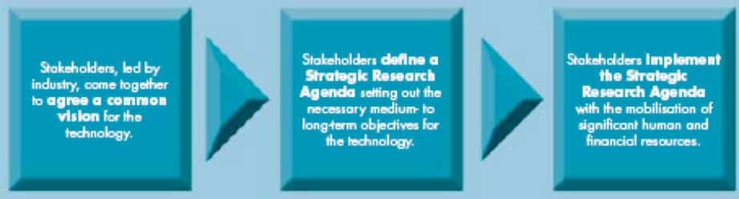
Source: ETP Leaflet [2]
Figure 1 EU research programmes in Assistive Technology
The ETPs cover the whole economic value chain, ensuring that knowledge generated through research is transformed into technologies and processes, and ultimately into marketable products and services. The set up of an ETP follows a bottom-up approach in which the stakeholders take the initiative and where the European Commission evaluates and guides the process. As of December 2007, there were 34 ETPs representing a wide range of technology fields and sectors [3].

The ETPs more directly related to Assistive Technology area are:
- Nanomedicine ETP [4]. This ETP will identify the major socio-economic challenges facing Europe, in providing high standards of healthcare across the population, ensuring high quality of life, and focusing on breakthrough therapies, in a cost-effective framework. The following three research areas have been identified as a basis of a Strategic Research Agenda (SRA)[5] in this field: Nanotechnology-based Diagnostics including Imaging; Targeted Drug Delivery and Release; and Regenerative Medicine.
- European Robotics Technology Platform (EUROP) [6]. The EUROP Strategic Research Agenda [7] identifies several application areas 23 different product visions. In this vision, the robot systems of the next decades will be human assistants, helping people do what they want to do in a natural and intuitive manner, including: Robot co-workers in the workplace, Robot companions in the home, Robot servants and playmates or Robot agents for security and space.

Joint Technology Initiatives[8] are proposed as a means to implement the Strategic Research Agendas (SRAs) of a limited number of ETPs. In these cases, the scale and scope of the objectives is such that loose co-ordination through ETPs and support through the regular instruments of the Framework Programme for Research and Development are not sufficient. Instead, effective implementation requires a dedicated mechanism that enables the necessary leadership and coordination to achieve the research objectives. To meet the needs of this small number of ETPs, the concept of "Joint Technology Initiatives" has been developed [9].
The JTIs related to Assistive Technology area are:

- Innovative Medicines Initiative (IMI) [10]. The IMI is a unique Public-Private Partnership between the pharmaceutical industry represented by the European Federation of Pharmaceutical Industries and Associations (EFPIA) and the European Communities represented by the European Commission. The aim of IMI is to support the faster discovery and development of better medicines for patients and enhance Europe’s competitiveness by ensuring that its biopharmaceutical sector remains a dynamic high-technology sector. The Innovative Medicines Initiative will ensure that Europe’s biopharmaceutical sector receives targeted strategic support for the benefit of patients, as well as the scientists and citizens of Europe. IMI proposes a number of clear, practical paths that will accelerate the discovery and development of more effective innovative medicines with fewer side-effects. IMI will implement innovative Patient Centred Projects that address the principles causes of delay or bottlenecks in the current biomedical R&D process. These bottlenecks have been identified as predicting safety, predicting efficacy, bridging gaps in knowledge management and bridging gaps in education and training. The Strategic Research Agenda [11] describes the recommendations to address these bottlenecks and a plan to guide their implementation.

The SRA is organised around four strategic areas, or Four-Pillars, as described below:
- Predictivity of Safety Evaluation (Pillar I): This addresses bottlenecks related to predictivity in safety evaluation and benefit–risk assessment with regulatory authorities;
- Predictivity of Efficacy Evaluation (Pillar II): This addresses bottlenecks related to predictive pharmacology, the identification and validation of biomarkers, patient recruitment and benefit–risk assessment with regulatory authorities;
- Knowledge Management (Pillar III): This addresses bottlenecks related to gaps in information technology, providing platforms to analyse large amounts of information in an integrated and predictive way. This pillar will be key to maximising the potential of new platform technologies such as genomics, and in analysing data generated by IMI in a consistently integrated manner;
- Education and Training (Pillar IV): This addresses the bottlenecks related to gaps in expertise in biomedical R&D knowledge and skills. This pillar will identify and address specific gaps in knowledge and capabilities: a bottleneck which must be resolved if the safety and efficacy pillars of the SRA are to be supported effectively. The education and training pillar will also ensure that Europe’s biomedical education landscape is enhanced to provide maximum support in revolutionising the conventional drug discovery and development paradigm.

Spain
The Spanish Technology Platform for the eInclusion & eHealth: eVIA [12], Plataforma Tecnológica Española de Tecnologías para la Salud, el Bienestar y la Cohesión Social, was founded in 2007 with the of support the Spanish Ministry of Industry, Tourism and Trade, the Ministry of Education and Science and CDTI (Spanish Center for the Technological and Industrial Development) and ISCIII (Institute of Health Carlos III). The aims of the eVIA platform include:
- to generate strategic high priority projects based on innovation within eVIA’s area to be supported by Regional, National and European plans, including all the participant agents for the marketing of the implemented solutions.
- to create spaces and methods for dialogue and cooperation between industry, researchers, administrations and users (end-users, cares, user associations) to ensure a real convergence between needs, technology opportunities and suitability of solutions.
- to advise national authorities (Ministries, CDTI, Regional authorities) on defining national R&D programmes. Collaboration with Spanish Public Administration in the prospective and technological monitoring activities; and to strengthen the Spanish participation in the European research programmes and institutions: FP7, EUREKA, CIP, AAL69.
- to complete and keep updated the Strategic Research Agenda.

The Strategic Research Agenda [13] has defined the following working groups:

- e-Accessibility
- e-Learning
- Ambient Assisted Living: “AAL”
- e-Health
- The possibilities of near future in Teleasistency and distance health-care.
- Assistive technologies
- Open Innovation Spaces
- Privacy, security and ethical aspect

Other EU activities
In the area of Information technologies, the European Union activities range from basic and applied research into tomorrow's cutting-edge Information Society technologies to stimulating the take-up of these technologies in different sectors of the economy and across Europe's regions. The eInclusion activity is linked to AT area in some of its policies:
- Assistive Technologies. e-Accessibility: make ICT accessible to all, meeting a wide spectrum of people's needs, in particular any special needs. The EC supports the development of ATs as a means of improving equality of access to the Information Society. ATs are a lifeline for their users, however – according to a Commission study – there is a great deal of fragmentation in the ATs market place. This makes it difficult and confusing for European consumers to compare products and services. Market fragmentation also makes it more complicated for industry to develop common standards, thus hampering the development and uptake of ATs.
- Ageing: empower older people to fully participate in the economy and society, continue independent lifestyles and enhance their quality of life. The Commission recognises the power of ICTs to support older people and the community around them. At work, new digital technologies can help people to remain active and productive as they age while improving work-life balance. This will become even more important in the future as Europeans retire later and the population ages. ICTs can help older people overcome isolation and loneliness, increasing possibilities for keeping in contact with friends and also extending social networks. As eGovernment and eCommerce become more important, it is vital that everyone can use new technologies to access public and commercial services. Products like smart homes technologies (to control heating, lighting, and even food stocks remotely), electronic alarm systems and tele-health facilities can also help older people live in their own homes, ensuring that they keep their independence for longer.
Responding to the needs of Europe's growing ageing population, the Commission has adopted a European Action Plan for "Ageing Well in the Information Society". This Action Plan is accompanied by a new joint European research programme raising to over €1bn the research investment on information and communications technologies (ICT) targeted at improving the life of older people at home, in the workplace and in society in general. The programme AAL is prepared as a so-called Article 169 initiative - referring to the respective article of the European treaty. This article allows the EC to participate in the AAL programme which, however, remains a member state driven initiative in the first place.

Ambient Assisted Living" (AAL) is the name for a new European technology and innovation funding programme. The programme is intended to address the needs of the ageing population, to reduce innovation barriers of forthcoming promising markets, but also to lower future social security costs. AAL aims - by the use of intelligent products and the provision of remote services including care services – at extending the time older people can live in their home environment by increasing their autonomy and assisting them in carrying out activities of daily living.
http://www.aal169.org

Analysis of industry technology offer at EU LEVEL
Already today it is estimated that more than 20.000 assistive technologies related products exits [14]. The enhancement in quality of life that will result from a wider use of ATs will lead to a generation of new demands and aspirations to promote improvement in such equipment to the benefit of people with disabilities, and thus to new innovations in a continuous positive feedback loop of market innovation and development.
AT products can be divided into different segments, one common classification based on the health conditions they address is the following:
- Mobility aids: help persons who are unable to stand or get around unassisted including ambulatory aids, wheelchairs and scooters, motor vehicle conversions, and navigation aids.
- Access aids: add-ons to a building or other structure to enhance its usability and accessibility for disabled persons (for instance home elevators, pool lifts, automatic door openers, etc.)
- Beds, seating systems, and ergonomic aids: devices designed to enable the physically and cognitively impaired to sit or sleep safely and comfortably, or position themselves to perform several tasks.
- Daily living aids: devices that provide self-help to support daily living activities (dressing, bathing, eating, personal hygiene, etc.).
- Communication aids: devices to help to communicate to persons with impaired speech, hearing or writing abilities.
- Computer access aids: devices to support the eInclusion and eAccessiblity can divided into: input devices (speech recognition devices, special keyboards, touch screens, etc.), output devices (Braille displays, screen magnifiers, etc.) and software.
- Vision and reading aids: designed to assist the visually impaired and the blind (electronic reading machines, Braille translators, magnifiers, accessible books devices, accessible electronic equipment)
- Environment aids: such as electronic systems that enable a person with limited mobility to control several appliances (telephone, lights, etc.).
- Medical/personal monitoring aids: devices that enable caregivers to monitor a disabled or elderly person such as activity/emergency location monitors or medical monitors.
The EU market for AT is huge and markets are geographically and sectorally very fragmented. Manufacturers and distributor are mostly medium to small enterprises, with the exception of some mass production items (such as basic hearing devices or basic wheelchairs). The market within EU can be considered as open market but what is difficult is getting a product included in the various public health services which finance provision of assistive devices. More and more care providers, local/regional public authorities or health insurers have greater influence on the regulation and provision of AT products to the end-users. Many AT products are allocated to the elderly (for instance in Sweden, around 70% of the prescribed assistive devices go to people aged over 65 [15].
In the particular case of AT in the area of Information and Communication Technologies (ICT) a recent report [16] for the European Commission has analysed the AT ICT industry, including identification and analysis of its structure, how it operates and its main actors. The report restricts the analysis to the definition provided by the Class 22 of ISO 9999:2007 “Assistive products for communication and information” [17] covering devices for helping a person to receive, send, produce and/or process information in different forms (for instance devices for seeing, hearing, reading, writing, telephoning, signalling and alarming, and information technology.).
The study has selected five product groups: Hearing instruments, Braille Displays, Environmental Control systems, Software and Communication devices.
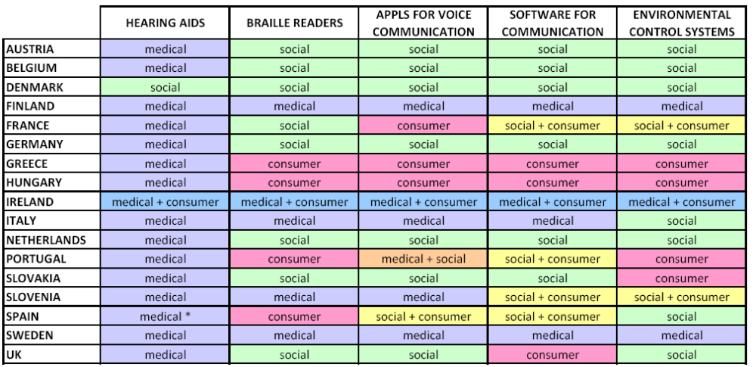
Source: Analysing and federating the European assistive technology ICT industry [16]
Figure 2 Procurement models by country for the five AT ICT product groups selected
There are many relevant players in the AT ICT industry in Europe, including some which are not a formal part of the value chain (i.e., the European Commission) but which have an indirect role, for example in opinion setting.
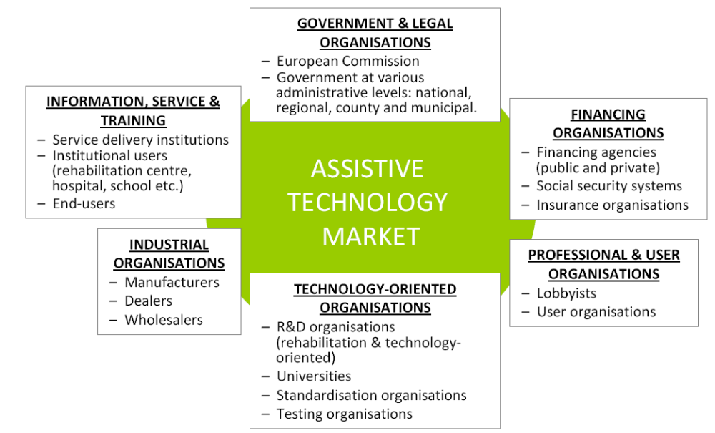
Source: Analysing and federating the European assistive technology ICT industry [16]
Figure 3 The variety of actors who participate – directly or indirectly – in the AT ICT industry.
The report also includes recommendations as to an organisation structure that would be most useful and effective for promoting the AT ICT industry in Europe, and by extension, improving the lives of millions of disabled end-users. A federation or other type of industry association could be useful and welcome by the industry if follows the principles:
- Network members should include both large and small industry players. It needs the voices of both multinationals and SMEs to be successful.
- Geographical coverage should cover all EU member states, for example via connections to existing national organisations, such that representatives of national organisations becoming members of the EU level network.
- Strong support for the implantation and start-up of the network, for example on the form of specific EC policy support action and/or a type of grant to off-set initial start-up costs.
- Good operational financial structure to guarantee continuity. This would be principally financed through member fees and income from network events, activities and services.
- And most importantly, that the EC recognises this network as the key point of contact with the AT ICT industry, and likewise, that the industry values and recognises the network as their voice to the EC.
Nevertheless the U.S. market analysis is beyond the scope of this report it is worth to pay attention to the results of a recent study about the Disabled and Elderly Assistive Technologies in the U.S. [18]. This report projects an annual growth rate of AT products in the U.S. market above the 5% during the period 2008-2013 reaching a $49.3 billion in 2013.
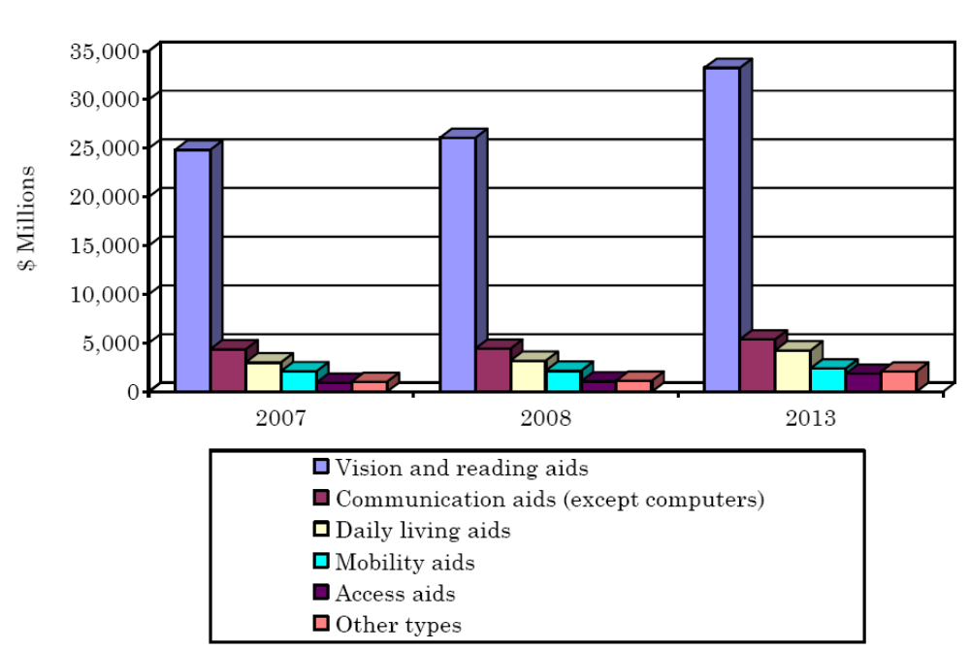
Source: BCC Research [18]
Figure 4 Projected U.S. Assistive Technology Sales, 2007 and 2013 ($ Millions).
Another important results of this study is fact that the market segmentation forecast for the year 2013 do not suggest a major change compared to the current market segmentation.

Analysis of the Assistive Technology research projects
The European Union’s main instrument for funding research is the Seventh Framework Programme for research and technological development (FP7)[19]. It bundles the EU research-related initiatives together under a common roof playing a crucial role in reaching the goals of growth, competitiveness and employment. The topics of the programme related to AT are:
- Challenge 5: Towards sustainable and personalised healthcare.
- Challenge 7: ICT for Independent Living and Inclusion
Regarding the AT field two additional research programmes are relevant: the Ambient Assisted Living Joint programme and the Competitiveness and Innovation Framework Programme.
The Ambient Assisted Living Joint Programme (AAL) [20]is a joint research and development (R&D) funding activity by actual 20 European Member States and 3 Associated States with the financial support of the European Community based on article 169 of the EC treaty. The overall objective of the programme is to enhance the quality of life of older people and strengthen the industrial base in Europe through the use of Information and Communication Technologies (ICT). The motivation of the new funding activity derives from the demographic change and ageing taking place in Europe, which implies not only challenges but also opportunities for the citizens and the social and healthcare systems as well as industry and the European market.
The Competitiveness and Innovation Framework Programme (CIP) [21] aims to encourage the competitiveness of European enterprises. With small and medium-sized enterprises (SMEs) as its main target, the programme supports innovation activities (including eco-innovation), provides better access to finance and delivers business support services in the regions. The AT is covered by the Information Communication Technologies Policy support Programme (ICT PSP), in particular, the THEME 1: ICT for Health, Ageing and Inclusion.
The following figure compares these research programmes in terms of time-to-market and technology risk.
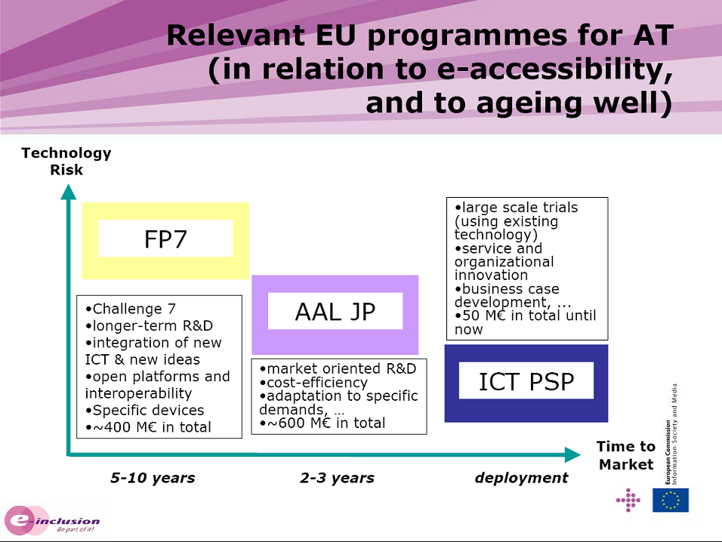 Source: AT presentation [22]
Figure 5 EU research programmes in Assistive Technology

Europe
The FP7 has financed an 18 month support action which aims to carry out a technology and foresight analysis in the field of Assistive Technologies: Market requirements, barriers and cost-benefit aspects of assistive technologies (MARE) [23]. The project has started in September 2008 and has completed recently the technology analysis. The following table presents the FPVI and FPVII ICT Projects related to Assistive Technology by area of ICF WHO Classification

ICF | EU PROJECTS
Learning and applying knowledge | DIADEM, COSY, ELDERGAMES, COGKNOW
General tasks and demands | MPOWER, COGAIN, COGKNOW, COSY, MAIA, HERMES, VM
Communication | HEARCOM, AGENT-DYSL, HaH, COGAIN
Mobility | SMILING, MOVEMENT
Self-care | SHARE-IT, SENSACTION-AAL, CAALY, OLDES, NETCARITY,  COMPANIONABLE
Domestic life | SHARE-IT, POLIS, SENSACTION-AAL, I2HOME, VITAL, EABILITIES,  SOPRANO, SM4ALL, IN HOME,  ACCESSIBLE, COMPANIONABLE,  EFORTT
Interpersonal interactions and relationships | PERSONA, MICOLE
Major life areas | UMSIC, NETCARITY, EASYLINE+, SWAMI,  CAPSIL, CONFIDENCE, EPAL
Community, social and  civic life | SHARE-IT, ALADIN, POLIS, ASK-IT, VITAL, MICOLE, MAPPED,  EINCLUSION, REPLAY, EPIST,  INCLUSO

Scientific research in the AT field
Scientific research publications in the field of assistive technologies can be divided into three broad types: technological development (design, modelling, simulation, bench testing, etc.), preliminary testing or experiments with human subjects, and clinical case studies or trials. In some areas the publications per year have increased over time while other areas have shown a more constant number of publications per year.
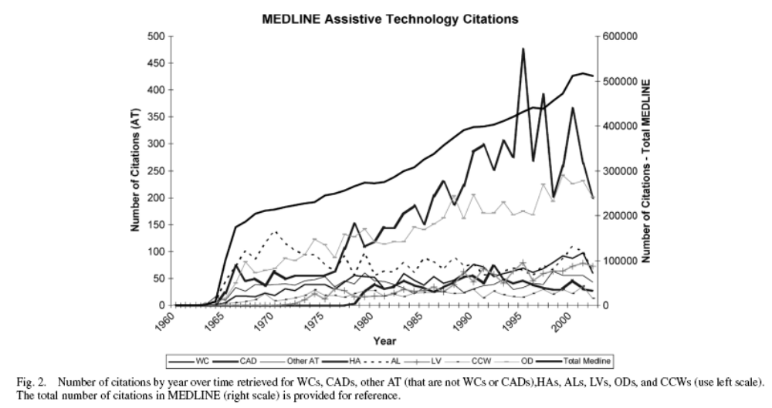 Source: Ryan 2004 [24]
Figure 6 Assistive Technology research works citations evolution.
A bibliometric analysis [24] has conducted a quantitative assessment to estimate the productivity and quality of research papers in Assistive Technology during the period 1963-2003. This study has shown that there is a clearly identified core of journals indexed in MEDLINE containing a significant portion of research findings on AT. The quality of this research varies, however, 61% of the journals carrying AT papers in this study had Impact Factors (IF) above the median. Thus, a number of journals publishing AT articles can be considered of high quality according to journal IF.

Analysis of patents in assistive technology
Patent and patent statistics are often employed in economic and technology forecasting in several ways: to trace research and development trends [25], to estimate of the technological innovation [26] or to determine the spillover effects between companies and technologies [27]. Using patent data for economic research has several important limitations and difficulties. First off all, the patent data set is incomplete because many inventions are not patented. Then, to conduct a patent bibliometric research, the patent type and claim scope need to be taken into consideration: in some cases the patent is a radical innovation, in other cases the invention is an improvement of a previous invention. Another factor that made patent analysis difficult is the patent classification system that comprises hundreds of major invention classes and thousands of subclasses [28]. Finally, patent trends are also influenced by administrative and judicial factors.
In spite of above mentioned restrictions conducting patent bibliometric research analysis some qualitative conclusions can be obtained performing a basic search in patent databases. In order to analyse the Assistive Technology related patents filed in the last years a database search has been performed in the European Patent Office [29] database. The search criteria have included some AT related keywords (impairment, hearing, Braille, mobility, elderly, disabled, handicapped, wheelchair, prosthetics and orthosis). This gives an estimation of the AT related patent evolution. The results are summarized in the following figures.
The first graph analyses the evolution of the EU filed patents in the AT area and it shows that patent activity has increased in this field in the last 5 years.
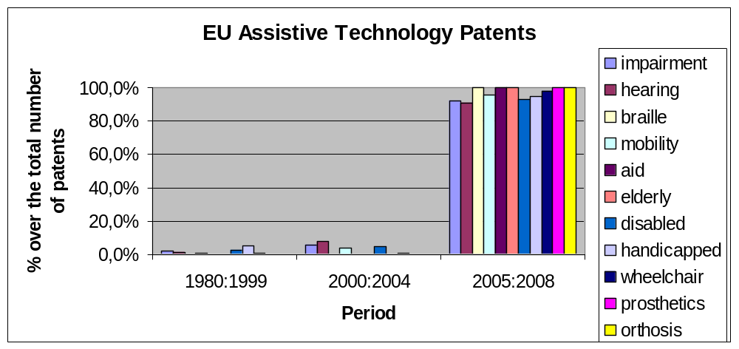
Figure 7 Evolution of EU Assistive technology patents
Then, a detailed evolution of the last 5 years is presented.
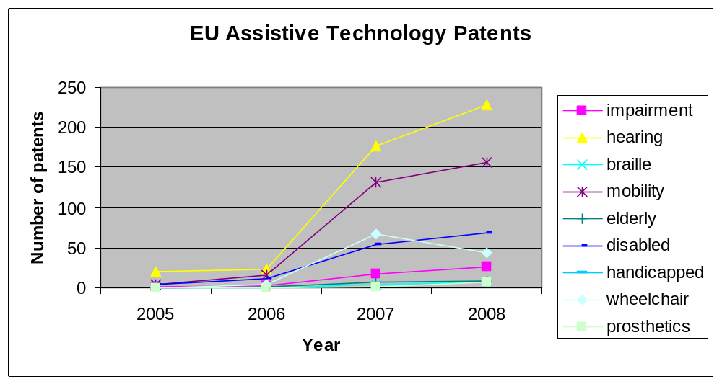
Figure 8 Last years EU Assistive patents
The following graph compares the AT patent activity in the EU database with the worldwide figures.
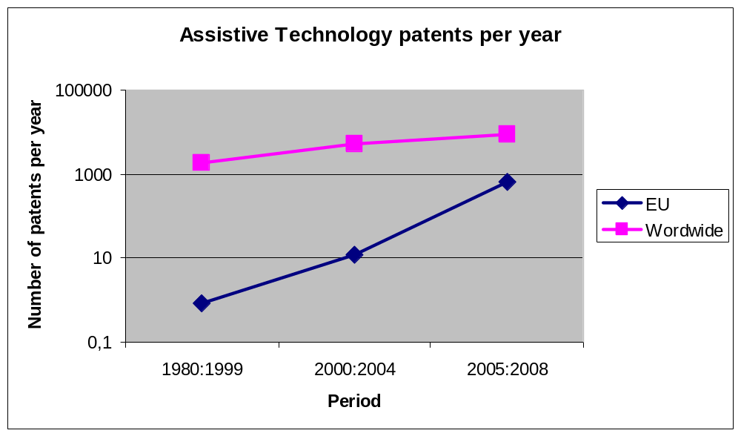
Note the logarithmic scale in the vertical axis.
Figure 9 Comparison of AT filed patents between EU and the whole world
Above diagrams suggest that the AT related patents filed in Europe have continuously increased during the last 30 years. The same happens if the total world patent filed number is considered but considering only the EU case this trend is more noticeable.

Analysis of standards in assistive technology
The European Committee for Standardization (CEN) and the European Committee for Electrotechnical standardization (CENELEC) form the specialized system for European standardization, together with the European Telecommunications Standards Institute (ETSI). Globally, the standards are developed by committees of the International Organization for Standardization (ISO), the International Electrotechnical Commission (IEC), Joint Technical Committee (JTC) 1 of the ISO & IEC, and coordinated with national standards bodies (e.g. the BSi, ANSI, AFNOR, DIN…) and many other organisations.
The more active technical committees working in the area of Assistive Technologies are the following:
- ISO/TC 173 Assistive products for persons with disability.
- ISO/TC 22/WG 4 Accessibility of vehicles to the persons with reduced mobility
- ISO/TC 59/SC 16 Accessibility and usability of the built environment
- ISO/TC 168 Prosthetics and orthotics
- CEN/TC 293 Assistive Products.
- CENELEC/TC79/WG4 Alarm systems, telecare.
- CENELEC/TC 205/WG 16 Home and Building Electronic Systems, domotics.

There are other groups that event do not directly generate norms, are working in the area of accessibility such as:

- CEN/DATSCG. Design for All and Assistive Technologies Standardization Co-ordination Group.
- CENELEC/BTWG 101-5 Usability and safety of electrical products with reference to people with special needs.
- CEN/BTWG 113 Safety and usability of products by people with special needs.
- CEN/BTWG 117 Revision of EN 175301-801:1999 and EN 175301-803:1999
- ETSI/HF Ergonomics.

The recently published ISO standards related to mobility aids are:
- ISO 11199-2:2005 Walking aids manipulated by both arms -- Requirements and test methods -- Part 2: Rollators
- ISO 11199-3:2005 Walking aids manipulated by both arms -- Requirements and test methods -- Part 3: Walking tables
- ISO 11334-1:2007 Assistive products for walking manipulated by one arm -- Requirements and test methods -- Part 1: Elbow crutches
- ISO 23600:2007 Assistive products for persons with vision impairments and persons with vision and hearing impairments -- Acoustic and tactile signals for pedestrian traffic lights.
- ISO 24415-1:2009 Tips for assistive products for walking -- Requirements and test methods -- Part 1: Friction of tips

Current international activities in the development of standards, technical reports and guidelines that include accessibility requirements and recommendations for ICT products are collected in the periodic reports by tiresias.org. Some of the latest report items (“9th Report on International ICT Accessibility Standards Proposed, Being Developed and Recently Published” [30]) are:

- Document Management - PDF/Universal Accessibility 1.0. This new proposed International Standard will specify how to use the Portable Document Format (PDF) to produce electronic documents which are accessible to users with disabilities.
- ISO/IEC Technical Report - Accessibility and usability of biometric systems. It is proposed that SC37 take on a new work item to establish a Technical Report for biometric system design and procurement to handle the range of accessibility issues; providing quantification of inclusiveness.
- CEN Working Group “Accessibility for All”. A recent survey has indicated that European standards developers need a better understanding of CEN/CENELEC Guide 6 – Guidelines for standards developers to address the needs of older persons and persons with disabilities.
- ISO 9241-920 - Guidance on tactile and haptic interactions. This standard (in development) will contain ergonomic requirements and recommendations for tactile and haptic hardware and software interactions.
- ISO 28803 - Ergonomics of the physical environment - Application of international standards for people with special requirements. This international standard (in development) provides guidance to people who use and apply international standards concerned with the Ergonomics of the physical environment. They include people who are involved in environmental design and assessment.
See the appendix 7.2 (Summary of on International ICT Accessibility Standards Proposed, Being Developed and Recently Published) for a complete summary of the new proposed standards and the standards currently in development.

CEN/CENELEC Guide 6 is the European equivalent of ISO/IEC Guide 71:2001 - Guidelines to address the needs of older persons and people with disabilities when developing standards, and also the Japanese Guide JIS Z 8071:2003. This Guide is intended to be part of the overall framework that standards bodies can use in their efforts to support the need for more accessible products and services. The ISO/IEC Policy Statement 2000 — Addressing the Needs of Older Persons and People with Disabilities in Standardization Work sets out the principles for ensuring that the needs of older persons and persons with disabilities) are incorporated in the standards-making process, providing justification on humanitarian and economic grounds. This Guide supplements the ISO/IEC Policy Statement by identifying problem areas which need to be considered when drafting standards, recognizing the constraint that standards should normally not be design-restrictive. It is intended for those involved in the preparation and revision of European and International Standards but also contains information which may be useful for others such as manufacturers, designers, service providers and educators.

Spain
The standards and norms derived from European directives are implemented by national technical committees by AENOR. The technical committees directly related to the assistive technologies are:

- AEN/CTN 26/SC 4 Accesibilidad de las personas discapacitadas a los vehículos.
- AEN/CTN 41/SC 1/GT 11 Accesibilidad en la edificación y el urbanismo.
- AEN/CTN 127 Prefabricados de cemento y hormigón. Incluye estudios de materiales antideslizantes a base de prefabricados de hormigón.
- AEN/CTN 139 Tecnologías de la Información y las Comunicaciones para la salud.
- AEN/CTN 153 Ayudas técnicas para personas con discapacidad. Incluye diferentes subcomités alcanzando a todo tipo de ayudas técnicas: ayudas para caminar y grúas (SC1), sillas de ruedas y sistemas de anclaje (SC2), camas ajustables (SC3), exoprótesis y ortesis (SC4), ayudas técnicas para la comunicación (SC5), ostomía e incontinencia (SC6), y terminología y clasificación de las ayudas técnicas (SC7).
- AEN/CTN 158 Gestión de servicios en las residencias de mayores.
- AEN/CTN 170 Necesidades y adecuaciones para personas con discapacidad y mayores. Incluye normas sobre accesibilidad global y se ocupa de la aplicación y seguimiento de los mandatos europeos M/273 y M/28323.

Conclusions
This report has analyzed the current situation of the Assistive Technologies covering both, on one side the novel research developments in the area and on the other side, the market and industry trends.
The public research programmes related to AT field are mainly concentrated in the following areas: Active ageing, e-Inclusion, e-Accessibility and Ambient Assisted living. Latest developments in the area of Information and Communication Technologies play an essential role in supporting daily life in today's digital society and will promote new solutions in the AT field. Nevertheless, new technologies in other fields (for instance new materials, sensors, electronics or robotics) will also bring innovation to the AT products. The increasing trend in AT patents filed in the last year is a consequence of this fact.
The market trends provide a different view on this evolution of AT. A technology push approach to translate new concepts into AT products in the market has been revealed not successful at all. More effort should be allocated to the proper identification of the user’s needs and the market opportunities to commercialize a particular technology. Design for All as well as mainstream services and products are encouraged due to end-user interest and also because of public policy that promotes accessibility.
The market for AT will become more and more important (with the demographic changes that are already starting to happen). The AT markets are geographically and sectorally very fragmented, manufacturers and distributor are mostly medium to small enterprises, with the exception of some mass production items (For example, the hearing instrument market has consolidated significantly and now in the EU market nearly 80% of the market is controlled by 4 companies) [16]. These factors as well as the variety of service providers and national/regional policies convert the AT industry sector into a complex one.
Annex

References
[1] “European Technology Platforms (ETPs).” http://cordis.europa.eu/technology-platforms/home_en.html
[2] European Technology Platforms Leaflet. ftp://ftp.cordis.europa.eu/pub/technology-platforms/docs/tp_leaflet_en.pdf
[3] Evaluation of the European Technology Platforms, 2008. ftp://ftp.cordis.europa.eu/pub/technology-platforms/docs/evaluation-etps.pdf
[4] “Nanomedicine ETP.” http://www.etp-nanomedicine.eu
[5] Nanomedicine Strategic Research Agenda, 2006. http://www.etp-nanomedicine.eu/public/press-documents/publications/strategic-research-agenda/at_download/file
[6] “European Robotics Technology Platform.” http://www.robotics-platform.eu/cms/index.php
[7] “European Robotics Technology Strategic Research Agenda,” May. 2006. http://www.robotics-platform.eu/cms/index.php?idcat=26
[8] “Joint Technology Initiatives (JTI).” http://cordis.europa.eu/fp7/jtis/home_en.html
[9] Commission report on European Technology Platforms and Joint Technology Initiatives, 2005. ftp://ftp.cordis.europa.eu/pub/fp7/docs/report_jtis_en.pdf
[10] “Innovative Medicines Initiative (IMI) JTI.” http://imi.europa.eu
[11] “Innovative Medicines Initiative - Research Agenda,” Mar. 2008. http://imi.europa.eu/sra_en.html
[12] “eVIA,” Plataforma Tecnológica Española de tecnologías para la Salud, El Bienestar y la Cohesión Social. http://www.evia.org.es
[13] Agenda Estratégica de Investigación
de la Plataforma Española de las Tecnologías para la Salud, el Bienestar y la Cohesión Social, 2008. http://www.idi.aetic.es/eVIA/CLI_AETIC/ftpportalweb/documentos/Agenda%20Estrategica%20de%20Investigacion%20eVIA%20v4%200.pdf
[14] G. Craddock and others, “Access to Assistive Technology in the European Union,” Assistive technology: shaping the future: AAATE'03, 2003, p. 98.
[15] Provision of Assistive Technology in the Nordic Countries, 2007. http://www.nsh.se/download/provisionassistivetechnology.pdf
[16] Analysing and federating the European assistive technology ICT industry, Europe's Information Society, 2009. http://ec.europa.eu/information_society/newsroom/cf/document.cfm?action=display&doc_id=606
[17] “ISO - International Organization for Standardization.” http://www.iso.org/iso/home.htm
[18] “Disabled and Elderly Assistive Technologies in the U.S. (HLC047B),” Oct. 2008. http://www.bccresearch.com/report/HLC047B.html
[19] “Seven Framework Programme (FP7).” http://cordis.europa.eu/fp7/home_en.html
[20] “The Ambient Assisted Living (AAL) Joint Programme.” http://www.aal-europe.eu/
[21] “Competitiveness and Innovation Framework Programme (CIP).” http://ec.europa.eu/cip/index_en.htm
[22] P. Timmers and F. Junique, “Assistive Technology a bright future in Europe? ,” Sep. 2008. http://portale.siva.it/files/AAATE_2008_Paul_Timmers%20Francois%20Junique.pdf
[23] “Market requirements, barriers and cost-benefit aspects of assistive technologies (MARE project).” http://www.mareproject.eu/
[24] C. Ryan, B. Tewey, S. Newman, T. Turner, and R. Jaeger, “Estimating research productivity and quality in assistive technology: a bibliometric analysis spanning four decades,” Neural Systems and Rehabilitation Engineering, IEEE Transactions on, vol. 12, 2004, pp. 422-429.
[25] W. Lepkowski, “Public science drives innovation,” Chem. Eng. News. Sept. 1 st, vol. 24, 1997.
[26] F. Narin and D. Olivastro, “Technology indicators based on patents and patent citations,” Handbook of Quantitative Studies of Science and Technology, Elsevier, Amsterdam, 1988, pp. 465-507.
[27] A.B. Jaffe, M. Trajtenberg, and R. Henderson, “Geographic Localization of Knowledge Spillovers as Evidenced by Patent Citations,” The Quarterly Journal of Economics, vol. 108, Aug. 1993, pp. 577-598.
[28] Z. Griliches, “Patent Statistics as Economic Indicators: A Survey,” Journal of Economic Literature, vol. 28, Dec. 1990, pp. 1661-1707.
[29] “The European Patent Office (EPO).” http://www.epo.org/
[30] “9th report on international ICT accessibility standards,” Apr. 2009. http://www.tiresias.org/research/standards/report_9.htm.

Summary of on International ICT Accessibility Standards Proposed, Being Developed and Recently Published

The proposed new standards are:

- ISO 9241-135 – Natural language dialogues
- ISO 9241-136 – Voice/Auditory interaction
- ISO 9241-152 – Interpersonal communication – Usability and accessibility of computer-based data and voice communication
- ISO/IEC XXXXX – Enhanced Terminal Accessibility (ETA) using cardholder preference interface
- Document Management - PDF/Universal Accessibility 1.0
- ISO/IEC Technical Report - Accessibility and usability of biometric systems
- CEN Working Group “Accessibility for All”

The standards currently in development are:

- ISO 9241-210 – Ergonomics of human-system interaction – Part 210: Human-centred design process for interactive Systems
- ISO 9241-129 – Guidance on software individualisation
- ISO 9241-154 - Ergonomics of human-system interaction – Part 154: Design guidance for interactive voice response (IVR) applications
- ISO 9241-910 – Framework for tactile and haptic interactions
- ISO 9241-920 - Guidance on tactile and haptic interactions
- ISO TR 22411 - Ergonomic data and guidelines for the application of ISO/IEC Guide 71 to products and services to address the needs of older persons and persons with disabilities (Revision)
- ISO 24500 – Accessible design – Auditory signals for consumer products
- ISO 24501 – Accessible design - Sound pressure levels of auditory signals for consumer products
- ISO 24502 – Accessible design - Guidelines for specification of age-related relative luminance contrast in visual signs and displays
- ISO 24503 - Ergonomics – Accessible design - Using tactile dots and bars on consumer products
- ISO 28803 - Ergonomics of the physical environment - Application of international standards for people with special requirements
- ISO/IEC 13066-1 - User interfaces - Information Technology - Interoperability with Assistive Technology (AT) – Part 1 Requirements and recommendations for interoperability
- ISO/IEC 13066-2 - User interfaces - Information Technology - Interoperability with Assistive Technology (AT) – Part 2 Windows Automation Framework accessibility API
- ISO/IEC 13066-3 - User interfaces - Information Technology - Interoperability with Assistive Technology (AT) – Part 3 IAccessible2 accessibility API
- ISO/IEC 24756 - Framework for specifying a Common Access Profile (CAP) of needs and capabilities of users, systems and their environments
- ISO/IEC 24786 – User interfaces - Accessible user interface for accessibility settings
- ISO/IEC 26511 – Software and systems engineering - Requirements for managers of user Documentation
- ISO/IEC 26512 – Software and systems engineering - Requirements for acquirers and suppliers of user documentation
- ISO/IEC 26513 - Software and systems engineering - Requirements for testers and assessors of user documentation
- ISO/IEC 29136 – Hardware accessibility functions for personal computers
- ISO/IEC TR 29138 - Information technology - Accessibility considerations for people with Disabilities
- ETSI ES 202 076 - Human Factors; User Interfaces; Generic spoken command vocabulary for ICT devices and services
- ETSI ES 202 975 - Human Factors: Harmonised Relay Services
- ETSI TR 102 612 - Human Factors: European accessibility requirements for public procurement of products and services in the ICT domain (European Commission Mandate M/376, Phase 1)
- ETSI ES 202 746 - Human Factors: Personalization and user profile management; User profile preferences and information standardization
- ETSI EG XXX XXX - Inclusive eServices for all: Optimizing the accessibility and use of upcoming user interaction Technologies
- CEN/BT WG 185 PT - Report on Conformance schemes (Second report as requested by M/376, Phase 1)
- (BSi) New Web accessibility standard in development
- British Standard (BS) to support “Readability”
- JIS X8341-1: 2004 - Guidelines for older persons and persons with disabilities – information communication equipment, software and services - Part1: Common Guidelines 2
- JIS X8341-2: 2004 - Guidelines for older persons and persons with disabilities – Information communication equipment and services - Part 2: Information processing equipment
- JIS X8341-3: 2004 - Guidelines for older persons and persons with disabilities – Information communication equipment and services - Part 3: Web content
- JIS X8341-4: 2005 - Guidelines for older persons and persons with disabilities – Information communication equipment and services - Part 4: Telecommunications equipment
- JIS X8341-5: 2005 - Guidelines for older persons and persons with disabilities – Information communication equipment and services - Part 5: Office equipment
- TTAK.KO-06.0180 - AD (Automatic Identification and Data Capture) 2D Bar Code for Visually Impaired Persons
- TTAK.KO-06.0181 - 2D Barcode for Printed Material Accessibility with Text to Speech for Visually Impaired Persons

Assistive Technologies, e-Inclusion policy. (EU e-Inclusion activity). http://ec.europa.eu/information_society/activities/einclusion/policy/accessibility/assist_tech/index_en.htm
Ageing policy (EU e-Inclusion activity). http://ec.europa.eu/information_society/activities/einclusion/policy/ageing/index_en.htm

