Project no. 229792
Tecforlife
Assistive Technology Cluster for Quality of Life

FP7 – Regions – 2008 – 2 Regions of Knowledge
FP7 CSA – Support Action

D.4.1. Report on the economic and R&D potential of San Sebastian

Due date of deliverable: 15th January 2010
Actual submission date: 15th January 2010

Start date of project: 01/01/2009 Duration: 24 months

Organisation name of lead contractor for this deliverable: ICAVI-BIKAIN

Project co-funded by the European Commission within the Seventh Framework Programme (2007-2013)
Dissemination Level
PU | Public | X
PP | Restricted to other programme participants (including the Commission Services)
RE | Restricted to a group specified by the consortium (including the Commission Services)
CO | Confidential, only for members of the consortium (including the Commission Services)

Table of contents
1. introduction 3
1.1 methodology 6
2. analysis of the local economic and technological situation and innovation indicators. 7
2.1 economic situation 7
2.1.1 main macroeconomic parameters: spain 7
2.1.2 economic situatio in the Basque country 9
2.1.3. the shift to an export oriented economy 11
2.3. innovation in spain and the basque country: analysis of the european regional innovation scoreboard. 15
european innovation scoreboard (eis) 2008 15
regional innovation scoreboard (ris) 2009 18
2.4 technological situation 29
2.5 industrial situation 29
2.6 analysis of market trends and barriers 30
3. analysis of the actors: presence in the region, presence of at in their strategic plan. 36
3.1 manufacturers of at 36
3.2 r&d centres or r&d units of companies. at companies subcontracting r&d units/centres. 37
3.3 users 40
3.4 AT consulting and integration activities. 41
3.5 training and education 45
3.6 support of administrations to at sector. 51
4. analysis of other supporting factors: 53
4.1 distribution channel. 53
5. local legislative frame. 58

Tables
table 1: latest available indicators of the basque economy. 2009 10
table 2: success factors for the exportation of products of the spanish companies. 12
table 3: normalised data per indicator for the basque country. 20
table 4: european innovation scoreboard 2008: definitions of indicators 28
table 5. analysis of presence of the at solutions in local and state level market. possible reason for that. 34
table 6. new companies detected in the area of at 36
table 7. projects of the field of at asking for support to the basque government support programme for health issues in the year 2009. 39
table 8. recommendations in the education and training area. (source: access to assistive technology in the european union, 2003) 45

Figures
figure 1: regional innovation scoreboard (ris) 2009. 18
figure 2. gizatik web portal http://www.gizatik.org 49
figure 9. gizatik web portal http://www.gizatik.org 50
figure 4. representation of actual distribution channel of at 53
figure 5. representation of desired distribution channel of at 54
figure 6. representation of value chain of ict at according to the conclusions of the congress abletech, 2008 55
figure 7. representation of distribution chain of ict at according to the conclusions of the congress abletech, 2008 56

Charts
chart 1: gross domestic product (seasonally adjusted). spain and the euro area 8
chart 2: financial indicators of the spanish economy (interest rates and financing) 9

INTRODUCTION

The objective of this deliverable is to report on the economic and R&D potential of the city of San Sebastian. This will be the basis for deliverable 4.2 that will present a final SWOT report on the possibilities of the cluster in the city. The SWOT will be validated by the experts’ panel and will be the basis for the definition of the cluster scope and research agenda to be addressed in WP6.
San Sebastian is situated in an area of the Spanish state which, despite being affected by the crisis sweeping the country, has kept more stable than average. The status in which we find the main economic indicators have been deeply analyzed in different studies. These indicators show that in the Basque Country there were a series of strategic decisions that resulted very successful and whose result was the growth experienced by the economy since 1985.
In terms of GDP per capita, the developments since 1985 in the Basque Country have been spectacular. Its level has been multiplied by 2.2 in real terms between then and 2006; and being a 30% lower than in the EU15 in 1985, is now 5% higher. Behind that better economic performance of the Basque Country there are three key factors: corporate, institutional and microeconomic policy.
The adaptation and resilience shown by Basque companies has always been crucial to the success of the region all through the different moments of the last decades, together with the Economic Agreement and its institutional structure of confederal nature, with a remarkable public-private overlap and greater implementation of socio-economic backgrounds.
Yet being in an era of negative growth, its rate is the least negative of all regions of the country. This puts the region in a situation that not being good, it is not unsustainable, but has made the industrial sector seek for new investment opportunities in emerging sectors. The AT sector is among those considered emerging, and organizations such as the Chamber of Commerce of Gipuzkoa, and the County Council of Gipuzkoa through the initiative of “Gipuzkoa Berritzen” (Renewing Gipuzkoa) are seeking for production and subcontracting options for their associated companies.
The Chamber of Commerce of Gipuzkoa has created, promoted from the Department of Subcontracting, various working groups formed by companies working as subcontractors for the general industry of the region and companies working in emerging sectors. The objective of the groups is to detect sources of “work” for this auxiliary industry. AT is among those emerging sectors and is the focus of one of the groups in which the subcontracting industry has placed its hopes in order to increase their activity.
The County Council of Gipuzkoa , through the Institution “Gipuzkoa Berritzen”, is promoting a working group in the field of AT that will, from many different angles, make the quality of life of the elderly and people with disabilities improve, in this case focus on the need to “maintain de person in his/her home and environment”. They define de initiative as a “laboratory of social innovation in multi-site real-world scenarios, which places the user of new product models and / or services as a central element of innovation by ensuring the creation and validation of products or services tailored to their needs.
The objective of the group is “To learn, explore, and later experience or propose to others, organizational and management models and advanced technologies or technological solutions and devices, targeted to meet current and future demands, either from the possibility of generating new services or improving existing, meaning the improvement from a broad concept (costs, benefits, security ,...).
Most participants of the group have already been introduced in different deliverable, such us GAIA, GUREAK, INGEMA, APTES, FATRONIK and INNOBASQUE. The rest will be introduced now:

MCC: A world leader in cooperative is the first business group in the Basque Country and the seventh in Spain, and one of the first big companies betting for the AT field in the Basque Country.
LKS: Consulting enterprise for the areas of auditing, legal services, market research, and personnel selection and training…
PROSPEKTIKER: Independent structure for reflection and strategic-prospective studies targeting both the public and the private sector
OSAKIDETZA: Basque health service

All the projects and ideas will be initially tested in a representative population of the region, before converting them into definitive programs of actions. Affecting the multiple different projects and ideas that are now under study, there is one particular idea with a special interest for this Cluster:
“The County Council says that if the tests of the ideas/projects include testing of AT devices, they will be interested in pushing the manufacturing of such devices in the region, specially thinking of devices to be later incorporated to the catalogue of AT financed by the Council for the user. Regarding AT devices, the list of possible solutions now under study would be:
  - Environmental control and safety,
  - Vital signs remote control.
  - GPS localizers.
  - Anti-falling materials.
  - Materials for stimulation.
  - Local production of AT and adapted furniture.

Both groups will continue working during the year 2010 and expect to have positive results and therefore work expectations for the industry in the year 2011 – 2012.

METHODOLOGY
The methodology designed for this study is the following:
- Analysis of the local economic and technology situation. Regional innovation indicators: Analysis of the European Regional Innovation Scoreboard.
- Analysis of the actors: presence in the region, presence of AT in their strategic plan.
- R&D Centres or R&D Units of companies: patents declared in the Basque country vs. Europe/ world and other indicators.
- AT companies subcontracting R&D units/centres.
- Users: big consumers (e.g.: building agents incorporating environmental control) and particular users.
- Manufacturers of AT (both solutions for the specific disability market and the general market. E.g.: wheelchairs vs. accessible general furniture)
- AT Consulting and Integration activities. (Is there any activity in the AT field that would positively influence the local R&D potential, through awareness, information to different agents and/or putting together the present offer and making it real for the users?)
- Support given by the Administrations to AT and future support according to their strategic plans.
- Training and education (How AT is included in the actual education of future professionals, in their regular education programmes).
- Analysis of other supporting factors:
- Distribution channel. (Is there any existing channel that would positively influence the local R&D potential?)
- Economic context of the agents and the region. Main macroeconomic parameters.
- Analysis of the local legislative frame. (How legislation supports access to AT and if it could positively affect to the local R&D potential)

ANALYSIS OF THE LOCAL ECONOMIC AND TECHNOLOGICAL SITUATION AND INNOVATION INDICATORS.

ECONOMIC SITUATION

The current economic situation in 2009 continues to be highly influenced by the consequences of the international financial crisis, after the burst in 2007 of the “subprime” mortgage crisis in the US and its contagion to the international markets. During the year 2008 the recession began in the majority of economies, with different degrees of severity depending on their particular situation, having a bigger impact on those countries with housing bubbles similar to that in the US (e.g. Spain).

The improvement in the economic and financial situation in recent quarters has led to an upward revision of growth prospects for 2010. The IMF forecasts an increase in world output of close to 3% (compared with the 1.1% decline estimated for 2009). Nonetheless, uncertainty over the timing and intensity of the recovery remains high due principally to the doubts overshadowing the growth capacity of the main economies once the fiscal and monetary stimuli are withdrawn. The continuing adjustments in the labour market, the deterioration in public finances and the ongoing deleveraging in the banking sector are factors that may compromise the path of recovery. At the same time, there is growing concern over the long-term effects for the massive public support provided, which has caused attention on the need for potential and appropriately designed exit strategies.

Turning to monetary policy, central banks kept in 2009 intervention rates at the all-time lows reached in the beginning of the year, with the interest rates on the interbank markets continuing to decline. In the United States, the continued offer of an unlimited supply of liquidity led to a depreciation of the dollar against the main currencies, including the euro.

2.1.1 MAIN MACROECONOMIC PARAMETERS: SPAIN

The last available macroeconomic data for Spain refers to the 3rd quarter of 2009. The indicators for Q3 seem to confirm a slowing trend of the rate of contraction in activity, in an environment in which financial market normalisation continued and in which global macroeconomic conditions showed signs of stabilising.

The quarter-on-quarter decline in GDP in Spain was of 0.3%, the least pronounced since the recession began; that said, this more favourable performance is linked in part to public measures with temporary effects and big costs in terms of the growth of public debt. The year-on-year rate of GDP in Spain contracted by 4.0% in Q3, slightly less than in Q2 as a result of a lesser fall-off in national demand (to 6.5%) and of a positive contribution of net external demand (of 2.7 pp).
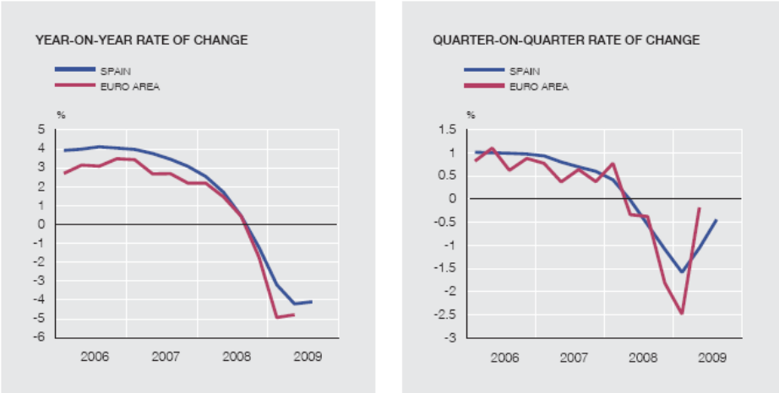

Chart 1: Gross Domestic Product (seasonally adjusted). Spain and the Euro area
Sources: ECB, INE and Bank of Spain
The easing of the quarter-on-quarter path of decline was extensive to the main components of domestic expenditure, although more markedly so in household consumption, where the direct aid for car purchases was influential, and in public investment, where there was headway in the roll-out of Local Investment Fund projects. The decline of GDP in 2009 was smaller in Spain than in some of the main economies of the eurozone, but instead the deterioration of the labour market was one of the sharpest, with unemployment hitting 19.1% in Q3 (Eurostat data). This particular feature of the recession in Spain points to a slower recovery, as compared to the eurozone, with a direct impact on household consumption during the coming years.

In the the three months from July to September there was a further reduction in the rate of change of the CPI to –1%, largely as a result of the sharp correction core inflation is undergoing, as reflected by the CPI excluding energy and unprocessed food prices, which stood at 0.1% at the end of the quarter, the lowest rate of the time series. Prices continued to trend more moderately in Spain than in the euro area, meaning that the price differential in Q3 remained negative at –0.7 pp. Moving into the medium term, the high level of slack in productive capacity makes it very unlikely that inflationary pressures will emerge in Spain. Nevertheless, it would be necessary to maintain the inflation level below that of the eurozone to entrench a comparative advantage on which to base the recovery via exportation.

In 2009 bank lending costs for households and firms generally continued to decline, although, at the same time, a more cautious lending policy is spreading among the banking institutions in response to the deterioration in the macroeconomic outlookand to the rise in bad debts.

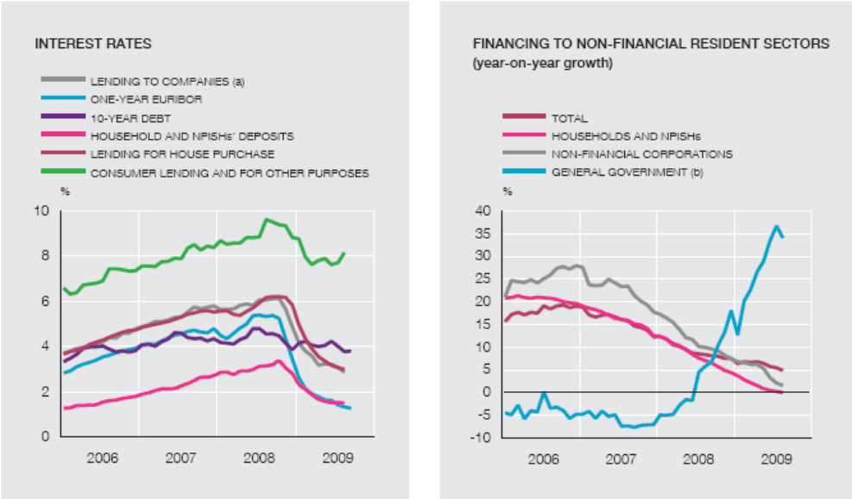

Chart 2: Financial indicators of the Spanish economy (Interest rates and financing)
Sources: ECB, INE and Bank of Spain

Finally, the projected deficit for 2009 stands at 9.5% of GDP, while the government plans to place it at 8.1% in 2010. The public debt ratio is expected to rise to 62.5% of GDP in 2009. The planned reduction of the deficit, in a less adverse cyclical environment than that in 2009, would stem mainly from the projected increase in revenue arising from the reversal of the temporary effects of some of the expansionary measures taken in recent years, and also from the increases planned for personal income tax, VAT and tax on saving, as well – albeit to a lesser extent – as from specific public spending adjustments.

ECONOMIC SITUATION IN THE BASQUE COUNTRY

The Basque GDP accounts for aproximately 6% of the GDP of Spain and comprises the activities of Services (60.7%), Industry (29.4%), Building (9.1%) and Agriculture (0.8%).

The distinctive features of the Basque economy in contrast with Spain are the bigger importance of its Industry and the smaller size of the Building activity. This different sectorial composition allowed the Basque Country to suffer a smaller impact in terms of GDP and employment during the first stages of the recession. Nevertheless, being Spain the main destination of the Basque exports (accounting for aproximately 75% of the total), in 2009 the Basque economy has begun to show a sharp decline, particularly in the industrial activity.

 | Period | Yearly change
ACTIVITY
GDP | Q3 2009 | -4
Agriculture | Q3 2009 | 3.5
Industry | Q3 2009 | -11.3
Building | Q3 2009 | -4.9
Services | Q3 2009 | -0.6
Household consumption | Nov. 09 | -4.3
Public admon. consumption | Nov. 09 | 3.0
PRICES
CPI | Nov. 09 | 0.6
Industrial prices | Nov. 09 | -5.0
Building costs | Nov. 09 | -1.1
Labour costs | Q2 2009 | 5.6
Export prices | Q2 2009 | -7.7
Import prices | Q2 2009 | -21.3

LABOUR MARKET
Unemployment rate | Q3 2009 | 5.28

EXTERNAL COMMERCE
Exports | Q3 2009 | -15.8
Imports | Q3 2009 | -15.5
Table 1: Latest available indicators of the Basque economy. 2009
Source: Basque Statistics Institute and Spanish Statistics Institute

The Basque GDP suffered a year-on-year contraction of 4% in Q3 of 2009, exactly the same figure as the Spanish GDP. The quarter-on-quarter data was +0.0% for the Basque Country and even slightly positive for the county of Gipuzkoa with +0.3%. Nevertheless, unemployment continued to rise reaching 11.6% of the active population.

The public consumption has played an important anticiclical role in offsetting the decrease in private consumption. Nevertheless, the public consumption is slowing down due to a decrease in the public purchases of goods and services, and also in the remuneration of public employees.

In the external commerce, the Basque economy is managing to maintain exports above the level of the imports, obtaining a positive balance. However, both exports and imports are diminishing, with exports showing a slight recovery only in the last months of the year 2009.

THE SHIFT TO AN EXPORT ORIENTED ECONOMY

The analysis of the macroeconomic variables points at an increasing need of the Spanish and Basque companies to export their products, due to the expected weakness of internal demand in the coming years. Nevertheless, it is necessary to analyse the situation of the companies for facing a new orientation to outside markets and offsetting the loss of competitiveness caused by a strong euro currency.

The Central Bank of Spain has published a study describing the success factors for the exportation of products of the Spanish companies. The conclusions of this report are relevant for analysing the potential of the AT companies as the study includes also specific analysis of the success indicators for the manufacturing industry. According to the study, the main features of the companies that export their products in Spain are: on average, these companies are bigger in size, have a relevant experience in the internal market and have a greater intensity in capital and technological innovation, as well as a greater level of productivity per employee. This last factor could explain why the average salary in export companies is higher and suggests also a better qualification of the workforce in these companies. But the characteristic that gives the companies the highest probability of being exporters is their resorting to other forms of internationalisation, such as direct foreign investment in other countries, and the participation of foreign capital in their property structure. The competitive advantages that companies obtain through these forms of internationalisation are the existence of scale economies in the production, organisative and institutional advantages and a better knowledge of external markets.

 |  | TOTAL | MANUFACTURING INDUSTRY
Size | Export | 55.0 | 66.0
Size | Non export | 27.0 | 27.0
Experience | Export | 21.0 | 24.0
Experience | Non export | 15.0 | 18.0
Innovation (% companies) | Export | 21.4 | 30.9
Innovation (% companies) | Non export | 4.8 | 1.8
Innovation intensity | Export | 2.4 | 2.8
Innovation intensity | Non export | 1.1 | 2.4
Qualification of the workforce | Export | 14.7 | 13.8
Qualification of the workforce | Non export | 11.8 | 8.5
Temporality Ratio | Export | 11.1 | 10.0
Temporality Ratio | Non export | 18.9 | 14.3
Physical captial Ratio per employee | Export | 25.2 | 30.3
Physical captial Ratio per employee | Non export | 20.0 | 22.2
Intangible assets Ratio per employee | Export | 1.2 | 1.3
Intangible assets Ratio per employee | Non export | 0.5 | 0.7
Direct foreign investment (% Co.) | Export | 14.8 | 15.2
Direct foreign investment (% Co.) | Non export | 2.6 | 1.2
Foreign capital participation (% Co.) | Export | 17.4 | 17.1
Foreign capital participation (% Co.) | Non export | 2.9 | 1.6
Indebtedness Ratio | Export | 29.0 | 26.6
Indebtedness Ratio | Non export | 30.0 | 26.2
Equity/ Total assets Ratio | Export | 32.6 | 35.8
Equity/ Total assets Ratio | Non export | 30.0 | 33.2
Stock market quotation (% Co.) | Export | 2.6 | 2.7
Stock market quotation (% Co.) | Non export | 0.8 | 0.3
Sectorial concentration | Export | 3.4 | 6.1
Sectorial concentration | Non export | 1.2 | 4.8
Table 2: success factors for the exportation of products of the Spanish companies.
SOURCE: Economic Bulletin of the Bank of Spain. December 2009

Likewise, the export companies show more diversity in their financing sources, which allows them to face more easily the costs for the initial entering in the outside markets. Evidence also suggests that sectorial concentration is also bigger in the export companies than in those operating only in the internal market.

The Basque companies tend to have a small size, which is not the most common feature of the export companies in Spain. However, according to the study by the Bank of Spain, the size of the companies is not the most relevant factor and shouldn’t be a significant restriction for exportation. In fact, in recent years the Spanish SMEs have positively contributed to the increase of Spanish export companies. In conclusion, the widening of the exporting activity requires the improvement of the efficiency in the national companies, and therefore, their productivity. In their commercial orientation, companies must focus on those products with the highest added value -where the competition through prices is smaller- and adapt to the preferences of the emerging demand.

THE INDUSTRIAL COMPANIES IN GIPUZKOA (SAN SEBASTIAN AREA)

The county of Gipuzkoa has a strong presence of industrial companies that have been severely affected by the consequences of the recession due to the decrease in the demand. The main activities of this companies are Metallurgy (33%), Machinery (20%), Transport material (6%) and Electric material (6%). Of their total production, 31.2% is currently exported outside Spain, being the following products the main exports: Metals and manufactures (20%), Car Industry (16%), Production Technology (19%) and Heavy machinery (11%).

In terms of productivity and labour costs, the competitiveness of the industry of Gipuzkoa can be considered low as compared to their main competitors (e.g. the United States). Nevertheless, it must be taken into account that competitiveness is determined not only by internal factors, but also by the variables of Country-competitiveness: institutional productivity, infrastructures, education, innovation support, fiscal policy, etc.

The industry of Gipuzkoa is very concentrated around two main chain values: Building related industry and Car Industry. These two activities have been severely hit by the economic recession and the industrial companies have now the opportunity of diversifying their products and markets. Apart from the final products the industry of Gipuzkoa produces the intermediate industrial goods for these two activities. On the other hand, the sales market is very concentrated on Spain and the EU.

The following are the main features of the industrial companies in Gipuzkoa:

- There are few industrial companies that are leaders in international markets, and they are leaders only in very specific products.
- The average size of the companies is small, which can difficult their strategic options abroad. Nevertheless, there is a significant number of medium size companies with a relatively high potential.
- The type of companies is predominantly family-companies, with an important presence of co-operatives.
- There exists some export industry but heavily concentrated in Spain and the EU. The external technology balance could clearly be improved: bigger technology imports than exports.
- Predominance of the industrial product (investment or intermediate), instead of consumer product.
- The sector has relevant experience in innovating in the organisational model.

There are different activities that can be a diversification opportunity for the industry in Gipuzkoa, one of which is the Health sector. Particularly, the following trends of future have been identified:

- Convergence of the advances in different disciplines: genome, nanotechnology, etc.
- Incidence of the regulation and cost reduction programmes in the Health system: rationalisation
- Cross border Licensing & partnering.
- Diagnosis and treatment at home.
- Innovation in diagnosis equipment.
- Healthcare Information Technology, after innovations by the main players (Google, Intel, Microsoft, Verizon).
- Electronic medical records.
- Market niches oriented to the final user (cardio, orthopedy, oncology).
- New alliances in the health sector: Medical equipment/ Pharmacy, Diagnosis/Pharmacy, and Medical equipment/ diagnosis/ pharmacy

2.3. INNOVATION IN SPAIN AND THE BASQUE COUNTRY: ANALYSIS OF THE EUROPEAN REGIONAL INNOVATION SCOREBOARD.

European Innovation Scoreboard (EIS) 2008

The European Innovation Scoreboard 2008 -published by PRO INNO EUROPE- analyses the current situation of Innovation for the EU27 Member States as well as for Croatia, Turkey, Iceland, Norway and Switzerland. In particular, Innovation outputs, Firm activities and Innovation enablers are evaluated for each country.

The core dimensions of national innovation performance: Enablers, Firm activities and Outputs

The Enablers dimension captures the main drivers of innovation that are external to the firm as:
- Human resources: the availability of high-skilled and educated people.
- Finance and support the availability of finance for innovation projects and the support of governments for innovation activities.
The Firm activities dimension captures innovation efforts that firms undertake recognising the fundamental importance of firms’ activities in the innovation process:
- Firm investments: covers a range of different investments that firms make in order to generate innovations.
- Linkages and entrepreneurship: captures entrepreneurial efforts and collaboration efforts among innovating firms and also with the public sector.
- Throughputs: captures the Intellectual Property Rights (IPR) generated as a throughput in the innovation process and Technology Balance of Payments flows.
The Outputs dimension captures the outputs of firm activities as:
- Innovators: the number of firms that have introduced innovations onto the market or within their organisations, covering technological and non-technological innovations.
- Economic effects: captures the economic success of innovation in employment, exports and sales due to innovation activities.
(See the Annex of this document to find the exact list of indicators for the EIS 2008)

Innovation in the EU and Spain

Based on their innovation performance across the analysed indicators, EU Member States fall into the following four Country groups:
- Innovation leaders (well above the average): Sweden, Finland, Germany, Denmark and the UK. Of these countries, Germany is improving its performance fastest while Denmark is stagnating.
- Innovation followers (below leaders, but above average): Austria, Ireland, Luxembourg, Belgium, France and the Netherlands. Ireland’s performance has been improving fastest.
- Moderate innovators (below the EU average): Cyprus, Estonia, Slovenia, Czech Republic, Spain, Portugal, Greece and Italy. The innovation trend is best for Cyprus and Portugal, while Spain and Portugal are not improving their relative position.
- Catching-up countries (well below the average): Malta, Hungary, Slovakia, Poland, Lithuania, Romania, Latvia and Bulgaria. Bulgaria and Romania have been improving their performance the fastest, while Lithuania has not been catching-up.

The EU as a whole has been improving its performance, especially in human resources (education), broadband and venture capital. Increases have been particularly strong in the numbers of graduates in science, engineering, social sciences and humanities, both at first degree and graduate level. Other areas of strong increase are in broadband and in venture capital investments.
The innovation gap with the US and Japan has also decreased: there has been a continued improvement in the EU’s performance relative to the US and a recent improvement relative to Japan. Nevertheless, there remains a significant gap between the EU and these two other regions and there appears to be some slowing down in the catching up with the US in recent years. The EU’s catching up is due to the previously mentioned factors and also to strong relative improvements in public private linkages (joint scientific publications). The remaining gap with both the US and Japan is concentrated in four areas:
- International patenting (as measured under the patent co-operation treaty)
- Public private linkages (despite the recent improvements)
- Numbers of researchers (despite the recent improvements)
- Business R&D expenditure

In relation to the emerging economies, the EU Member States have been holding their ground. The EU27 block has a higher overall performance than emerging economies such as China, India and Brazil. Besides, several EU countries are among those that have most improved their relative ranking in the period between 1995-2005.
For Spain, one of the Moderate innovators, innovation performance is below the EU27 average and the rate of improvement is just below that of the EU27. Relative strengths, compared to the country’s average performance, are in Finance and support and economic effects, and relative weaknesses are in Firm investments and Linkages & entrepreneurship.
Over the past 5 years, Finance and support and Firm investments have been the main drivers of the improvement in innovation performance, in particular as a result from strong growth in Private credit (12.7%), Broadband access by firms (15.3%) and Non-R&D innovation expenditures (13.4%). Performance in Linkages & entrepreneurship and Innovators has worsened, in particular due to a decrease in the Firm renewal rate (-6.0%). The growth in performance in Human resources is significantly below the EU average. Also during the past 5 years, Spain has shown a slower progress than the EU27 average, together with Italy and Norway.

Regional Innovation Scoreboard (RIS) 2009
The European Regional Innovation Scoreboard (RIS) provides a comparative assessment of innovation performance across the NUTS 2 regions of the European Union and Norway. The RIS replicates the methodology used at national level in the European Innovation Scoreboard (EIS), using 16 of the 29 indicators used in the EIS.

Innovation in the European regions: The Basque Country
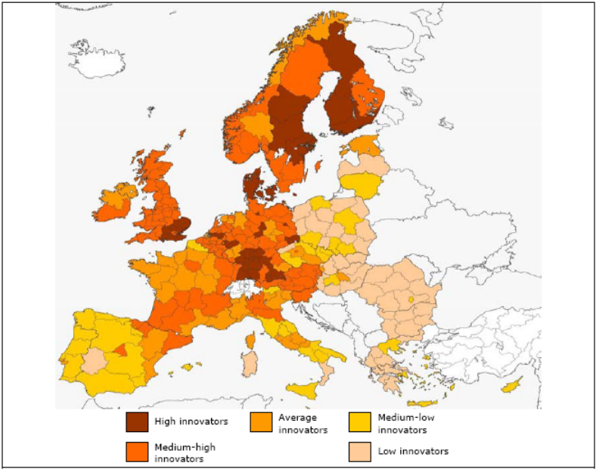

Figure 1: Regional Innovation Scoreboard (RIS) 2009.
Source: Pro Inno Europe
The main findings of the RIS report are the following:
- There is considerable diversity in regional innovation performances, as all countries have regions at different levels of performance. The most heterogeneous countries are Spain, Italy and Czech Republic where innovation performance varies from low to medium-high.
- The most innovative regions are typically in the most innovative countries: nearly all the “high innovators” regions are in the group of “Innovation leaders” identified in the EIS. Similarly all of the “low innovators” regions are located in countries that have below average performance in the EIS. However, there are regions that outperform their country level; for example, the regions of the Basque Country and Navarre outperform Spain.
- Regions have different strengths and weaknesses. This means that regions are performing at different levels across the three dimensions of innovation performance included in the EIS: Innovation enablers, Firm activities and Innovation outputs.
- Regional performance appears relatively stable since 2004.

The European regions are classified in 5 different groups: the high performers, medium-high performers, average performers, medium-low performers and low performers. For the three evaluated aspects, the situation of the Basque Country is the following:
- Enablers: The Basque Country is in the group of the high performers.
- Firm activities: The Basque Country is in the group of the Medium-high performers. Still, it is the best performing region in Spain, together with Navarre and Catalonia.
- Outputs: The Basque Country is in the group of the high performers.
The region has had no changes in its relative position in these three aspects since the previous year of data collection (2004). The overall innovation performance for the Basque Country is in the group of the Medium-high innovators.

Innovation strengths and weaknesses of the Basque Country

The RIS report classifies the European regions by their innovation strengths and weaknesses. The Basque Country is classified in the group of the “enablers strength”; this means the region shows one of the most equal performance patterns with a relative strength in Enablers.
Regarding each specific indicator, the following is normalised data for the Basque Country, where 0 is the value for the lowest performing region and 1.0 is the maximum value for the best performing region:
 | 2004 | 2006
Tertiary education | 0.82 | 0.92
Life-long learning | 0.41 | 0.60
Broadband access | 0.45 | 0.45
Public R&D expenditures | 0.41 | 0.41
Business R&D expenditures | 0.62 | 0.62
Non-R&D innovation expenditures | 0.41 | 0.41
SMEs innovating in-house | 0.56 | 0.45
Innovative SMEs collaborating with others | 0.44 | 0.47
EPO patents | 0.41 | 0.41
Product and/or process innovators | 0.63 | 0.53
Marketing and/or organisational innovators | 0.37 | 0.38
Resource efficiency innovators- Labour | 0.47 | 0.51
Resource efficiency innovators- Energy | 0.46 | 0.41
Employment medium-high & high-tech manufacturing | 0.58 | 0.55
Employment knowledge-intensive services | 0.46 | 0.51
New-to-market sales | 0.48 | 0.49
New-to-firm sales | 0.59 | 0.68
Table 3: Normalised data per indicator for the Basque Country.
Source: Pro Inno Europe
The indicators in which the Basque Country has the best relative performance are Tertiary education (0.92), New-to-firm sales (0.68), Business R&D expenditures (0.62), life-long learning (0.60) and Employment in medium-high & high-tech manufacturing (0.55). These indicators belong to the dimensions of Human resources (Enablers), Economic effects (Outputs) and Firm investments (Firm activities).
On the other hand, the worst performing indicators for the Basque Country, as compared to other European regions, are Marketing and/or organisational innovators (0.38), Public R&D expenditures (0.41), Non-R&D innovation expenditures (0.41), EPO patents (0.41) and Resource efficiency innovators- Energy (0.41). These indicators belong to the dimensions of Finance and support (Enablers), Firm investments and Throughputs (Firm activities) and Innovators (Outputs). So these could be potential areas of Innovation improvement to be addressed in the Basque Country.
Another important thing to look at is the evolution of the indicators, which show that the Basque Country has been improving mainly in those indicators where it has a better relative performance. However, it has been getting relatively worse in others, such as: Products and/or process innovators, Resource efficiency innovators- Energy and Employment medium-high & high-tech manufacturing. It is also important for the region to make some effort in order not to fall back in those indicators in which it has a better performance.
Nevertheless, it must be noted that these are values relative to the situation of other regions. This is the reason why the Basque Country has worsened its relative values of some indicators in which there has been some improvement in absolute terms. That is the case for:
- Broadband access: The percentage of companies with Broadband access was 66.8% in 2004, 82.8% in 2006 and 91.9% in 2008. However, the Basque Country has gained no relative improvement, because the rest of the European regions have had a similar evolution.
- Business R&D expenditures: The percentage of Business R&D investment over GDP was 1.14% in 2004, 1.17% in 2006 and 1.34% in 2007. Yet, the Basque Country has gained no relative improvement in this indicator.
- SMEs innovating in-house: The percentage of SMEs innovating in-house was 26.8% in 2004, 27.5% in 2006 and 30.5% in 2007; but the Basque Country has had a relative worsening in this indicator.

It can be understood from this information that the Basque Country is doing some effort to improve its innovation performance in these indicators, but not enough as compared to the European average. This means that additional emphasis needs to be placed also on the improvement of these indicators so that the innovation performance of the Basque Country remains competitive internationally.
In addition to the previously stated about the relative situation of the Basque Country using the 16 indicators analysed at the RIS, the Basque Statistical Institute offers the 29 indicators equivalent to those used at the ESI. Therefore, it is possible to see the relative situation of the Basque Country in relation to the EU27 also for the rest of the indicators appearing at the ESI.

The Basque Country is above or at the EU27 average on the following ESI indicators:
- S&E and SSH graduates (2006): The EU27 value is 40.3, and the Basque Country value is 48.
- Youth education (2007): The EU27 value is 78.1, and the Basque Country value is 79.7.
- Private credit (2007): The EU27 value is 1.31 and the Basque Country value is 1.39.
- IT expenditures (2007): The EU27 value is 2.7 and the Basque Country value is 2.7.
- Firm renewal (2005): The EU27 value is 5.1 and the Basque Country value is 12.4.
- Medium-tech and high-tech manufacturing exports (2006): The EU27 value is 48.1 and the Basque Country value is 53.6.

On the other hand, the Basque Country is below the EU27 average on the following ESI indicators:

- S&E and SSH doctorate graduates (2006): The EU27 value is 1.11, and the Basque Country value is 0.67.
- Venture capital (2007): The EU27 value is 0.107, and the Basque Country value is 0.03.
- Community trademarks (2007): The EU27 value is 124.6, and the Basque Country value is 13.3.
- Community designs (2007): The EU27 value is 121.8, and the Basque Country value is 10.15.
- Technology Balance of Payments flows (2006): The EU27 value is 1.07, and the Basque Country value is 0.58.
- Knowledge-intensive services exports (2006): The EU27 value is 48.7, and the Basque Country value is 46.2.

In conclusion, taking as a whole the innovation performance of the Basque Country in relation to the EU27 average for the ESI and RIS indicators, the strongest innovation dimensions of the region are Human resources and Economic effects. On the other hand, the weakest Innovation performance of the Basque Country is on the dimension of Throughputs, with all of its indicators below EU27 average.

According to the latest data provided by the Basque Statistics Institute (2007), in the city of San Sebastian there is a total of 3.767 researchers and technicians working in innovation activities. The majority of them are employed by companies (2,027), followed by higher education institutions (1,511) and Public administration (229).

The funds that local companies allocate to innovation come from: the Public administration (58.4%), Private companies (36%), foreign capital (4.6%) and other institutions (1%). The local innovation activity focuses on Engineering (56.3% of innovation expenditure), Exact sciences (19.2%), Medical sciences (18.1%), Social Sciences (6.2%) and Agrarian sciences (0.2%).

ANNEX: European Innovation Scoreboard 2008: Definitions of indicators

 | INDICATORS | NUMERATOR | DENOMINATOR
ENABLERS
Human resources
1.1.1  (EIS) | S&E and SSH graduates per 1000 population aged 20-29 (first stage of tertiary education) | Number of S&E (science and engineering) and SSH (social sciences and humanities) graduates at first stage of tertiary education (ISCED 5) | Population between 20 and 29 years
1.1.2  (EIS) | S&E and SSH doctorate graduates per 1000 population aged 25-34 (second stage of tertiary education) | Number of S&E (science and engineering) and SSH (social sciences and humanities) graduates at second stage of tertiary education (ISCED 6) | Population between 25 and 34 years
1.1.3  (EIS, RIS) | Population with tertiary education per 100 population aged 25-64 | Number of persons in age class with some form of post-secondary education (ISCED 5 and 6) | Population between 25 and 64 years
1.1.4  (EIS, RIS) | Participation in life-long learning per 100 population aged 25-64 | Number of persons involved in life-long learning. Life-long learning is defined as participation in any type of education or training course during the four weeks prior to the survey | Population between 25 and 64 years
1.1.5  (EIS) | Youth education attainment level | Number of young people aged 20-24 years having attained at least upper secondary education attainment level, i.e. with an education level ISCED 3ª, 3b or 3c long minimum | Population between 20 and 24 years
Finance and support
1.2.1  (EIS, RIS) | Public R&D expenditures (% of GDP) | All R&D expenditures in the government sector (GOVERD) and the higher education sector (HERD), Both GOVERD and HERD according to the Frascati-manual definitions | Gross Domestic Product
1.2.2  (EIS) | Venture capital (% of GDP) | Venture capital investment is defined as private equity being raised for investment in companies. Management buyouts, management buyins, and venture purchase of quoted shares are excluded. VC includes Early stage (seed + start-up) and Expansion and replacement (expansion and replacement capital) capital | Gross Domestic Product
1.2.3  (EIS) | Private credit (relative to GDP) | Claims on the private sector by commercial banks and other financial institutions that accept transferable deposits such as demand deposits (line 22d of IMF International Financial Statistics) | Gross Domestic Product (line 99b of IMF International Financial Statistics)
1.2.4  (EIS, RIS) | Broadband access by firms (% of firms) | Number of enterprises (excluding the financial sector) with 10 or more employees with broadband access | Total number of enterprises (excluding the financial sector) with 10 or more employees
FIRM ACTIVITIES
Firm investments
2.1.1  (EIS, RIS) | Business R&D expenditures (% of GDP) | All R&D expenditures in the business sector (BERD), according to the Frascati-manual definitions | Gross Domestic Product
2.1.2  (EIS) | IT expenditures (% of GDP) | Total expenditures on IT. IT expenditures capture hardware, software and other services. The data cover the total market, including expenditure of the public and private sector (enterprises, as well as those of individuals and households) | Gross Domestic Product
2.1.3  (EIS, RIS) | Non-R&D innovation expenditures (% of turnover) | Sum of total innovation expenditure for enterprises, in national currency and current prices excluding intramural and extramural R&D expenditures | Total turnover for all enterprises
Linkages & entrepreneurship
2.2.1  (EIS, RIS) | SMEs innovating in-house (% of SMEs) | Sum of SMEs with in-house innovation activities. Innovative firms are defined as those firms which have introduced new products or processes either 1) in-house of 2) in combination with other firms | Total number of SMEs
2.2.2  (EIS, RIS) | Innovative SMEs collaborating with others (% of SMEs) | Sum of SMEs with innovation co-operation activities. Firms with co-operation activities are those that had any co-operation agreements on innovation activities with other enterprises or institutions in the three years of the survey period | Total number of SMEs
2.2.3  (EIS) | Firm renewal (SMEs entries + exists) (% of SMEs) | Sum of the number of births and deaths of SMEs. Only SMEs with at least 5 employees and who are active in NACE classes, C, D, E, G51 I, J and K are included | Total number of SMEs
2.2.4  (EIS) | Public-private co-publications per million population | Number of public-private co-authored publications. “Public-private co-publications” are defined as all research-related papers (document types: ‘research articles’, ‘research reviews’, ‘notes’, and ‘letters’) published in the Web of Science database. | Total publications
Throughputs
2.3.1  (EIS, RIS) | EPO patents per million population | Number of patents applied for at the European Patent Office (EPO), by year of filing. The national distribution of the patent applications is assigned according to the address of the inventor | Total population
2.3.2  (EIS) | Community trademarks per million population | Number of new community trademarks. A trademark is a distinctive sign, identifying certain goods or services as those produced or provided by a specific person or enterprise | Total population
2.3.3  (EIS) | Community designs per million population | Number of new community designs. A registered Community design is an exclusive right for the outward appearance of a product of part of it, resulting from the features of, in particular, the lines, contours, colours, shape, texture and/or materials of the product itself and/or its ornamentation | Total population
2.3.4  (EIS) | Technology Balance of Payments flows (% of GDP) | Royalty and license fees, receipts (Balance of Payments, current US$) plus Royalty and license fees, payments (Balance of Payments, current US$) | Gross Domestic Product (current US$)
OUTPUTS
Innovators
3.1.1  (EIS, RIS) | SMEs introducing product or process innovations (% of SMEs) | Number of SMEs who introduced a new product or a new process to one of their markets | Total number of SMEs
3.1.2  (EIS, RIS) | SMEs introducing marketing or organisational innovations (% of SMEs) | Number of SMEs who introduced a new product or a new process to one of their markets | Total number of SMEs
3.1.3 | Resource efficiency innovators, unweighted average of the following 2 indicators:
3.1.3ª  (EIS, RIS) | Reduced labour costs (% of firms) | Number of innovating firms who replied that their product or process innovation had a highly important effect on reducing labour costs per unit of output | Total number of innovating firms
3.1.3b  (EIS, RIS) | Reduced use of materials and energy (% of firms) | Number of innovating firms who replied that their product or process innovation had a highly important effect of reducing materials and energy per unit of output | Total number of innovating firms
Economic effects
3.2.1  (EIS, RIS) | Employment in medium-high & high-tech manufacturing (% of workforce) | Number of employed persons in the medium-high and high-tech manufacturing sectors | Total workforce
3.2.2  (EIS, RIS) | Employment in knowledge-intensive services (% of workforce) | Number of employed persons in the knowledge-intensive services sectors | Total workforce
3.2.3  (EIS) | Medium and high-tech manufacturing exports (% of total exports) | Value of medium and high-tech exports | Value of total exports
3.2.4  (EIS) | Knowledge-intensive services exports (% of total exports) | Exports of knowledge-intensive services are measured by the sum of credits in EBOPS (Extended Balance of Payments Services Classification) 207, 208, 211, 212, 218, 228, 229, 245, 253, 254, 260, 263, 272, 274, 278, 279, 280 and 284 | Total services exports as measured by credits in EBOPS 200
3.2.5  (EIS, RIS) | New-to-market sales (% of turnover) | Sum of total turnover of new or significantly improved products for all enterprises | Total turnover for all enterprises
3.2.6  (EIS, RIS) | New-to-firm sales (% of turnover) | Sum of total turnover of new or significantly improved products to the firm but not to the market for all enterprises | Total turnover for all enterprises
Table 4: European Innovation Scoreboard 2008: Definitions of indicators

TECHNOLOGICAL SITUATION

Technologically, The Basque Country has an Innovation Policy that lays the foundation for the integration of Science, Technology and Companies, with an orientation towards market demand. Technology and R&D Centres of the Basque Country -belonging to the Basque Innovation Agency (INNOBASQUE) - installed in the parks and its surroundings, are a European reference model in the field of research and technology transfer, providing businesses a wide range of technology services.
One of the main objectives of the parks network is to promote collaboration between the University and Enterprise. The Basque Country has four universities (3 of them situated in the San Sebastian area) doing research and teaching, with an important dedication to growing business needs.
- University of the Basque Country.
- University of Deusto.
- University of Mondragon.
- University of Navarra.

INDUSTRIAL SITUATION

The Basque Country has an economic structure with a heavy industrial sector and an important potential growth area in the added value services related to that activity. Arguably, the industry has been, and remains, an engine for economic development.
Industrial innovation

The Basque industry has suffered a great transformation in a few years,. Poised in traditional sectors has learned, first, to renew products and processes to enable these sectors back in the first line ahead, and secondly, opening the door to the diversification and innovation in emerging sectors of industry to new technologies, performance in which technology parks have played a prominent role.

These three factors situate San Sebastian technologically above the average of the state and close to the European countries that invest the most in R & D, so it is hoped that the technological challenges of the AT sector are not an obstacle for the success of the cluster, and the economic situation will not avoid, even if it will make it more difficult than in other more optimistic periods, the development of this project.

ANALYSIS OF MARKET TRENDS AND BARRIERS

The area of Gipuzkoa might be the one with the highest rate of market development of the state in terms of AT consumption. Nevertheless, there is still a great difference between what the world wide market offers and what is consumed in the region. The reasons for such a difference might be very different, but some of them might be:

- Economical limitation of the final user to acquire them.
- Lack of existence of the product in the world market.
- Lack of knowledge about the existence of such solutions.
- Lack of distributors in the area.
- Lack of adaptation of the product to the local user’s needs.
- Lack of suitable technical service for the device.

The analysis of the level of presence in the market (both in San Sebastian and in Spain) of the total scope of AT solutions, based of the ISO 9999:2007 official classification, and the assumption of the reasons that justifies that level, will allow us to detect a gap and there fore an opportunity in the market and for the cluster.

PRODUCT DESCRIPTION | LEVEL OF PRESENCE IN LOCAL MARKET | LEVEL OF PRESENCE IN STATE MARKET | POSSIBLE REASONS
04 Assistive products for personal medical treatment
04 03 Assistive products for respiratory therapy | LOW | LOW | 3,4,6
04 06 Assistive products circulatory therapy | LOW | LOW | 3,4,6
04 09 Assitive products for phototherapy | MEDIUM | MEDIUM
04 15 Assitive products for dialysis | LOW | LOW | 3,4,6
04 19 Assitive products to administer medication | MEDIUM | MEDIUM
04 22 Sterilization teams | MEDIUM | MEDIUM
04 24 Equipment and materials for physical, physiological and biochemical | MEDIUM | MEDIUM
04 to 25 computers and cognitive assessment materials | MEDIUM | MEDIUM
04 27 Stimulators | LOW | LOW | 3,4,6
04 30 Assitive products for treatment through the cold and heat | MEDIUM | MEDIUM
04 33 Assitive products for the prevention of pressure ulcers | HIGH | HIGH
04 36 Assitive products for the training of perception | MEDIUM | MEDIUM
04 39 Assitive products for visual training | LOW | LOW | 3,4,6
04 45 Assitive products for the spine traction | MEDIUM | MEDIUM
04 48 teams for movement training, strength and balance | MEDIUM | MEDIUM
05 Assitive products for training / learning skills
05 03 Assitive products for therapy and training / learning of communication | LOW | LOW | 3,4
05 06 Assitive products for training / learning and alternative /augmentative communication | LOW | LOW | 3,4
05 09 Assitive products for training continence | MEDIUM | MEDIUM
05 12 Assitive products for training cognitive skills | MEDIUM | MEDIUM
05 15 Assitive products for training and learning of basic functions | LOW | LOW | 3,4
05 18 Assitive products for training and learning of various subjects of education | MEDIUM | MEDIUM
05 21 Assitive products for training / apprenticeship | MEDIUM | MEDIUM
05 24 Assitive products for arts education | LOW | LOW | 3,4
05 27 Assitive products for training and learning of social skills | LOW | LOW | 3,4
05 30 Assitive products for training in the control of input devices | LOW | LOW | 3,4
05 33 Assitive products for training / learning in daily life activities | LOW | LOW | 3,4
06 Orthoses and prostheses
06 03 spinal orthosis | MEDIUM | MEDIUM
06 04 Bracing abdominal | MEDIUM | MEDIUM
06 06 upper limb orthosis (carried on the body) | MEDIUM | MEDIUM
06 09 upper limb orthosis (not carried on the body) | MEDIUM | MEDIUM
06 12 lower limb orthosis | MEDIUM | MEDIUM
06 15 stimulates functional electric and hybrid orthotic systems | MEDIUM | MEDIUM
06 18 systems for upper limb prosthetic | MEDIUM | MEDIUM
06 21 upper limb prosthesis aesthetic | MEDIUMV | MEDIUMV
06 24 System prosthetic leg | MEDIUM | MEDIUM
06 27 lower limb prosthesis aesthetic | MEDIUM | MEDIUM
06 30 prostheses other than artificial limbs | MEDIUM | MEDIUM
06 33 Orthopedic footwear | MEDIUM | MEDIUM
09 Assitive products for the care and personal protection
09 03 Clothing and footwear | HIGH | HIGH
09 06 Assitive products to protect the body (carried on the body) | HIGH | HIGH
09 07 Assitive products to support the stabilization of the body (not carried on the body) | MEDIUM | MEDIUM
09 09 Assitive products for dressing and undressing | LOW | LOW | 5
09 12 Assitive products to support toilet functions (evacuation) | HIGH | MEDIUM
09 15 Assitive products for tracheotomy | MEDIUM | MEDIM
09 18 Assitive products for Ostomy | MEDIUM | MEDIUM
09 21 Assitive products for the protection and skin cleansing | HIGH | HIGH
09 24 enablers of urine | MEDIUM | MEDIUIM
09 27 urine collectors | MEDIUM | MEDIUM
09 30 Assitive products for absorption of urine and faeces | MEDIUM | MEDIUM
09 31 Assitive products to prevent involuntary leakage of urine and / or faeces | LOW | LOW | 3
09 33 Assitive products for washing, bathing and showering | HIGH | HIGH
09 36 Assitive products for a manicure and pedicure | MEDIUM | MEDIUM
09 39 Assitive products for Hair Care | MEDIUM | MEDIUM
09 42 Assitive products for dental care | MEDIUM | MEDIUM
09 45 Assitive products for facial care and skin | MEDIUM | MEDIUM
09 48 Assitive products for measuring human physical and physiological properties | MEDIUM | MEDIUM
09 54 Assitive products to support sexual activity | LOW | LOW | 3
12 Assitive products for personal mobility
12 03 Assitive products walking arm operated | MEDIUM | MEDIUM
12 06 Assitive products walking operated by both arms | MEDIUM | MEDIUM
12 07 Accessories for assistive walking products | MEDIUM | MEDIUM
12 10 cars | HIGH | HIGH
12 12 Adaptations for automobiles | MEDIUM | MEDIIIUM
12 16 Motorcycles and mopeds | MEDIUM | MEDIUIM
12 18 cycles | MEDIUM | MEDIUM
12 22 Manually propelled Wheelchairs | HIGH | HIGH
12 23 Power wheelchairs | HIGH | MEDIUM
12 24 Accessories for wheelchairs | HIGH | MEDIUM
12 27 vehicles | MEDIUM | MEDIUM
12 31 Assitive products for transfer and spin | HIGH | MEDIUM
12 36 Assitive products for lifting | HIGH | MEDIUM
12 39 Manually propelled for the guidance | LOW | LOW | 3,4
15 Assitive products for domestic activities
15 03 Assitive products to prepare food and drink | HIGH | HIGH
15 06 Manually propelled for dishwashing | LOW | LOW | 2
15 09 Assitive products for eating and drinking | HIGH | HIGH
15 12 Assitive products for house cleaning | LOW | LOW | 2
15 15 Assitive products for making and maintaining textiles | LOW | LOW | 2
18 Furnishings and adaptations to homes and other properties
18 03 Tables | MEDIUM | MEDIUIM
18 06 Machines for lighting | MEDIUM | MEDIUM
18 09 Furniture for sitting | HIGH | MEDIUM
18 12 Beds | HIGH | MEDIUM
18 15 Assitive products for adjusting the height of the furniture | MEDIUM | MEDIUM
18 18 Support devices | HIGH | HIGH
18 21 Devices for opening and closing doors, windows and curtains | MEDIUM | MEDIUM
18 24 Building components in the home and other premises | MEDIUM | MEDIUM
18 30 Assitive products for vertical accessibility | MEDIUM | MEDIUM
18 33 Safety equipment for home and other premises | MEDIUM | MEDIUM
18 36 Furniture Storage | LOW | LOW | 1,5
22 Assitive products for communication and information
22 03 Assitive products to see | MEDIUM | MEDIUM
22 06 Assitive products for hearing | HIGH | HIGH
22 09 Assitive products for vocal production | LOW | LOW | 3,6
22 12 Assitive products for drawing and handwriting | LOW | LOW
22 15 Assitive products for calculation | LOW | LOW | 3,4,5,6
22 18 Assitive products for the management of audiovisual information and video | LOW | LOW | 1,3
22 21 Assitive products for OTL | MEDIUM | MEDIUM
22 24 Assitive products to telephone (for messaging and telematics) | HIGH | HIGH
22 27 Assitive products for alarm indication and signaling | HIGH | HIGH
22 30 Assitive products for reading | MEDIUM | MEDIUM
22 33 Computers and terminals | HIGH | HIGH
22 36 input devices for computers | LOW | LOW | 2,5
22 39 output devices for computers | LOW | LOW | 2,5
24 Assitive products the manipulation of objects and devices
24 04 Materials and tools to make | LOW | LOW | 3,5,6
24 06 Assitive products for handling containers | LOW | LOW | 3,5,6
24 09 Assitive products for operating or controlling devices | LOW | LOW | 3,5,6
24 13 Supporting products for controlling | LOW | LOW | 3,5,6
24 18 Assitive products to offset or replace the functions of the arm, hand or fingers | LOW | LOW | 3,5,6
24 21 Assitive products to reach remote | LOW | LOW | 3,5,6
24 24 Assitive products for placement | LOW | LOW | 3,5,6
24 27 Assitive products for location | LOW | LOW | 3,5,6
24 30 Assitive products to support reposition and lift support | LOW | LOW | 3,5,6
24 36 Assitive products to load and transport support | LOW | LOW | 3,5,6
24 39 Industrial Transport vehicles | LOW | LOW | 3,5,6
24 42 Conveyor | LOW | LOW | 3,5,6
24 45 Cranes | LOW | LOW | 3,5,6
27 Assitive products and equipment to improve the environment, tools and machines
27 03 Assitive products to improve the environment | LOW | LOW | 2
27 06 Instrument for measuring | LOW | LOW | 3
09 27 Working Furniture | LOW | LOW | 1,3,5
27 12 Manual tools for special jobs | LOW | LOW | 3,4,5
27 15 machines, powered tools and accessories | LOW | LOW | 2
30 Assitive products for recreation | LOW | LOW
30 03 Toys | LOW | LOW | 3,5
30 06 Games | LOW | LOW | 3,5
30 09 Assitive products for exercise and sport | LOW | LOW | 3,5
30 12 Instruments musical | LOW | LOW | 3,5
30 15 Supporting products to produce photos, movies or videos | LOW | LOW | 3,5
30 18 Tools, materials and equipment for crafts | LOW | LOW | 3,5
30 21 Tools, materials and equipment for indoor and outdoor gardening | LOW | LOW | 3,5
30 24 Assitive products for hunting and fishing | LOW | LOW | 3,4,5
30 27 Assitive products and go camping trailer | LOW | LOW | 3,4,5
30 30 Assitive products for Smoking | LOW | LOW | 3,4,5
30 33 Assitive products for care of pets | LOW | LOW | 3,4,5
Table 5. Analysis of presence of the AT solutions in local and state level market. Possible reason for that.
Source: Continuous market Research done by ICAVI – BIKAIN. 205-2010

As we can see in table 5, the level of presence of Assistive Technology in both the local and the state level market is medium or high in those products that target the basic activities of daily living, especially the low-tech products.

There might be several reasons justifying it:

-Lack of public funding support: assistive technologies in Spain are financed by the Health System, in the case of Orthoses and prostheses, and Social Services Systems of each province for the rest of the assistive devices, but in very different degrees.

Many provinces have no provision system for assistive products at all, apart from those financed by the Health System. In those regions which have Assistive Products Provision System, usually depending on Social Service Departments, the tendency is to cover products considered basic and necessary, so the AT devices might be financed but including only the most basic features. EG: Tilting systems for wheelchairs, power wheelchairs for children or the elderly, ceiling hoists (vs. wheeled hoists)… are considered “luxuries” that the current budget can not afford.

Therefore, we could say that products with a high technological component are outside the funding system. In the case of Gipuzkoa, with the highest per capita spent on AT, product catalogue includes assistive devices for Instrumental activities of daily living and most technologically advanced solutions, much ahead the rest of the State.

. -Difficulty finding adequate guidance for possible solutions: few provinces in Spain have a Information and home by home Prescription/ Orientation Service for AT, and despite the increasing number of services, only Gipuzkoa offers this service at user's own home.

-Difficult to find a distributor / seller of these products: despite the fact that multiple products are available in the market, not only companies from Gipuzkoa but also Spanish companies prefer to sell products that they expect to be sold in large numbers and in an easier way, i.e. without further adaptation to the user. This is generating a market niche and some new companies dedicated to these individualized assistive technologies are emerging in Gipuzkoa.
The presence and availability of products in the state and local market is very similar, although sales in Gipuzkoa far exceed the state sales due to Assistive Product Program of the County Council of Gipuzkoa mentioned above. However, we observe differences with other European countries, especially Scandinavian countries, where the budget for Assistive Technology is much higher and, there fore, the available range of products is much greater.

ANALYSIS OF THE ACTORS: PRESENCE IN THE REGION, PRESENCE OF AT IN THEIR STRATEGIC PLAN.

Manufacturers of AT
The companies involved in the manufacturing of AT working in the City of San Sebastian were already analyzed in Deliverable D.1.1. Guidelines on key aspects for creation of a research driven cluster. There are a few other that have been detected apart from those (Iriscom, X-Madina, Areka, Osoa, Emedica, Osetech, Orona, Saludnova):

NAME OF THE COMPANY | AREA OF ACTIVITY
HERMES MEDICAL ENGINEERING S.L. | Design of high added value solutions for the field of health
LETRALAN S.L. | Integration through technology for traditionally disadvantaged groups
NESPLORA S.L. | Design of high added value solutions for the field neurosciences
Table 6. New companies detected in the area of AT

This makes a total amount of 11 private companies (most of them SME) involved through their main or auxiliary activities in manufacturing AT, most of them created in the last 3 years. This fact shows a clear tendency and bet of the industrial activity of the city towards AT. There are many other entities, such as clusters and R&D centres that would also benefit from the cluster, as well as probably the multiple companies and entities of the same sector sited in other areas of the region of Gipuzkoa.
There is another important factor to be taken into consideration, which is that of the particular entrepreneurs pushing their particular projects in the field of AT, usually focused in one unique and specific device. These entrepreneurs usually address to the local BIC’s (Business and innovation Centre), where both the idea and the entrepreneur are evaluated. In the last few years several project ideas have been presented to the different BIC’s, many of which ask for support to the specialized companies in one moment or other of the development.
This is how we known that, usually after a particular experience in the field of people with disabilities and the elderly, many entrepreneurs in Gipuzkoa try to export to the market an innovative device that they have developed for their own needs. This effort is made once and again with each of the ideas and no centralized and coordinated effort is done. In fact, the companies with more experience in the field of AT have to repeat once and again the same information and support activities for those entrepreneurs.
Both entrepreneurs and companies of AT field demand a professional support programme that will not only provide information about the market and business opportunities, but generate synergies among the different initiatives, generate unified catalogues if necessary or integrate products in other existing catalogues, has control over the distribution channel and first hand information on other initiatives (GIpuzkoa Berritzen, Chamber of Commerce…)… so that particular efforts will be minimized and results maximized.
The presence of private companies in the manufacturing step of the value chain and distribution channel is of high value for the future of the cluster. Together with the numerous sales establishments (more than 15 in the city) and R&D Centres, manufacturers guarantee the stability of the distribution channel.

R&d Centres or R&D Units of companies. AT companies subcontracting R&D units/centres.
The role R&D centres should become more and more relevant in an emerging field like AT, as a service for private/public companies developing what companies cannot do with their own resources.

It seems that the R&D centres are pushing the sector without a specific demand from the side of companies, or with a demand that has a different composition. The main reasons for this might be that:
- Companies are generally looking for applications of R&D in the short - middle term, while R&D centres are looking for middle – long term solutions. The actual difficult economic situation of the region might aggravate this fact, with companies decelerating their investments and measuring their risks more than ever.
- Many of the solutions demanded nowadays by AT consumers are not necessarily innovative in terms of technology or specific developments. They are often existing technologies that could be though produced locally and could actually increase the turnover of the companies, but if the solutions do not consume enough research and development resources, they might not be of the interest of the R&D centres.
On the other hand, the presence of R&D activities in the actual agendas of the companies and R&D Centres of Donostia – San Sebastian is modest but increasing. The analysis should be addressed to both solutions for the specific disability market –e.g. wheelchairs- and the general market -accessible furniture for general use.
It is important to remark that even if the budget allocated to the sector of AT is exponentially increasing, HEALTH, DISABILITY, AGEING… or any other similar categories in which we would include AT are not recognized as strategic lines yet, as they are others such as aeronautics, environment, sustainable transport… It is also difficult to get information about all the projects of the area of AT as it is often addressed as a transversal field, as we mentioned before. This means that there are many initiatives taking place in other areas such as housing linked to environmental control /domotics, transport linked to accessibility… but there is no detailed information available about all these initiatives.

This is a selection of the projects that have solicited for financial support to the Basque Government, from the R&D Department. Among the 21 projects presented in the year 2009 in the area of HEALTH, there were 6 leaded by entities from San Sebastian, most of them leaders of the projects.

ACCRONIM | TITLE | AREA OF ACTIVITY | APPROVED | PARTICIPANT | TYPE
LOCCARE | Gerontology Centre management system based on tracking systems and mobility as a commercial product for a new business | TELECOMUNICATIONS | NO | FUNDACION INSTITUTO GERONTOLOGICO MATIA | R&D
VAPORIZA | Launch of a new company of portable vaporization systems for palliative applications | BIOSCIENCIES | YES | HERMES MEDICAL ENGINEERING S.L. | SME
EVOCAN | Mathematical Modelling of Tumour Growth and Parameterization by Medical Imaging for Treatment Optimization | TELECOMUNICATIONS | YES | ASOCIACION GAIA | CLUSTER OF IT
SN2009 | INTELLIGENT TELEMETRY oriented elderly and chronically ill | TELECOMUNICATIONS | YES | SALUDNOVA, S. COOP. | SME/COOP
E-LIFE | ICTs as improving the quality of Independent Living of Persons with Intellectual Disabilities in their Homes. | TELECOMUNICATIONS | YES | ASOCIACION GAIA | CLUSTER OF IT
MIRESPEN | Development of the game "MIRESPENA" for the training of self-esteem in children based on artificial intelligence | AUDIOVISUAL | YES | NESPLORA S.L. | SME
Table 7. Projects of the field of AT asking for support to the Basque Government support programme for HEALTH issues in the year 2009.

Users
Users of Assistive Technology Market can be classified in big users (e.g.: building agents consuming domotic… nursing homes and other customers that may consume AT in large amounts for their own customers) and particular users, this is, people with disabilities.
BIG USERS

In Gipuzkoa, Nursing homes and the senior centres are the best representatives of the group of Big Users). Nursing homes are the most important consumers of all, as the fact that people LIVE in their institutions makes them address many more different activities and situations than in a day or senior centre. There are 67 nursing homes in Gipuzkoa, 25 of which are located in San Sebastian, and in which up to 5,000 people live. There are 61 Senior Centres in Gipuzkoa, 14 of them located in San Sebastian, which attend to 1,500 senior citizens.
Building agents are not yet too much into integrating AT in their projects, and nowadays not even public house promotions, in the percentage booked for people with disabilities, integrate any AT device or pre-installation for environmental control. This group of potential users has to be worked on.

PARTICULAR USERS
In the group of particular users we can distinguish three categories:
1. People with permanent disabilities.
2. People with temporary disabilities.
3. Elderly people.
According to the latest data of INE (Statistic Institute of the Spanish Government), potential users of Assistive Technology should be around 169.400 people in The Basque Country, of which 54,500 are located in Gipuzkoa and 14,000 in the Metropolitan area of San Sebastian.

Customers are buyers (payers) of products. They may coincide with the final user, but in many cases the customer is usually an intermediary, such as clinics, insurance companies, public health systems, nursing homes, etc.., facilitating AT to the final consumer.
It is convenient, when analyzing the industry of technical aids, to make a clear distinction between users and customers. In many cases technical assistance providers are more focused on meeting customer needs (administrations and other payers), instead of measuring the degree of satisfaction of the final users. This might be so because, currently, the capacity of influence of users in the market of Assistive Technology is very limited and so technical assistance providers, being aware of this situation, focus their business efforts on commercial customers.
In the case of particular users or individuals, usually they themselves or a caregiver address the establishment and buy the product. There are about 50 Orthopedics in Gipuzkoa and approximately 15 of these establishments are located in the metropolitan area of San Sebastian.

AT Consulting and Integration activities.

It is a fact that the presence of AT integration activities is essential to make AT accessible for final users. Independent developments that are not integrated in a general catalogue and presented to the user by professionals of the AT field have more difficulties to reach the final user.
In this way, we should analyze if there is any activity in San Sebastian or Gipuzkoa in this field that could positively influence the local R&D potential, through rising awareness, providing information to different agents and/or putting together the present offer to make it real for the consumers and users.

The fact is that the County of Gipuzkoa is the most developed region in the whole Spanish State regarding AT. Gipuzkoa is actually closer to Sweden and Denmark (important AT consumers) in AT consumption than to any other region in the Spanish country.
The reasons why in Gipuzkoa in general, and San Sebastian in particular as the capital of the region, the consumption of AT is so high is the following:
  - A wide public programme providing information and economic support for access to AT and Accessibility (Currently called ETXETEK) is held, with increasing budget since the 90´s, reaching currently more than 4 million euro per year.
  - The strong belief in the importance of a continuous Market and Product surveillance to provide information to users about the state of the art of AT, making consumers aware of the possibilities available in the market even if not always economic support is available to get the AT solutions.
The philosophy of “giving information to ensure that the lack of it will not be a handicap for the access to the needed solution” was the main reason why the County Council of Gipuzkoa relaunched a programme in AT and Accessibility that had been working ever since the early 90’s but with a very discrete budget.
Since the year 2003, the bet has been directed in three directions:
1) The increase of the budget dedicated to direct funding of AT, that has been increased from 125,000 euro in 2001 to 4 million euro in 2009.
2) The promotion of an AT reuse service, with a cost of approximately 0.24 € per euro of the original price of the AT, and which allows inheriting AT between users, saving approximately EUR 1,500,000 per year.
3) The bet for the AT consumption market, through the generation of business competition and the commitment to private enterprise, which has better guarantees of service quality and higher levels of competition than public management.
  - The existence of a professionalized consulting firm that has been disseminating knowledge supported on a constant product surveillance and high direct contact with the final user, ICAVI – BIKAIN, allows the detection of what is offered in the market and of what IS NOT offered. The year 2003, when the public AT provision system (ETXETEK) changed from public to private management, meant a turning point in the consumption of AT and the role of user, that has changed from “patient” to “consumer”.
  - The existence of professionalized AT integrating companies, that complement the work of orthopaedics in an increasingly demanding field. The fact is that products that used to be part of the financed catalogue remained fairly constant over time and were of low technological content. However, ever since 2003 there have been several facts that have changed the essence of that catalogue:
    - The inevitable influence of the popularization of information technology.
    - The widespread social change in the attitude towards any discriminated group. In this case also supported by extensive legislation that will gradually allow the integration of persons with disabilities in society. This has increased the areas of daily living that require specific solutions and therefore generate new demand for AT.
    - The inclusion of high technology solutions in the catalogue of subsidized products in the AT program of the County Council of Gipuzkoa, ETXETEK (such as computer access, environmental control, augmentative and alternative communication ...)
A good example of an innovating AT local manufacturer is OSOA, an Assistive Technology Engineering whose mission is to achieve greater autonomy (and quality of care if any) in the basic tasks of daily life for people with disabilities through technology. To achieve its objective, and mindful of the need to optimize the resources of people with disabilities, they have designed an integrated solution in which the responses to these needs are compatible with future needs.
This has been possible thanks to the consortium of the following companies:
Bj Adaptaciones: state market leader in technology support and supplier of control system (accessible to all people). Cambridge equipment: state-market leader in ceiling cranes.
Matz-Erreka: Market leading manufacturer of door automation state.
Areka: manufacturer of a universal solution of embeddedness of showers.
The market changes force a professionalization of the sector and the creation of services beyond the simple sale, which is what is fundamentally covered by the orthopaedics. Thus, the particularized advice, training in the use of AT solutions, finding/prescribing solutions for a much broader range of activities and with a new perspective of autonomy and independence, requires the creation of two new professional profiles:
- Expert in prescribing AT solutions: trained in both socio-sanitary and technical areas, that can make a prescription closer to user needs and the technical possibilities.
- Expert in implementation of AT solutions: Professionals from the construction and technical industries trained in accessibility and control environment, capable of designing and executing works that address these disciplines and working with evaluation/ prescribing teams for AT solutions.
These profiles will be more deeply described in next chapter 3.5. Training and education.

TRAINING AND EDUCATION
This chapter tries to analyze the level up to which AT is included in the actual education of future professionals’ agenda.
A wider use of Assistive technologies (AT) results in an improvement of the quality of life and it also generates a positive feedback for the generation and development of new innovations that fulfil new demands and aspirations of users. Education and training is a matter that becomes essential to spread the adoption of AT products.
A study requested by the EU commission that analyses the situation of ATs has identified six main areas where measures should be adopted to improve the access to the ATs: Information and Advice, Education and Training, Market efficiency, Complexity of national systems, Assistive technology in the workplace and Anti-discrimination issues.
The recommendations in the area of Education and Training are oriented to improving the theoretical and practical knowledge of functional problems, and the solutions that the use of Assistive Technology can offer.
- To promote the development and delivery of multiplier education and training programmes which would fulfil the requirements of the professionals involved. Such an approach might involve three main components:
  - initial (higher) education of professionals (e.g. occupational therapists)
  - specialised continuing training via modules (e.g. rehabilitation techniques for doctors)
  - dedicated training in Assistive Technology products and their capabilities (e.g. for technical experts;
- To promote e-learning for training purposes (including the development of learning materials that can be used across borders);
- To promote mandatory training for all health professionals and social system players dealing with disability issues in the broad sense;
- improve the knowledge of general practitioners on disability issues through the specific systems of permanent education and accreditation in the Member States;
- introduce a mandatory certificate for medical doctors and paramedics prescribing assistive technology products;
- promote recognition of education and training qualifications at EU level in order to encourage information and knowledge transfer.
Table 8. Recommendations in the education and training area.
(Source: Access to Assistive Technology in the European Union, 2003)
In the context of the Basque Country, the city of San Sebastian is well positioned in the area of Education and Training in the specific field of the AT, not only for professionals but also for caregivers thanks to the following pillars:
- The University of the Basque Country offers a specific master degree in the area of AT for the personal autonomy.
- Training services related to AT areas are offered by local actors (Ingema, Icavi-Bikain, Kutxazabal).
- There is a web place focused on knowledge transfer between the multiple actors in the Assistive Technology area (medical professionals, user associations, caregivers …) promoted by the region public authorities (Diputación Foral de Guipúzcoa) and the APTES association.
- At National level Gipuzkoa is this year coordinating the recently created FORO IPROA, a nationwide cooperation forum.
1) MASTER DEGREE IN ASSISTIVE TECHNOLOGIES FOR THE PERSONAL AUTONOMY

The University of the Basque Country (www.ehu.es) offers a master degree in the specific area of Assistive Technologies for the personal autonomy http://www.mastertecnologiadeapoyo.ehu.es.
The course is targeted to three main collectives:
- technology scientists and engineers (Computer science, Physics, Electronics, …)
- social scientists (psychology, pedagogy, …)
- socio-sanitary professionals (nurses, caregivers, rehabilitation, etc.).
and it covers the ageing and disability topics complemented with some horizontal topics. The 2-years duration degree is structured in the following contents:
- Technologies (mobility, communication, accessibility, sensory impairment, intelligent environments …).
- Users (needs, active ageing, independent living, …)
- Policies (Legislation, standards, ethical issues, …)
- Horizontal skills (leadership, communication, business opportunities, …)

2) TRAINING RESOURCES RELATED TO ASSISTIVE TECHNOLOGIES
Training offer of Ingema
- Care for people with dementia. The importance of attitude in attention (e-learning).
- Intergenerational Programs Manager
- Psychosocial Intervention in Gerontology
- The emotions in the Elderly
- Master in Neuropsychology
- Psychiatric aging (face)
- Older people and mental illness. How to Cope (e-learning)

Training offer of Icavi-Bikain
ICAVI - BIKAIN has been offering for the last 6 years training to all the different agents participating in the value chain of AT and services for people with disabilities. With a very practical approach, always based on site demonstrations, practice of the techniques and theories, the offer of courses is very wide:
- Assistive Products: basic, advanced and general theme.
- Supporting products: by product type or pathology.
- Accessibility and universal design.
- How to mobilize and transfer on a basic and advanced level.
- Management of personal assistance from the Independent Living philosophy.
- Systems for assessing the Unit
- Specialization course in personal care and independent living.
- Specialization course in assistive solutions (assistive products and accessibility)
- Specialization course in execution / implementation of assistive solutions (assistive products and accessibility)
The courses are aimed at Universities and training centres of Occupational Therapy, Physiotherapy, Nursing, Medicine, and Senior Technical Architecture, construction trades, public employment services, government, firms in the area of SAD, People with disabilities and informal caregivers...

KUTXAZABAL CENTRE
Kutxazabal is a non-profit financial and social entity founded by the County Council of Gipuzkoa and the Town Hall of San Sebastian.
Its aim is to provide a platform to support training for all groups involved with people with disabilities and AT (professionals, family networks, stakeholders and the general population) and produce impact on improving the quality of care to people in situations of dependency.
The training offer is divided into three sections:

Continuing Education: Professional and family care
Specific courses aimed at professionals shortened and family caregivers, allowing the updating of knowledge-both own experience and training, acquiring new resources and thematic approach to social assistance before the need to respond resolutely in situations that may arise.

Professional Training
Basic training courses in various professional activities of the field of social assistance consisting of two sections, one develops the theoretical part and the other develops the practical one in experienced institutions in the sector with personalized follow-up from the centre. These courses are aimed at people who want to develop their professional path in this field.
Training on demand
Courses to suit the needs and possibilities of different companies and that can be carried out in their own installations.
3) ASSISTIVE TECHNOLOGIES WEB PLACE
GizaTik, www.gizatik.org, is a web place oriented to professionals in the area of Assistive Technologies offering different services to spread the knowledge in this field and fostering the creation of a network of professionals. User associations are also collaborators of this initiative. This service is supported by the APTESError: Reference source not found association and the Social affairs department of the regional government (Departamento de politica social e Innovación de la Diputación Foral de Gipúzcoa).
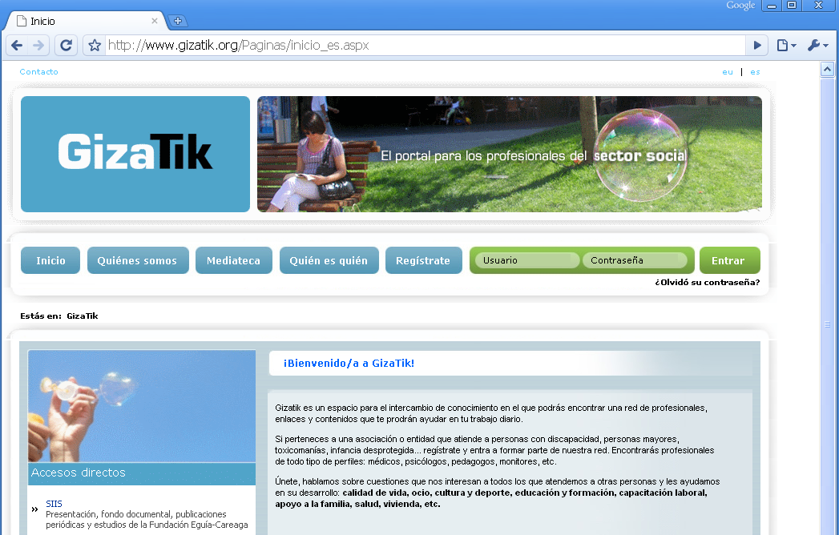
Figure 2. Gizatik Web portal http://www.gizatik.org
4) IPROA FORUM
The Forum IPROA is a structured forum for cooperation among centres performing Information and Advisory of Assistive Products. The County Council of Gipuzkoa, through the support Programme for AT and Accessibility called ETXETEK, is a founder member of this Forum and the coordinator of real activities during the first year (2010) after its constitution in 2008.
The centres, distributed nationwide and dependent on other agencies, join voluntarily in order to develop strategies to promote information sharing and knowledge management.
The purpose of the Forum is to allow a more active role for people with disabilities and elderly people, and all those involved in the selection and beneficial use of Assistive Technology, now called Support Products.
The forum, launched in 2008, was inspired by the International Alliance of Providers of Assistive Technology Information.
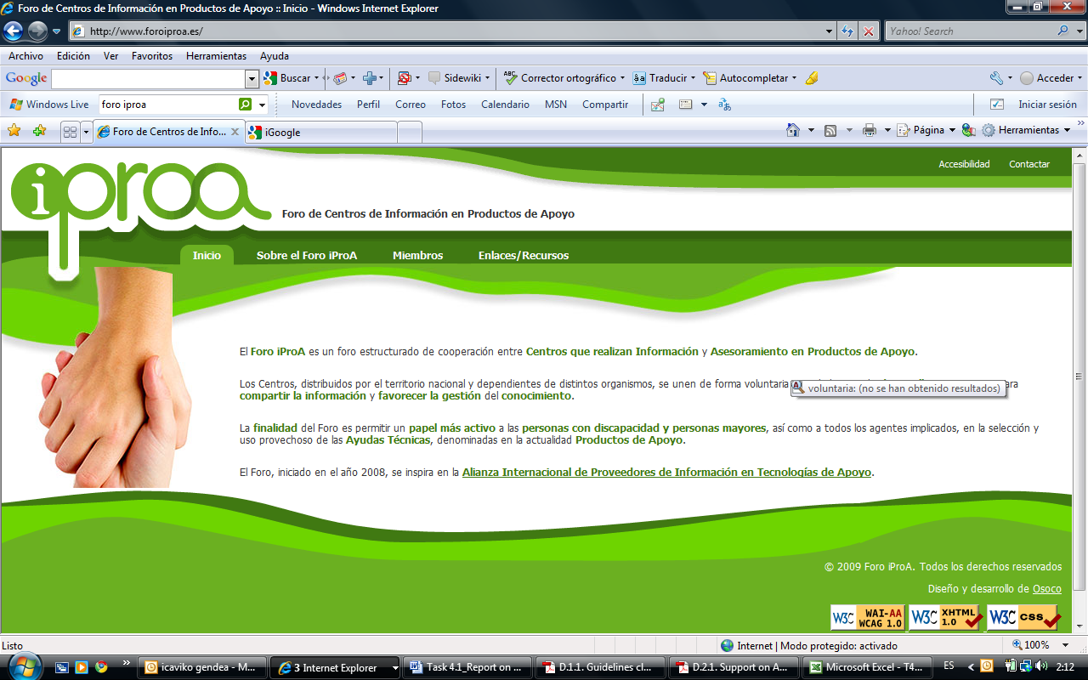
Figure 9. Gizatik Web portal http://www.gizatik.org

The forum is a place to exchange best practices and search effective solutions together and effective action involves structured voluntary work, sharing and transmitting knowledge about products, technologies and support solutions. The Forum is coordinated with IPROA, as well as with other networks and platforms for sharing resources and managing knowledge. Other participants are EASTIN (cooperating with the European network), and the Network Information Centres Support Products (cooperating with the Association AAATE for the Advancement of Technology Support in Europe, the Ibero-American Cooperation RIICOTEC and the European Network Design for All).

Support of Administrations to AT sector.

The study of the support that Administration may give to AT sector is an important clue to analyze the potential of the cluster. This support could be analyzed through different aspects: support for purchasing, support for R&D, support for Manufacturing…
Support for purchasing
In the case of Gipuzkoa, assistive technology is mainly financed by two public entities such as the Provincial Council of Gipuzkoa and the Health Department of the Basque Government. In both cases, the user is free to choose the brand and model of the product itself, while it is true that there is a limitation imposed by both institutions in the type of product to buy and to the amount per grant that determines the final product selection.
These institutions make large number of purchases of Assistive products to major distributors. In such massive purchases the particular needs of each potential user are in any case taken into account. The County Council of Gipuzkoa also performs regular purchases of assistive products.
Traditionally Assistive Technologies have been publicly financed, at least in the case of those communities that have a system of financing for them, by Social Services or the Public Health System in the case of orthoprosthetic products and mobility products. In the group of potential users we have not taken into account all those users without an officially recognized disability or even without any disabilities that can benefit from the conveniences that the use of technology can offer to each and every one of us. On this basis, we understand that the whole Building sector and in particular the Housing Department of the Basque Government, are potential Big Users of any home domotic solutions that should be implemented in the new housing.
The total amount dedicated is more than 4M euro and increasing, the highest amount per capita in the Spanish state as mentioned in chapter 3.4.

Support for R&D and manufacturing
The various support programmes for R&D and manufacturing have already been analyzed in different deliverables and chapters. As mentioned above, the Basque Country in general and San Sebastian in particular, enjoys of one of the highest rates of public and private investment in R&D and programmes that promote the development of prototypes and their industrialization.

ANALYSIS OF OTHER SUPPORTING FACTORS:

Distribution channel.

The objective of the analysis of this point is to check if there is any existing distribution channel that would positively influence in the local R&D potential.
The current distribution chain of AT is conceptually very similar to that of any other area of the market, which suggests AT market is somehow a "normalized" market, except for the first and last steps of the chain. The truth is that when making this concept of distribution channel a reality, we find a lack of some key aspects typically missing in an immature market:
- Knowledge of the state of the art of the offer.
- Integrated solutions.
- Integrated R&D initiatives.
- Specialist professionals.
- Associated services for the AT solutions.
R & D
MANUFACTURERS
IMPORTERS
DISTRIBUTORS
RETAILERS + low quality after sale services
GENERAL RETAILERS (ORTHOPEDICS)
SPECIALISTS
GENERAL R & D CENTRES
Figure 4. Representation of actual distribution channel of AT

Often R&D centres belong to a specific area in which they are specialists. In the Basque Country, this has typically been the case of machine tool, furniture, IT… and many other fields, that are represented by specific R&D Centres. This is not the case of AT, that has been up till today addressed by R&D Centres from other areas when diversifying their activities.
At the other end, when it comes to retailers, in the general market they are usually specialized in more than one but always professionally similar areas. This is not the case of AT solutions, which are nowadays sold, whichever the application field, through the same general retailers. This does not follow the natural path of any other common distribution channel: accessibility works, wheelchairs, communicators, environmental control solutions… are sold through the same retailer when the knowledge and services required are totally different.
Some of these areas of expertise will also require an offer of after sale services adequate to the generally expensive items, with high technological content and responding to primary needs. Therefore, the desired distribution channel would be the following:
SPECIFIC R&D CENTRES
MANUFACTURERS
IMPORTERS
DISTRIBUTORS
SPECIALIST RETAILERS AND INSTALLERS (R&I)
MOBILITY SPECIALIST
AAC¹ SPECIALIST
ACCESIBILITY SPECIALIST
ENVIRONMENTAL CONTROL SPECIALIST
…
Figure 5. Representation of DESIRED distribution channel of AT

This scheme is very much like the one presented in ABLETECH, the International Conference on Technologies for Accessibility and Support for Dependent People, held in Bilbao, Basque Country, in December 2008, a place where International experts from the sector can exchange their experiences in order to learn from the good practices of other countries.
The value chain was also analyzed in that conference, and the result was the following:

1) ACC: Alternative and Augmentative Communication
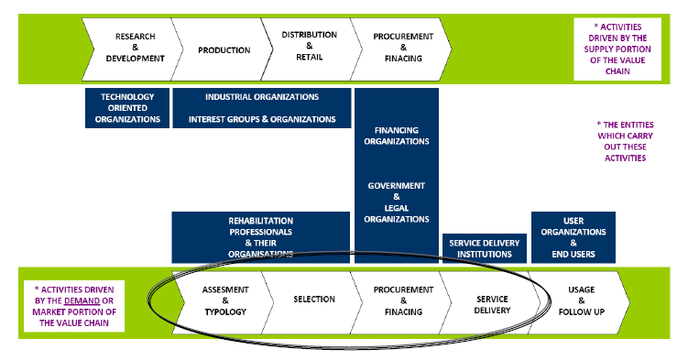
Figure 6. Representation of value chain of ICT AT according to the conclusions of the congress Abletech, 2008
SOURCE: Analysis of the AT industry in Europe. Outcomes and recommendations.

According to the conclusions presented in the Conference, research (based on Interviews and questionnaires) confirm that for the most important step of the channel is the Service Delivery Systems (assessment, product selection & financing) and National Procurement Systems.
(30% very much agree; 60% somewhat agree; 7% somewhat disagree; 3 very much disagree.)

This fact holds back the industry because:
–The different rules and procedures depending on the country and the product type make It difficult for companies to achieve important levels of economies of scale.
–Due to decentralised distribution networks, specific product adaptations to individual markets, additional costs have to be incurred to develop solutions adapted to the different national markets.

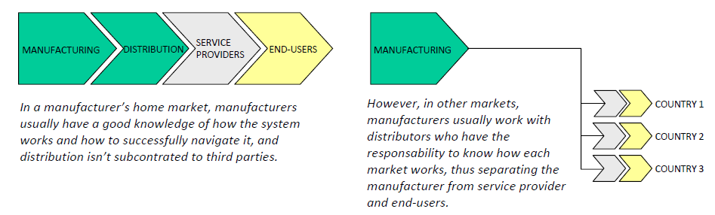
Figure 7. Representation of distribution chain of ICT AT according to the conclusions of the congress Abletech, 2008
SOURCE: Analysis of the AT industry in Europe. Outcomes and recommendations.

The fragmentation caused by different national systems and policies makes an already limited market (accessibility products), even smaller. In addition, companies have to bear the costs of building and maintaining an extensive decentralised distribution network. Such a network is costly to build and maintain, and also ends up being a type of barrier to manufacturer’s having direct knowledge of different markets, including the specific needs and requirements of these markets.

The conference also concluded in a reflexion on the basic tenets For an association to work and achieve the objective of promoting and strengthening the EU AT ICT industry. The following are the recommendations for the EU level association, and bellow be will translate them into a local level association,
EU LEVEL TENENTS:
- Network members should include both large and small industry players. It needs the voices of both multinationals and SMEsto be successful.
- Geographical coverage should cover all EU member states, for example via connections to existing national organisations, such that representatives of national organisations becoming members of the EU level network.
- Strong support for the implantation and start up of the network, for example on the form of specific EC policy support action and/or a type of grant to offset initial start‐up costs.
- Good operational financial structure to guarantee continuity. This would be principally financed through member fees and income from network events, activities and services. And most importantly, that the EC recognises this network as the key point of contact with the AT ICT industry, and likewise, that the industry values and recognises the network as their voice to the EC.

LOCAL LEVEL TENENTS (IN SAN SEBASTIAN):
- Network members should include both large and small industry players. It needs the voices of both multinationals and SMEs to be successful.
- The local level association should be linked to the EU level association, so that state of the art in trends, tendencies and other interesting synergies are exploited so that local and possibly weaker associations are not stifled by the effort that a work already done by others can mean for them.
- It is essential that the regional governments (at least town hall of San Sebastian and County Council of Gipuzkoa), support through their legislation and programmes the implantation and start up of the network.
- The association should try to be financially independent as soon as possible and be, like in the EU case, principally financed through member fees and income from network events, activities and services. The association is thought to bring richness and innovation to the region through the AT field, not be a permanent cost not overtaken by the benefits brought.
- The region should recognize the cluster as the key point of contact for AT industry.

LOCAL LEGISLATIVE FRAME.

The analysis of the current legislation and the way it supports access to AT will define whether we are in front of a weakness or an opportunity for the cluster.

Looking at Deliverable D.2.1 Report on local, national and European policies and initiatives in support of AT or related sectors, we can analyse more in detail the possibility of legislation working towards making it compulsory for administrations to promote free access to AT for users, total implementation of accessibility in constructed environment… This would definitely affect positively to the local R&D potential.

The fact is that most legislation try to guarantee the equal opportunities of people with disabilities but, when it comes to developing the law through its articles and decrees, the AT is left in additional binding. In other words, AT implementation depends of the will of the administration to develop tools and programs that facilitate access and funding support for AT.

The only two instruments that facilitate access to AT in San Sebastian, which are exactly the same that affect to the whole region of Gipuzkoa are:

- The official ortoprotesic catalogue of the Health System that provides financing for wheelchairs and standers, hearing aids and other external prosthesis.
- The ETXETEK programme for AT and Accessibility of the County Council of Gipuzkoa, which is not in itself a law but is a stable voluntary programme that provides information and funding for an open and wide AT catalogue, including any AT solution in the field of mobility, accessibility, augmentative and alternative communication, access to information and computer, environmental control, AT for hearing impairments, AT for visual impairments…

The trend in the state is to promote initiatives such as ETXETEK, which effectively serve as a reference to the IPROA forum, already presented in this document. Currently the investment of Gipuzkoa for a population of 700,000 inhabitants is of 4 million euro, although it would take nearly double to meet the actual demand requirements. The administration in Gipuzkoa (San Sebastian doesn’t have a specific programme itself, it is regulated by the county programme) has a clear intention of maintaining the programme and is actually looking for ways to improve the scope of AT solutions provided, the professionalization of the prescription service and ways to have a more flexible access to AT by acting over the traditional distribution channel.

SOURCE: Informe de competitividad del País Vasco: hacia una propuesta de Valor. Instituto Vasco de Competitividad. (Basque report on competitivity: towards a proposal of value. Basque institute of competitivity),
Gipuzkoa Berritzen has set itself the goal of making “Gipuzkoa a territory of innovation” and of pressing forward, by co-ordinating its efforts with those of other institutions, to create an especially propitious environment for innovation, which will constitute a key element of Gipuzkoa's regional competitive advantage.
Main determinants for the decisition of exporting at the Spanish Companies (Determinantes principales de la decisión de exportar de las empresas españolas). Economic Buletin of the Bank of Spain. December 2009.
Except for the indicator “Public-private co-publications”, which is not offered by the Basque Statistics Institute.
G. Craddock and others, “Access to Assistive Technology in the European Union,” European Commission Directorate-General for Employment and Social Affairs, Deloitte & Touche (2003).
APTES (Association for the Promotion of Social Technology). http://www.tecnologiasocial.org is a multidisciplinary network of professionals working in different areas concerned with Social Technology (providing information, knowledge and opportunities to persons and organisations involved in solving social problems through the use of technology).

